APPENDIX B

COMMENTS received ON THE nop/initial study and response to comments

Comments
Response to Comments
INTRODUCTION

This appendix contains the comments received during the public review period on the Notice of Preparation/Initial Study (NOP/IS) for the proposed 2003 Air Quality Management Plan (AQMP). A total of 16 comment letters were received. The comment letters are provided below and each comment has been numbered. The responses to each comment are presented in this Appendix following the comments.
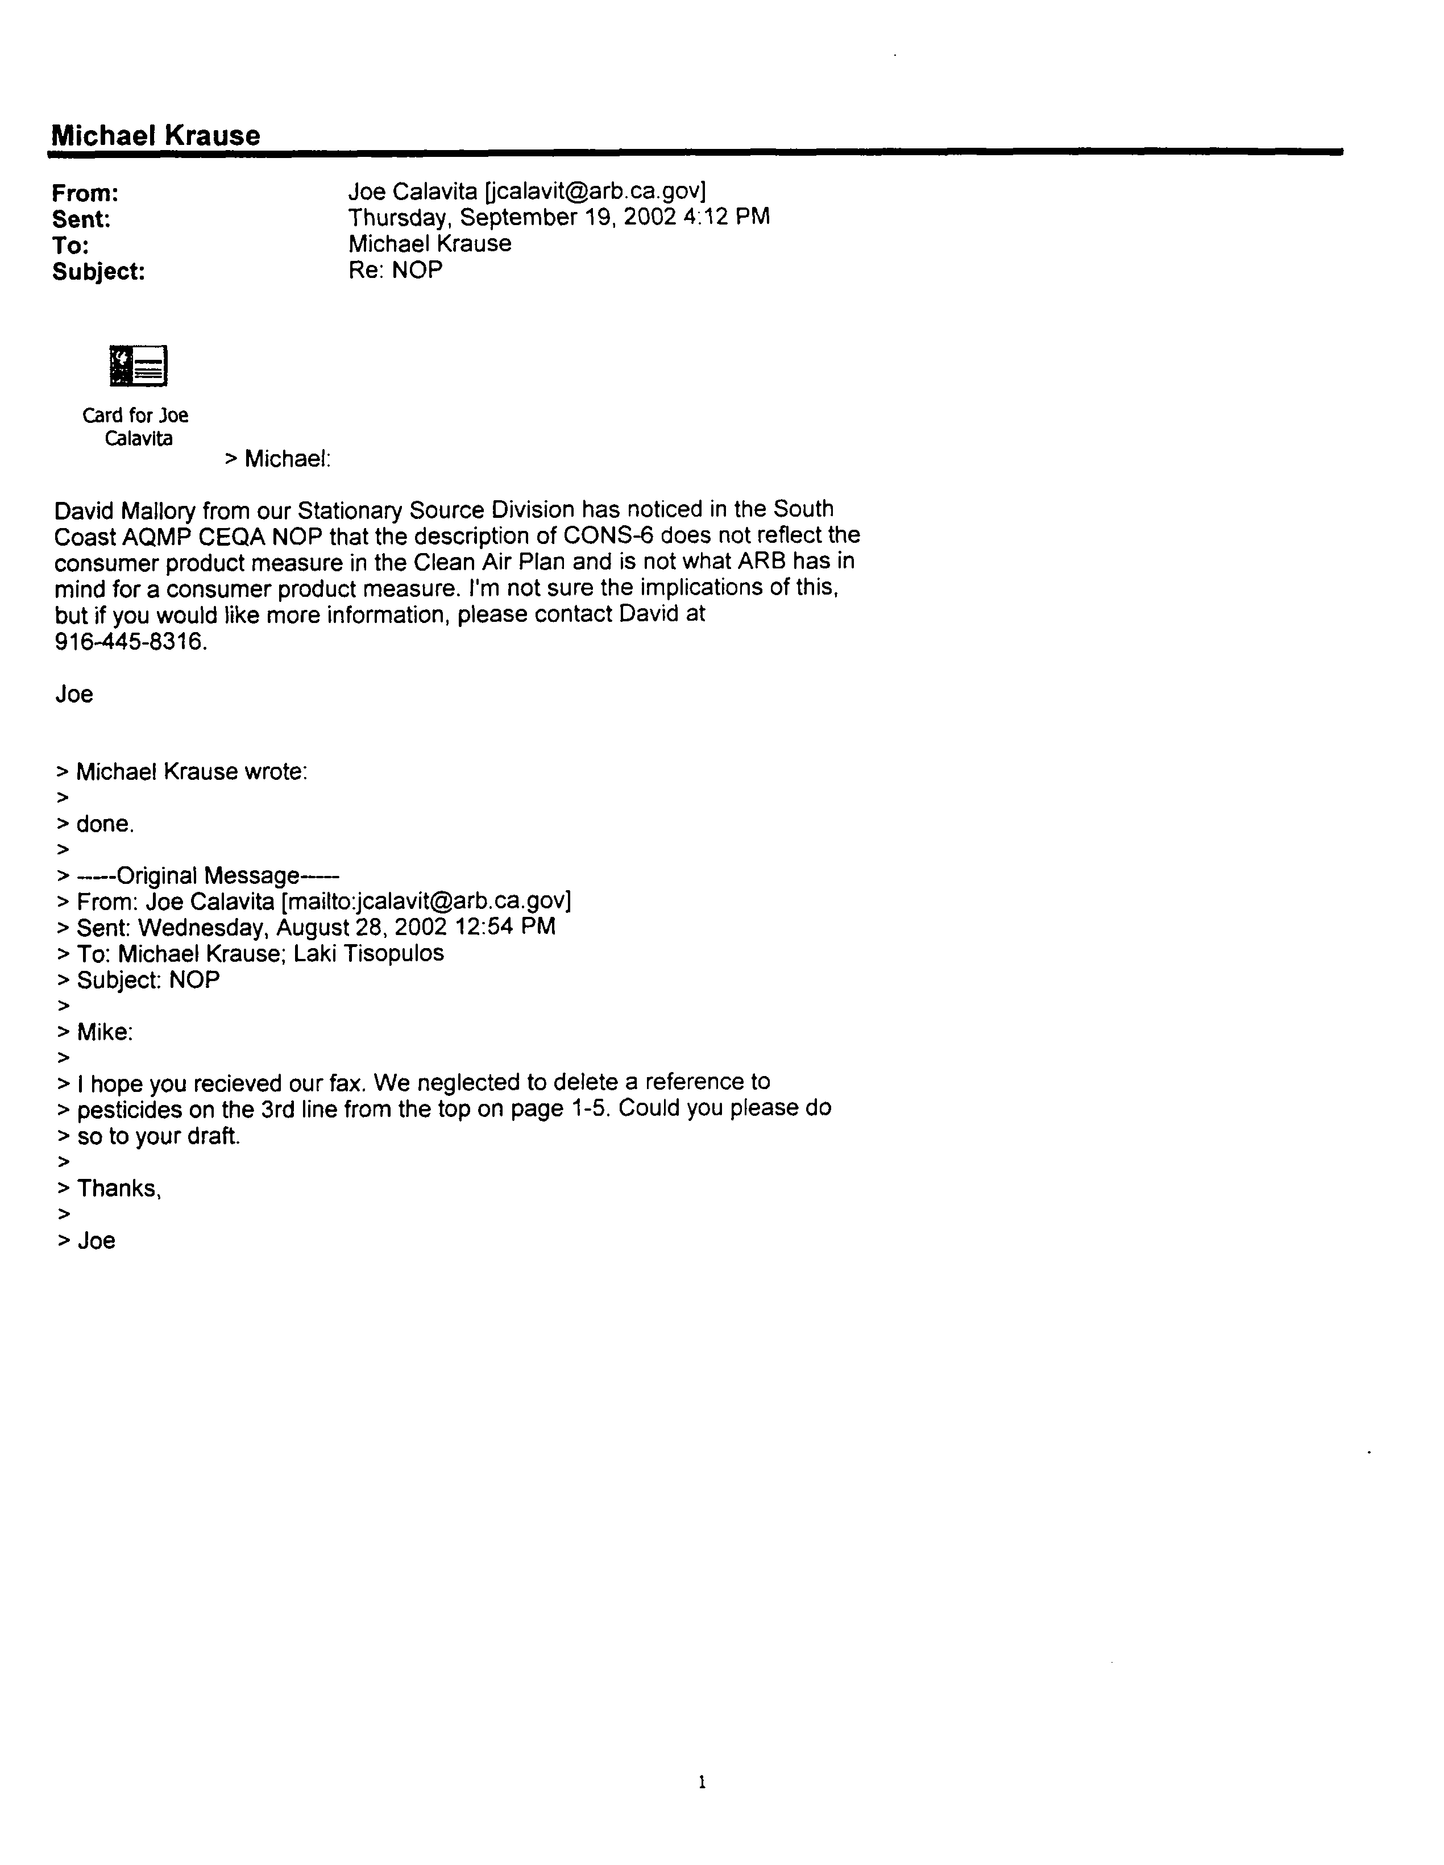
1-1
1-2
COMMENT NO. 1
E-MAIL FROM CALIFORNIA AIR RESOURCES BOARD

Joe Calavita

September 19, 2002

Response 1-1

The control measures in the AQMP have been revised to be consistent with CARB’s Draft State and Federal Element of South Coast State Implementation Plan, Section IV, Long-Term Strategy, December 2002. CONS-6 has been removed by CARB as a long term control strategy and has been deleted from the 2003 AQMP.

Response 1-2

The comment was noted and this change was incorporated into the NOP/IS.

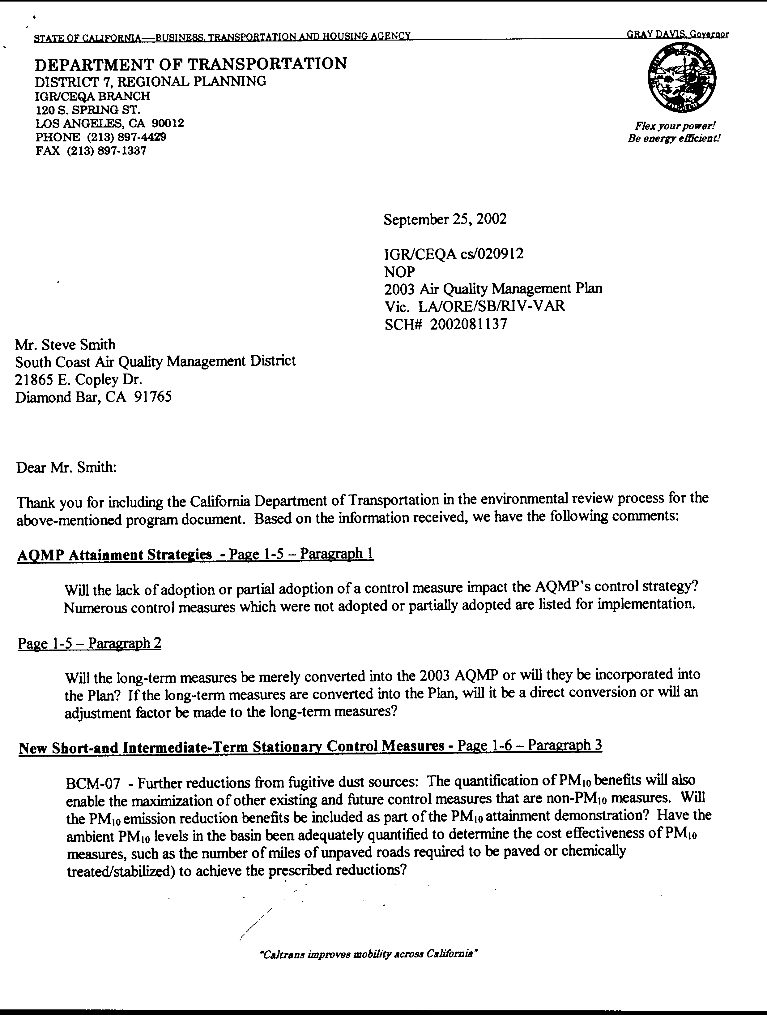
2-1
2-2
2-3
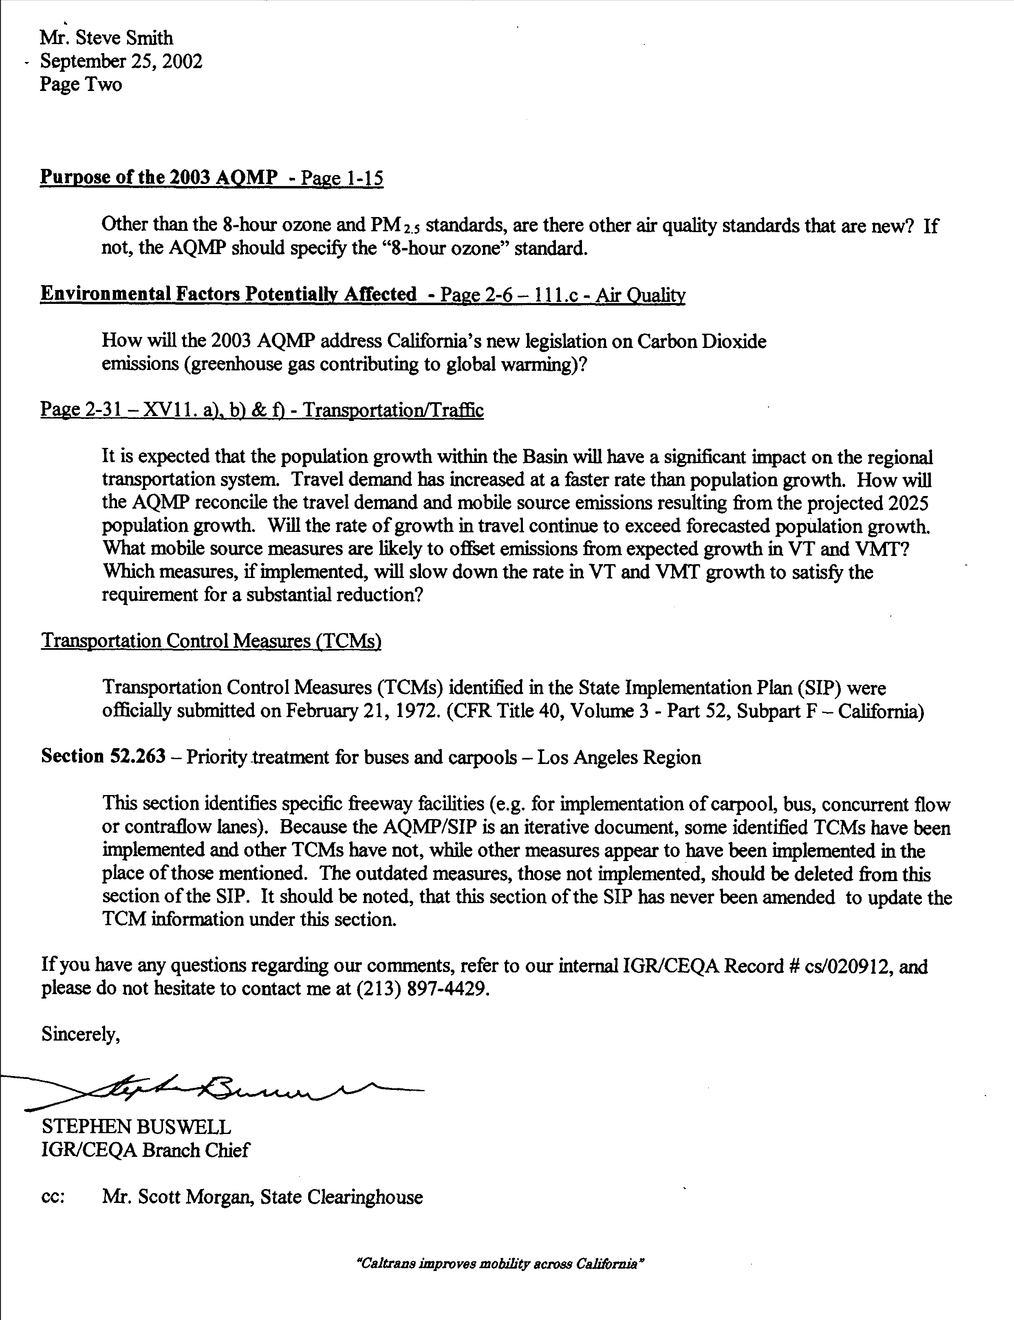
2-5
2-6
2-4
2-7
2-8
COMMENT NO. 2
LETTER FROM CALIFORNIA DEPARTMENT OF TRANSPORTATION

Mr. Stephen Buswell

September 25, 2002

Response 2-1

The lack of adoption or partial adoption of control measures could impact the ability of the Basin to attainment the ambient air quality standards. Four of the 1997 AQMP long-term VOC control measures under SCAQMD jurisdiction have been included in the 2003 AQMP. The impact of the control measures on air quality is presented in Subchapter 4.1, Air Quality. In addition, alternatives to the implementation of the control measures in discussed in Chapter 5, Alternatives.

Response 2-2

Four of the 1997 AQMP long-term VOC control measures under SCAQMD jurisdiction have been included in the 2003 AQMP as short- or intermediate-term control measures. Additional new control measures have also been added to the 2003 AQMP. The emission benefits associated with each control measure have been estimated in the 2003 AQMP based on the latest information available. New long-term measures proposed by the SCAQMD as well as CARB have been proposed in the 2003 AQMP. See Chapter 2 of the EIR for more details on the control measure.

Response 2-3

The control measures proposed as part of BCM-07 are described in Appendix IV-A of the 2003 AQMP. This control measure is intended as a means to ensure compliance in those areas that are subject to high levels of PM10.

The ambient levels of PM10 are summarized in Subchapter 3.1 of the Draft EIR for the 2003 AQMP. Sufficient data are available to determine that the Basin does not comply with state or federal PM10 ambient air quality standards. Sufficient information is not available to determine the cost effectiveness of BCM-07 which is expected to include improved compliance test methods, soil stabilization requirements, modified work practices, construction project signage, and mandatory use of track-out control devices.

The SCAQMD has already implemented rules to control fugitive dust from unpaved roads so this measure is not included as part of the 2003 AQMP. The SCAQMD already Rule 403 (Fugitive Dust from transportation, handling, construction or storage activities) and Rule 1186 (PM10 Emissions from Paved and Unpaved Roads that includes requirements for clean-up of material onto paved roads, use of certified street sweeping equipment and treatment of high use unpaved roads).

Response 2-4

In 1997, the U.S. EPA promulgated new federal standards for ozone (8-hour) and PM2.5 standards. The 2003 AQMP includes an initial assessment of progress towards attaining the new standards but is not required to demonstrate attainment of these standards. The implementation guidelines for the new standards have not been finalized, although preliminary feedback from the U.S. EPA indicates that the likely attainment dates for PM2.5 and ozone standards will be 2014 and 2021, respectively. The State Implementation Plans to demonstrate attainment with the standards are expected to be due in 2007. A separate planning process will be required in the future to determine control strategies to comply with these standards. Implementation of the control strategies including in the 2003 AQMP will help to achieve some of the emission reductions that are expected to be necessary to comply with the 8-hour ozone and PM2.5 standards.

Response 2-5

Table 1-6 of the 2003 AQMP lists the Clean Air Act planning requirements addressed by the 2003 AQMP which include pollutants for which ambient air quality standards have been developed. The 2003 AQMP address does not address carbon dioxide emissions. The air quality planning process for control of greenhouse gases has not been developed and emission standards for carbon dioxide have not been developed. The control of greenhouse gases is expected to be largely regulated by CARB.

Response 2-6

Demographic growth forecasts for various socioeconomic categories (e.g., population, housing, employment), developed by SCAG for their 2001 RTP, were used to estimate future emission (see 2003 AQMP, Chapter 3). Current forecasts indicate that this region will experience a population growth of 15 percent by the year 2010 with a 20 percent increase in vehicle miles traveled. Therefore, the 2003 AQMP predicts that the growth in travel will be greater than the growth in population. The 2003 AQMP does not estimate air emissions through 2025.

As discussed in the AQMP (See Chapter 10), uncertainties exist in the demographic and growth projects for the future base years. As projections are made to longer periods (i.e., over 10 or more years), the uncertainty of the projections become greater.

The control measures proposed in the 2003 AQMP are included in Chapter 2 of the EIR (also see Chapter 7 of the 2003 AQMP). SCAG has proposed transportation-related control measures that are aimed at reducing VMTs. A number of control measures are aimed at reducing emissions from mobile sources including FSS-05, FSS-06, FSS-07, TCM-1A, TCM-1B, and TCM-1C. Virtually all of the control measures to be implemented by CARB or the U.S. EPA also would reduce emissions from on-road and off-road mobile sources (see Chapter 2 of the 2003 AQMP EIR). These measures would all reduce emissions from mobile sources and are expected to provide sufficient emission reductions, even though the population and growth of VMTs are expected to increase. No specific control measures are proposed that would slow down the rate of population growth.

The jurisdiction for a number of transportation improvements is with the Southern California Association of Governments (SCAG) who is responsible for preparing and implementing the Regional Transportation Plan (RTP). The RTP establishes the transportation control measures that will be implemented by the SCAG to help with the attainment of air quality goals in the Basin.

The central objective of the control measures in the RTP, and now incorporated into the 2003 AQMP, is to increase (or at least maintain at current levels) the proportion of trips made using modes other than single occupancy vehicles. This remains the primary goal of the Region’s transportation control strategy and HOV projects are an important component of such efforts.

Response 2-7

The transportation control measures that are part of the 2003 AQMP are identified in Chapter 2 of the EIR for the 2003 AQMP and discussed in detail in Appendix IV-C of the AQMP.

Response 2-8

The transportation control measures that are part of the 2003 AQMP are identified in Chapter 2 of the EIR for the 2003 AQMP and discussed in detail in Appendix IV-C of the AQMP. Revisions to the SIP are under the jurisdiction of CARB.

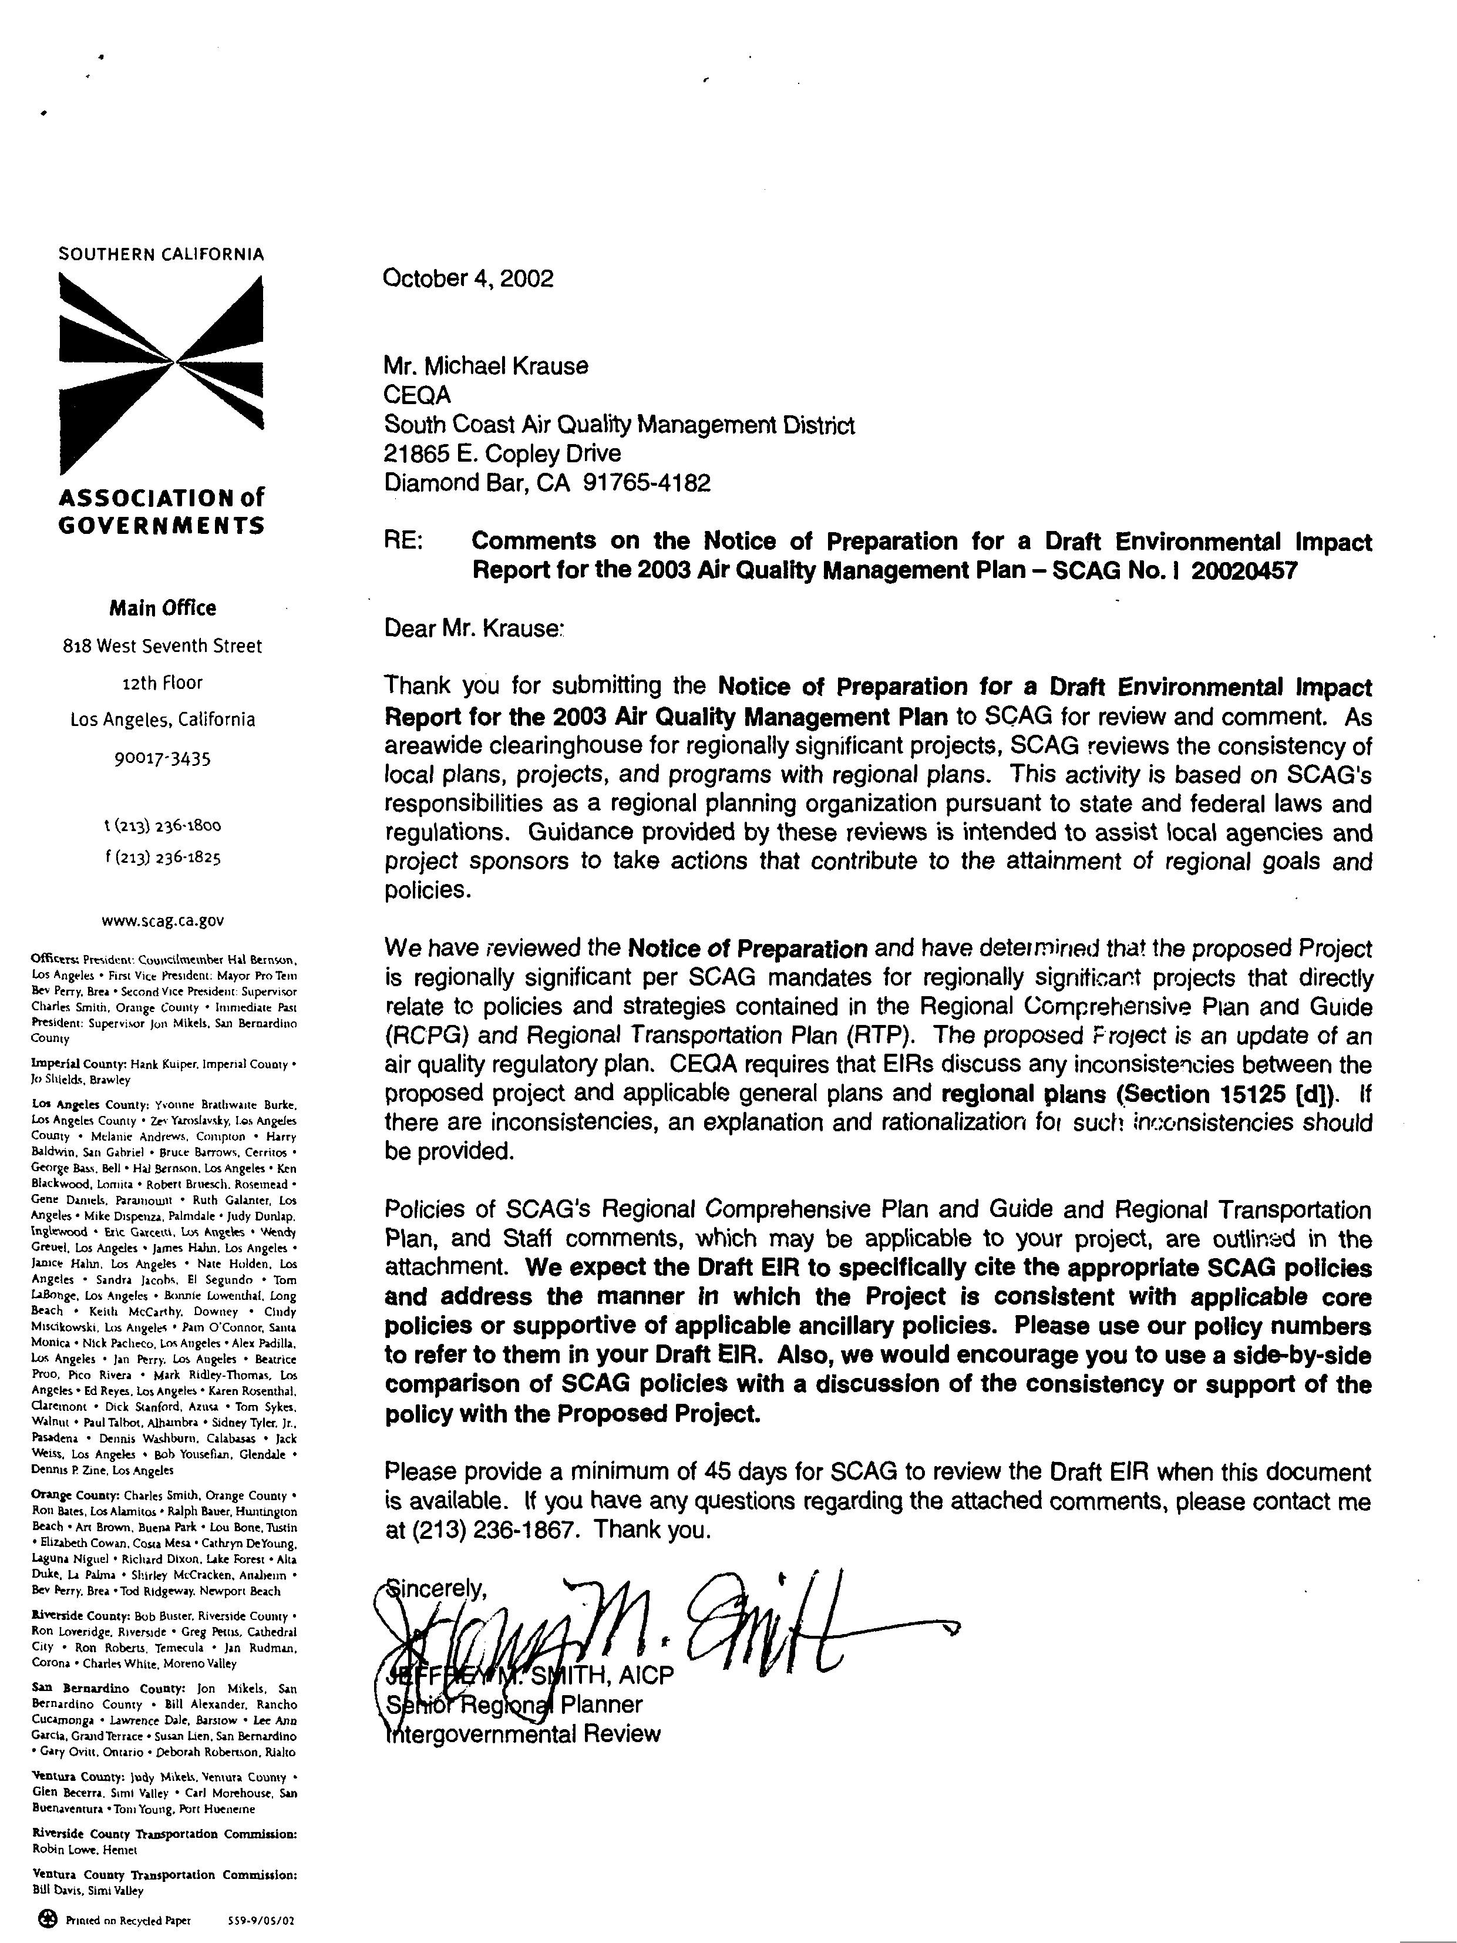
3-1
3-2
3-3
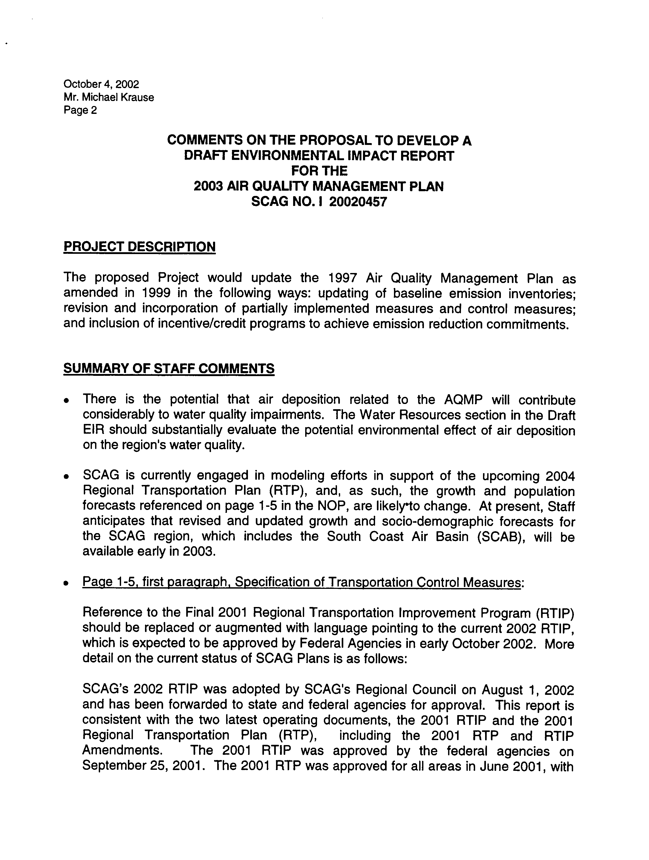
3-4
3-5
3-6
3-7
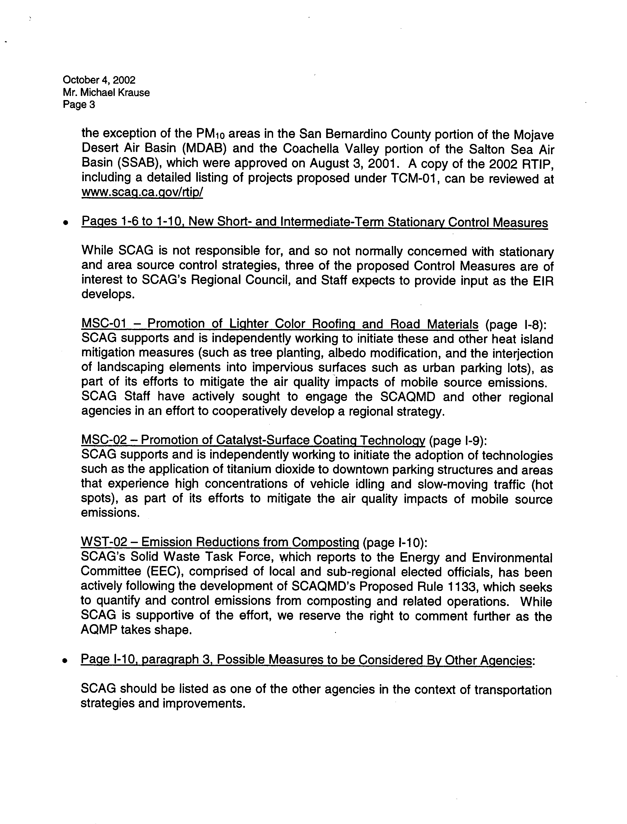
3-7
Cont’d
3-8
3-9
3-10
3-11
3-12
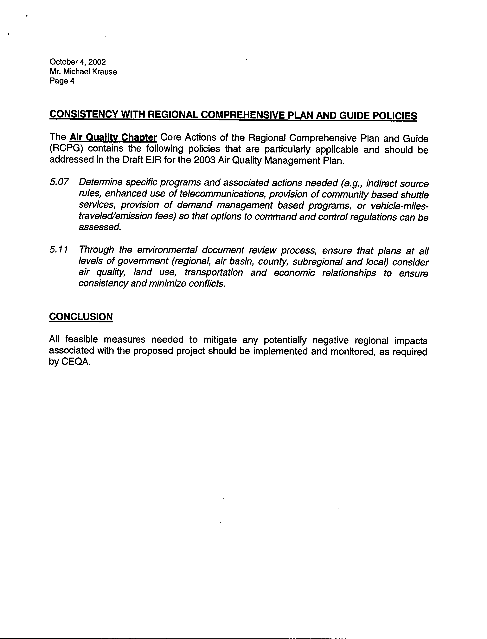
3-13
3-14
COMMENT NO. 3
LETTER FROM SOUTHERN CALIFORNIA ASSOCIATION OF GOVERMENTS

Mr. Jeffrey Smith

October 4, 2002

Response 3-1

The SCAQMD understands that the 2003 AQMP is considered regionally significant. The proposed 2003 AQMP complements the SCAG Regional Comprehensive Plan and Regional Transportation Plan, and includes applicable control measures from the RTP. The SCAQMD is specifically excluded from infringing on existing city of county land use authority (California Health & Safety Code §40414). Land use and other planning considerations are determined by local governments and no present or planned land uses in the region or planning requirements will be altered by the proposed AQMP.

Response 3-2

The response to the issues outline in your attachment are addressed below.

Response 3-3

A 45-day public comment period will be provided on the Draft 2003 AQMP EIR.

Response 3-4

See Chapter 2 of the 2003 AQMP EIR for a full description of the proposed 2003 AQMP.

Response 3-5

A discussion of water quality impacts associated with the implementation of the 2003 AQMP are included in the 2003 AQMP EIR (see Chapter 4.3). Implementation of the 2003 AQMP is expected to reduce emissions, including PM10 emissions (about 2.0 to 6.0 tons per day), thus reducing the potential for deposition. Therefore, no significant impacts on water quality due to increased deposition of PM10 are expected due to implementation of the 2003 AQMP.

Response 3-6

Demographic growth forecasts for various socioeconomic categories (e.g., population, housing, employment), developed by SCAG for their 2001 RTP, were used to estimate future emissions (see 2003 AQMP, Chapter 3). These represent the most recent socio-demographic forecasts provided by SCAG.

Response 3-7

Comment is noted. The 2003 AQMP includes the most recent transportation control measures developed by SCAG (see Appendix IV-C of the 2003 AQMP).

Response 3-8

The SCAQMD understands that SCAG has interest in some of the stationary source control measures.

Response 3-9

Your comment is noted. MSC-01 is included in the 2003 AQMP.

Response 3-10

MSC-02 has been removed and is no longer included in the 2003 AQMP.

Response 3-11

Your comment is noted. WST-02 is included in the 2003 AQMP and Phase 1 of which has been proposed as the SCAQMD Rule 1133 series. Phase II of WST-02 will be focusing on greenwaste and foodwaste.

Response 3-12

SCAG’s control measures are identified in the 2003 AQMP (see Chapter 2, Project Description).

Response 3-13

See Response 3-1. All applicable environmental resources have been considered in the Draft AQMP EIR.

Response 3-14

Mitigation measures have been identified where significant environmental impacts have been identified.

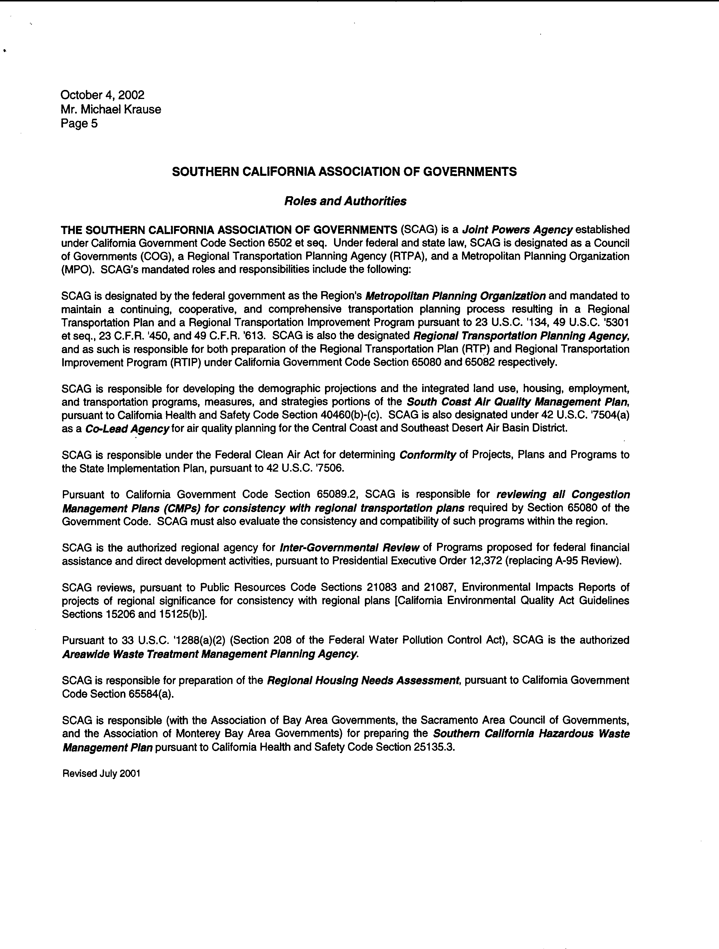
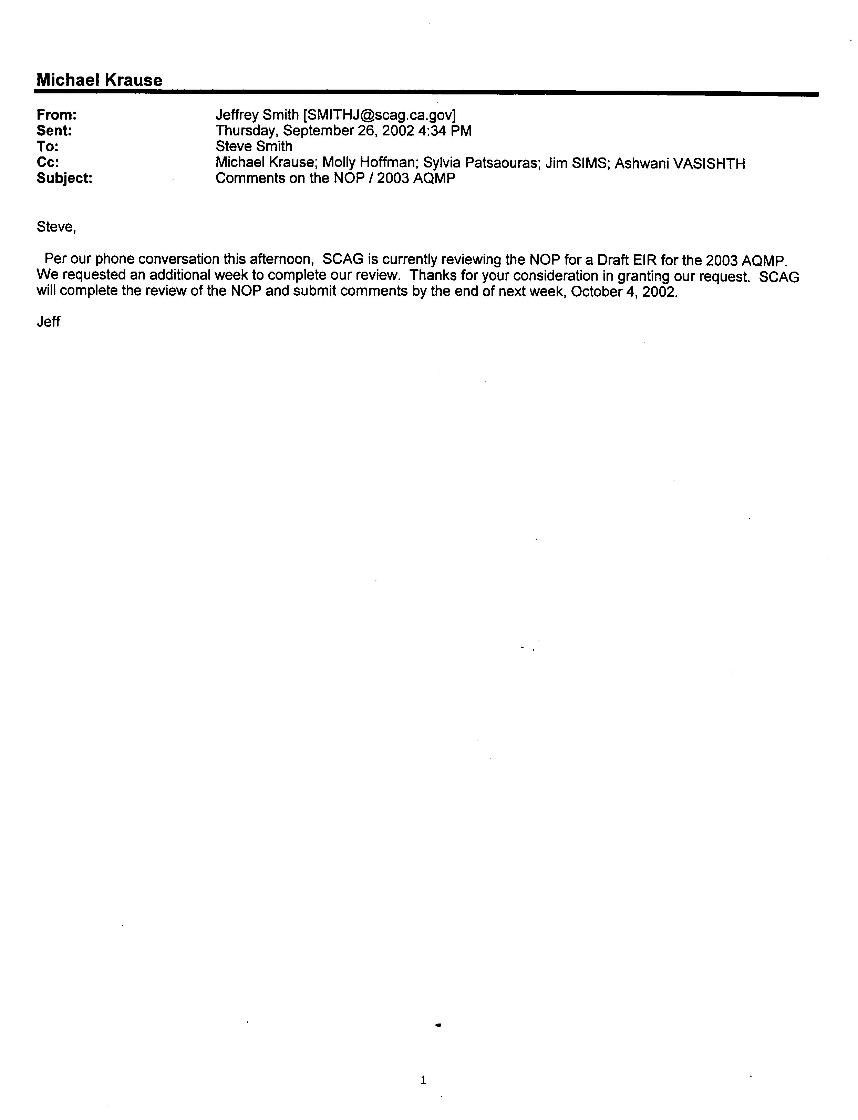
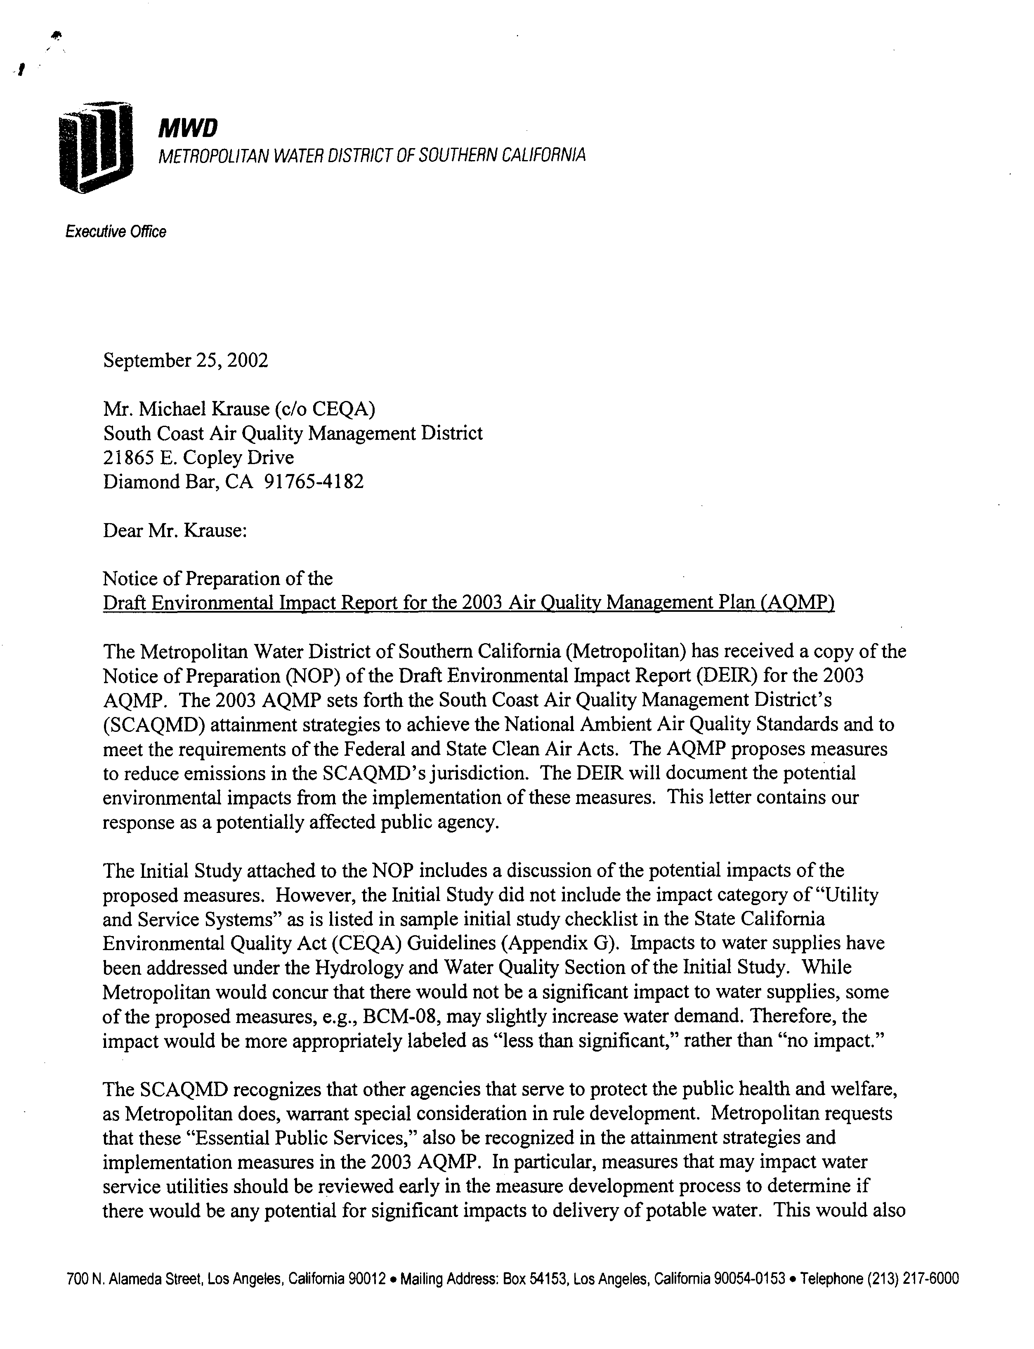
4-1
4-2
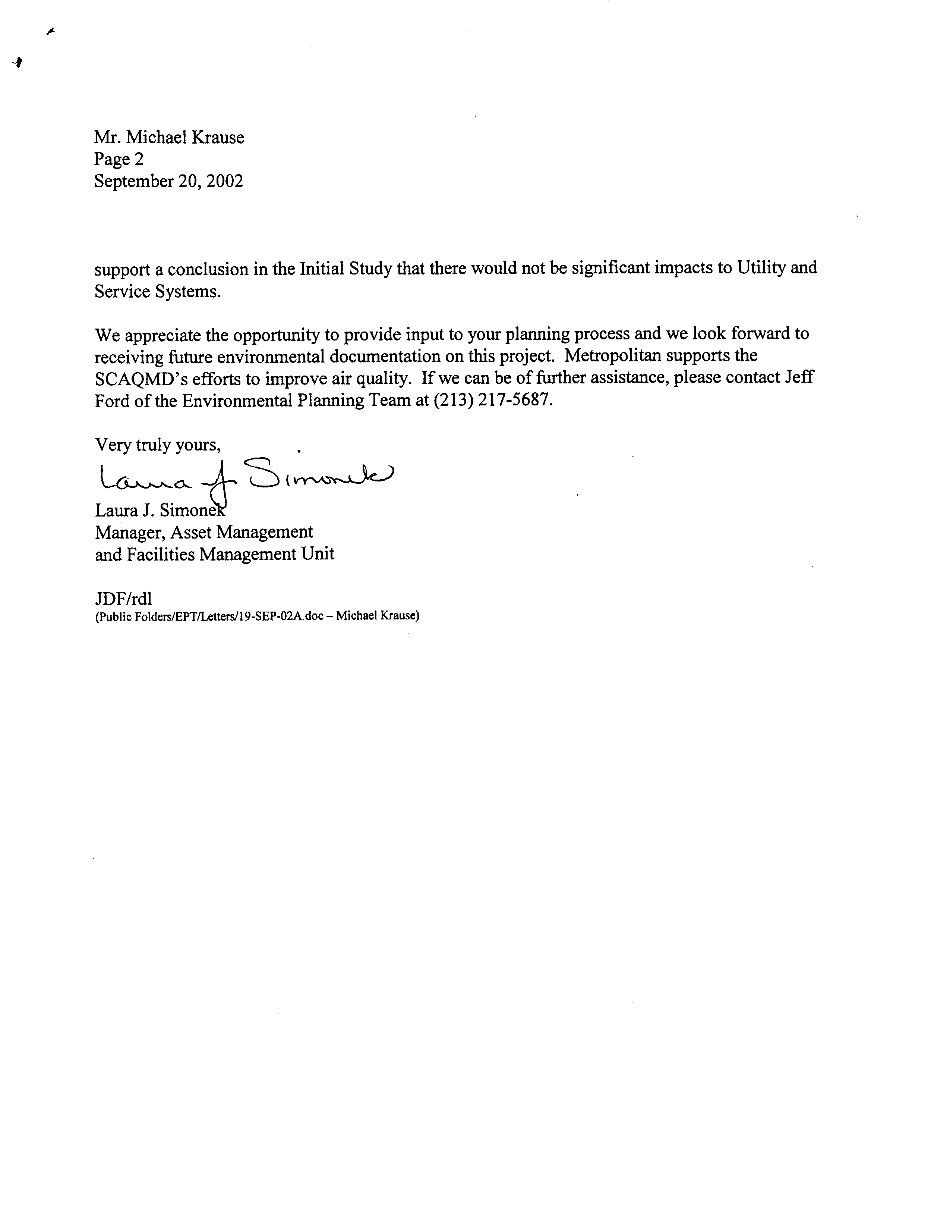
4-3
4-2
Cont’d
COMMENT NO. 4
LETTER FROM METROPOLITAN WATER DISTRICT OF SOUTHERN CALIFORNIA

Ms. Laura Simonek
September 20, 2002

Response 4-1

The potential impacts of the 2003 AQMP on water demand have been included in Chapter 4.4 of the Draft EIR. The impacts of the 2003 AQMP on water demand have been determined to be less than significant.

Response 4-2

The potential impacts of the 2003 AQMP on water demand have been included in Chapter 4.4 of the Draft EIR. Additional environmental review will be completed as each of the control measures are implemented. Details on the potential impacts of the control measures on water supplies will be further addressed at that time.

Response 4-3

Your comment is noted and information on the 2003 AQMP will be directed to your attention.

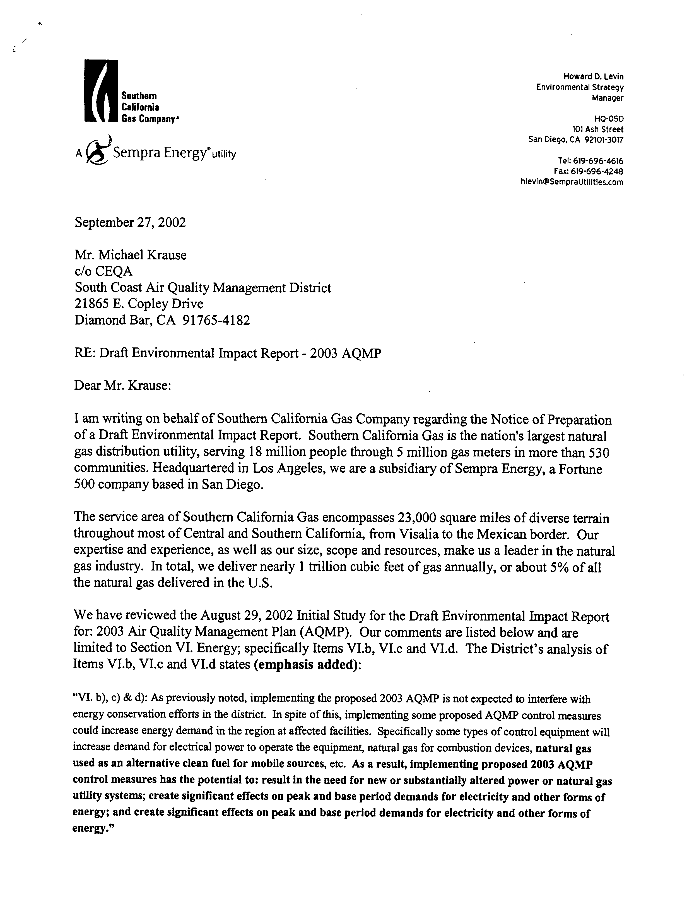
5-1
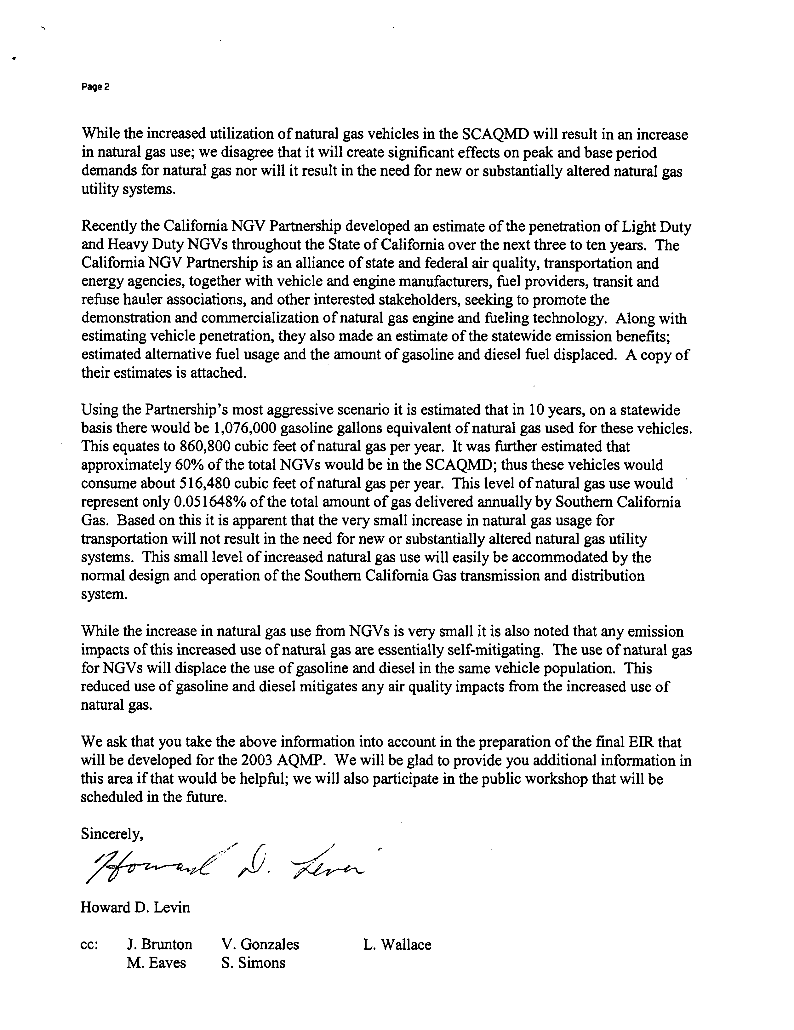
5-3
5-4
5-5
5-2
COMMENT NO. 5
LETTER FROM SOUTHERN CALIFORNIA GAS COMPANY

Mr. Howard D. Levin
September 27, 2002

Response 5-1

The potential energy impacts associated with the 2003 AQMP are addressed in Chapter 4 of the Draft EIR.

Response 5-2

The potential energy impacts associated with the 2003 AQMP are addressed in Chapter 4 of the EIR. The EIR concluded that the impacts of implementation of the 2003 AQMP on natural gas resources would be less than significant.

Response 5-3

Your comments regarding the impacts of the conversion of the vehicle fleet from gasoline to natural gas are appreciated. The EIR concluded that the impacts of implementation of the 2003 AQMP on natural gas resources would be less than significant. Section 4.2.5.2 discusses the reduction in fuel consumption, and the increased need for natural gas, in year 2010.

Response 5-4

See Response 5-3. The SCAQMD concurs that the impacts associated with the use of natural gas, in some cases will displace the use of gasoline and diesel, resulting in emission benefits from these sources.

Response 5-5

Your comments have been incorporated into the Draft EIR and the SCAQMD appreciates your input.

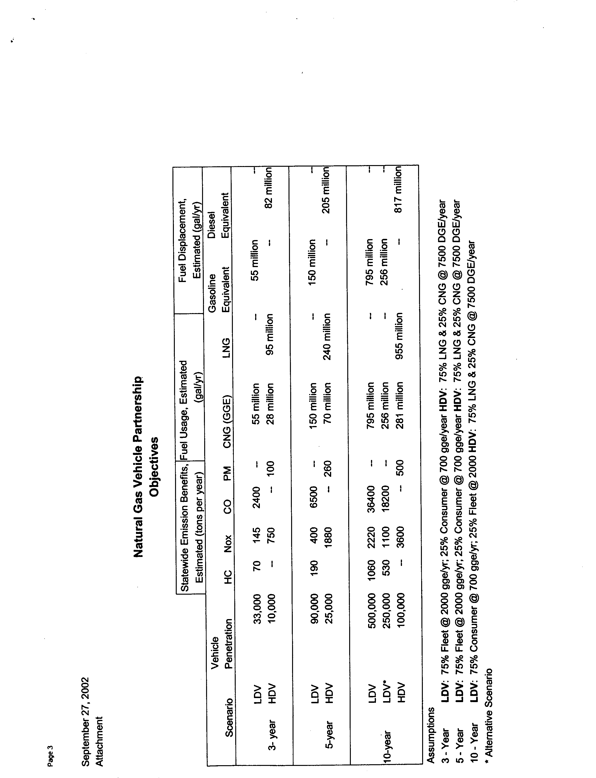
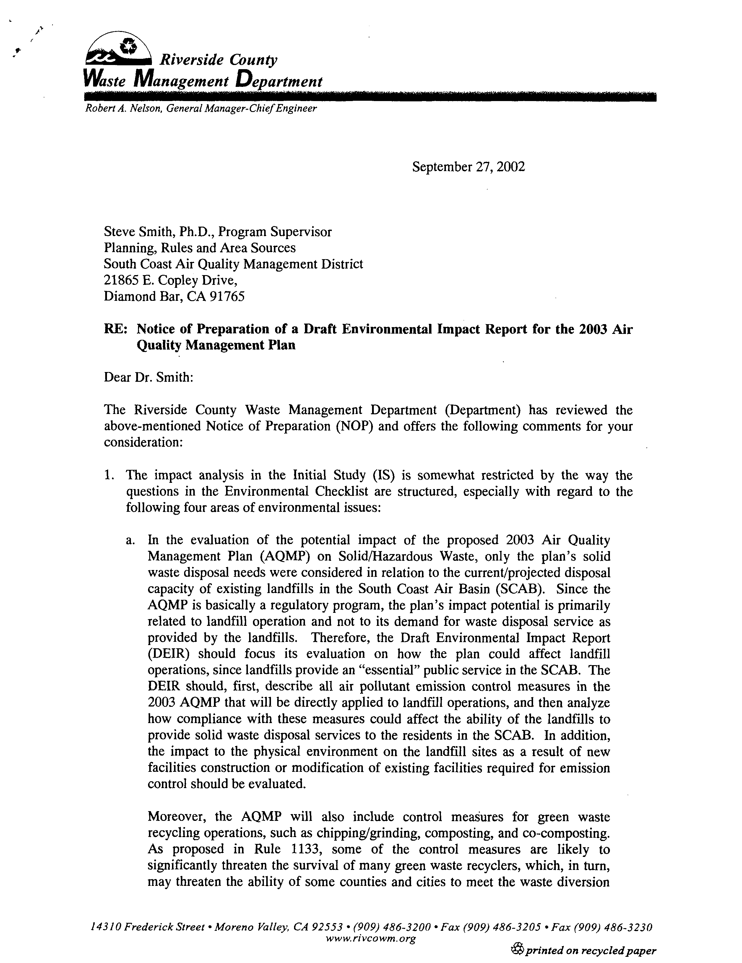
6-1
6-2
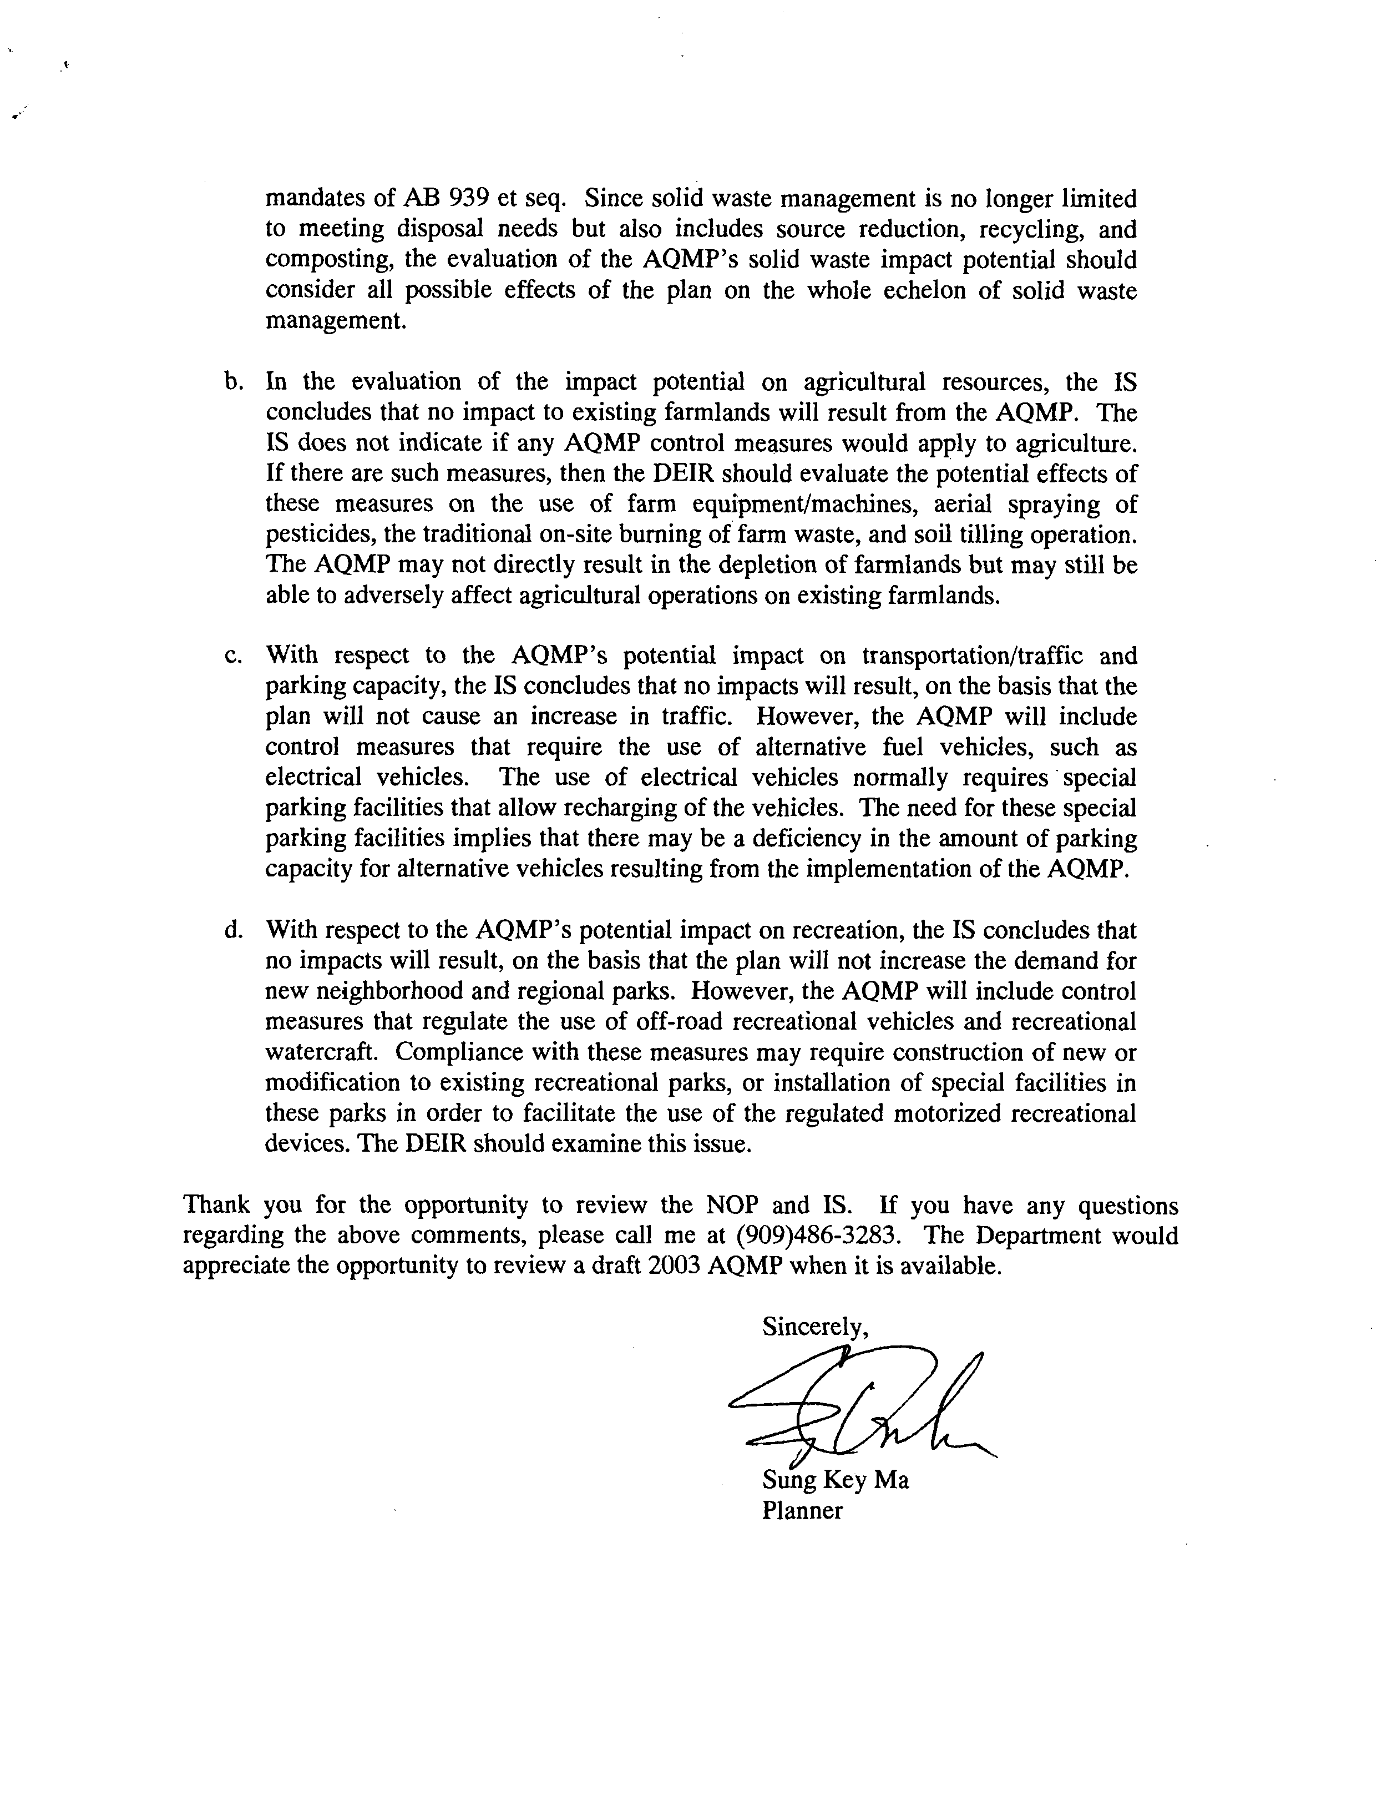
6-2
Cont’d
6-3
6-4
6-5
6-6
COMMENT NO. 6
LETTER FROM THE RIVERSIDE COUNTY WASTE MANAGEMENT DEPARTMENT

Sung Key Ma
September 27, 2002

Response 6-1

The Draft EIR for the 2003 AQMP is a Program EIR and focuses on the impact of the overall implementation of the 2003 AQMP on the environment. The Draft EIR includes a discussion on the impacts of the 2003 AQMP on the generation of solid and hazardous waste and related facilities (see Chapter 4 of the EIR). The potential impacts to regulated facilities are included in the Draft EIR to the extent that impacts are known. Impacts associated with specific control measures at landfills have not been identified. This type of information will be available as the rules are promulgated.

Response 6-2

Your comments on the waste disposal, reduction, recycling and composting are noted. The impacts associated with composting (WST-02) are included in the Draft EIR (see Chapter 4). The SCAQMD has already approved Rules 1133, 1133.1 and 1133.2 in January 2003. These rules already require that operators of co-composting operations achieve VOC and ammonia emission reduction targets using any combination of composting methods and control technologies included but not limited to enclosures, aeration systems, best management practices, process controls and add-on control devices.

WST-02 in the AQMP would identify control measures to reduce VOC and ammonia emissions from greenwaste composting and food composting operations. The AQMP notes that the cost impact for this industry would be substantial and, therefore, has not proposed specific control methods. Rather, the SCAQMD is proposing to continue to work with the stakeholders including the California Integrated Waste Management Board, sanitation districts and local municipalities to seek funding sources and identify feasible and cost-effective control options for greenwaste composting operations while maintaining the SB939 objectives.

Response 6-3

As indicated in the NOP/IS, no control measures have been proposed that would be expected to have physical impact agricultural resources (e.g., convert prime farmland, conflict with zoning for agricultural use or result in the conversion of farmland to non-agricultural uses).

Some of the control measures could require control of off-road diesel engines, which could impact agricultural as well as a number of other industries. The impacts associated with these types of control measures are addressed in their appropriate section of the EIR. For example, the impacts associated with controlling off-road diesel engines are addressed in the EIR in Chapter 4.1 - Air Quality Impacts, and the impacts associated with reformulated pesticides are addressed under hazards.

Response 6-4

The impacts of using alternative fuels are addressed in the appropriate sections of the EIR, include the Energy Impact section and the Air Quality Section (see Chapter 4 of the EIR). The potential impacts of using alternative fuels include energy impacts (requirements for additional electricity) and air quality impacts (need to generate additional electricity, as well as construct new support facilities). No increase in traffic or the requirement for additional parking is expected from implementation of the control measures identified in the AQMP.

Response 6-5

The Initial Study concluded that the control measures in the AQMP would not generate population growth and would not increase the use of existing parks and would not require the construction or expansion of recreational facilities. The impact of the construction and implementation of the control measures on other resources, e.g., air, hydrology/water quality, solid/hazardous waste have been addressed in the appropriate section of the EIR.

Response 6-6

Notice will be provided to the Riverside County Waste Management Department when the document is available.
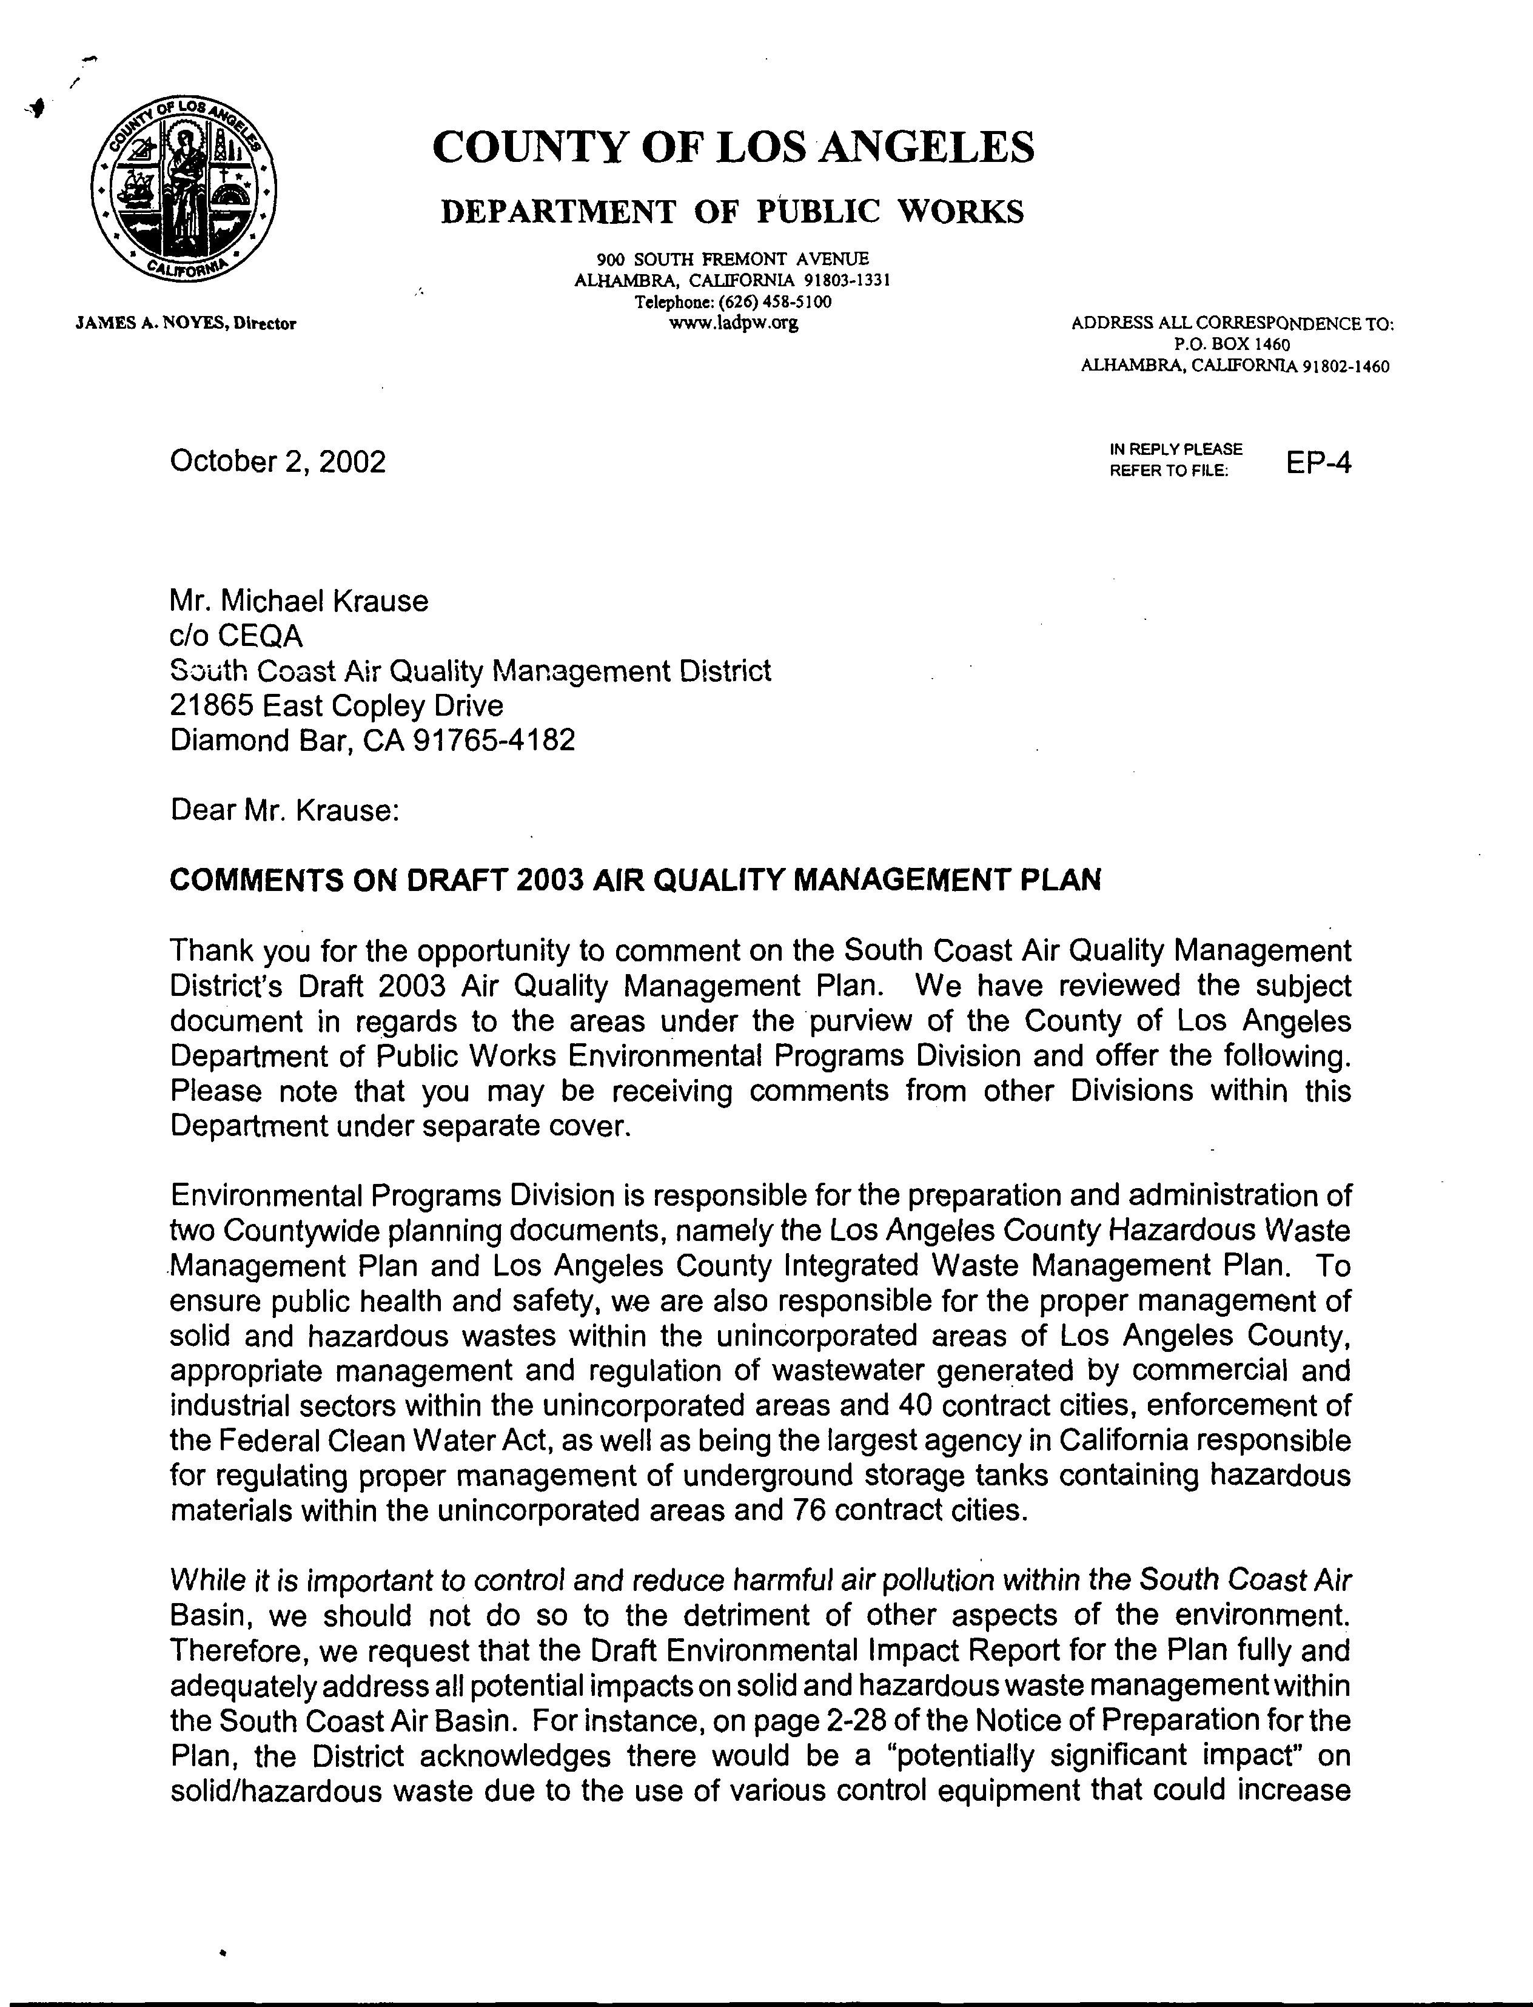
7-2
7-1
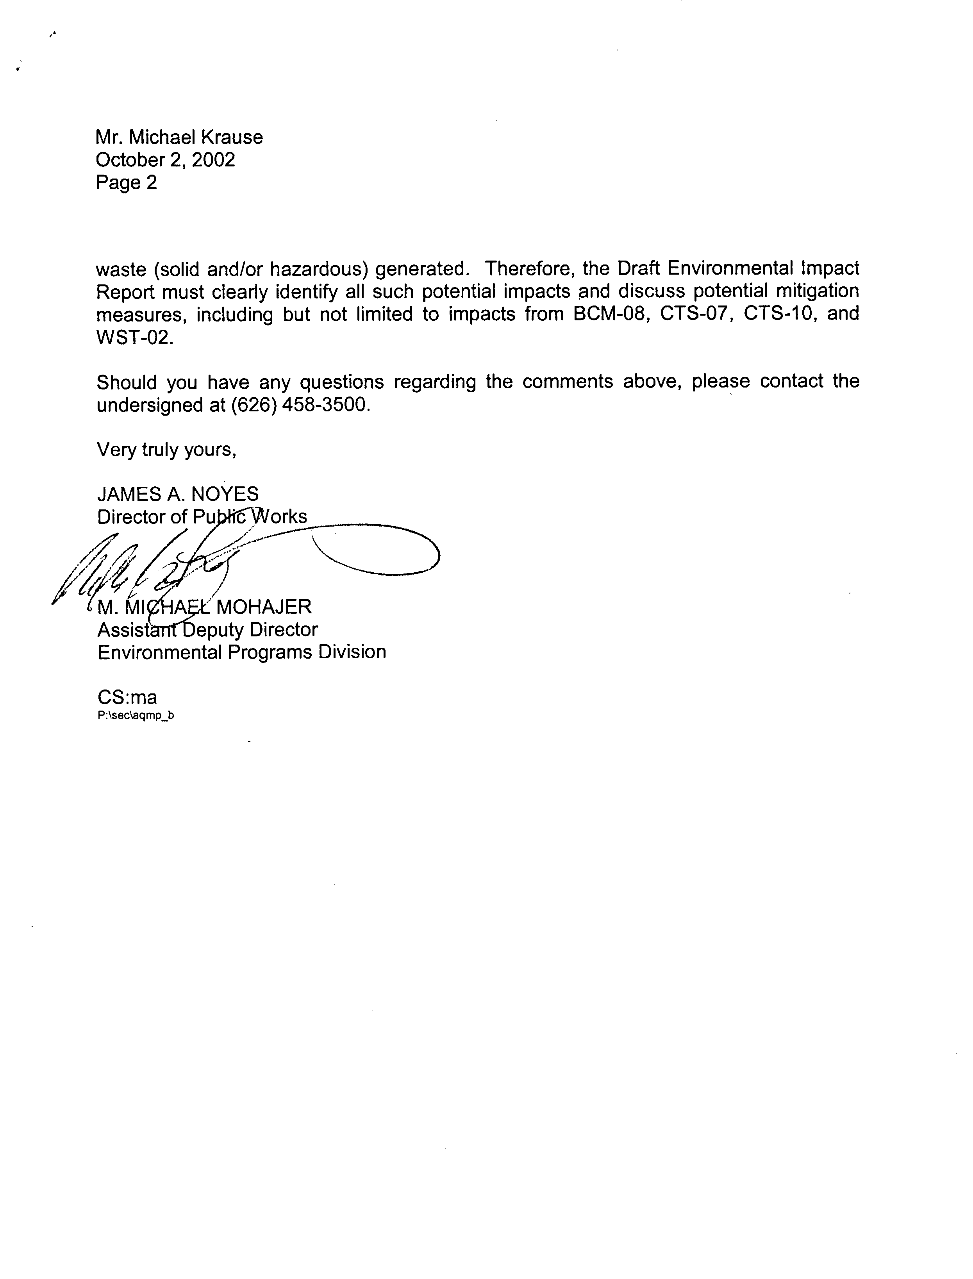
7-2
Cont’d
COMMENT NO. 7
LETTER FROM THE COUNTY OF LOS ANGELES DEPARTMENT OF PUBLIC WORKS

James A. Noyes
M. Michael Mohajer
October 2, 2002

Response 7-1

The SCAQMD understands that the County of Los Angeles Department of Public Works is responsible for various aspects of the management of solid/hazardous wastes, regulation of wastewater, and management of underground storage tanks.

Response 7-2

Your comment is noted. The potential impacts associated with implementation of the control measures in the 2003 AQMP are discussed in Chapter 4.5, Solid/Hazardous Waste.

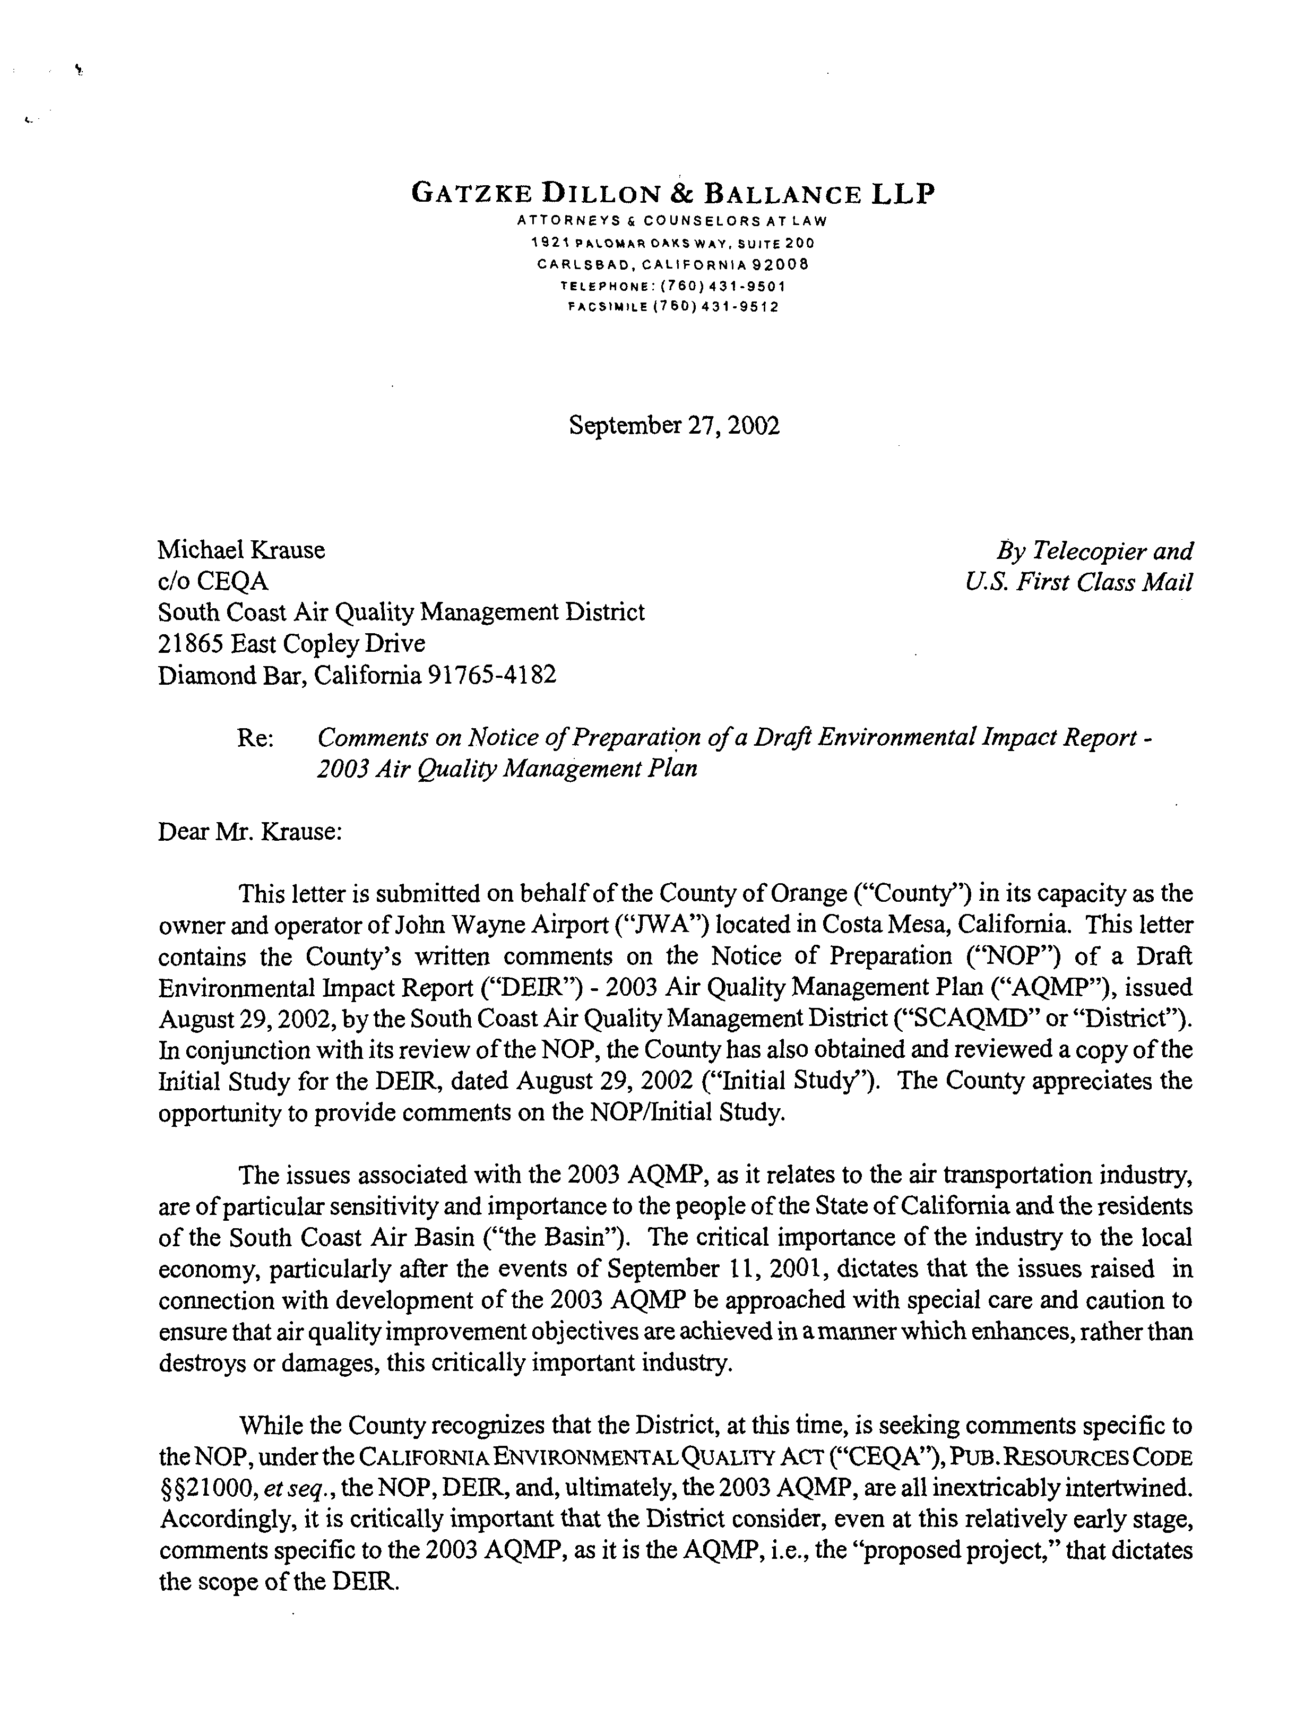
8-1
8-2
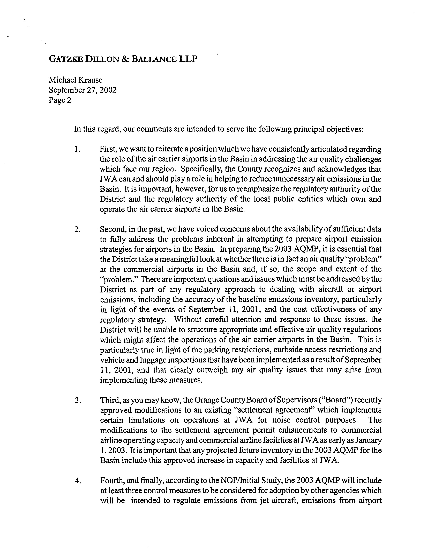
8-4
8-5
8-6
8-3
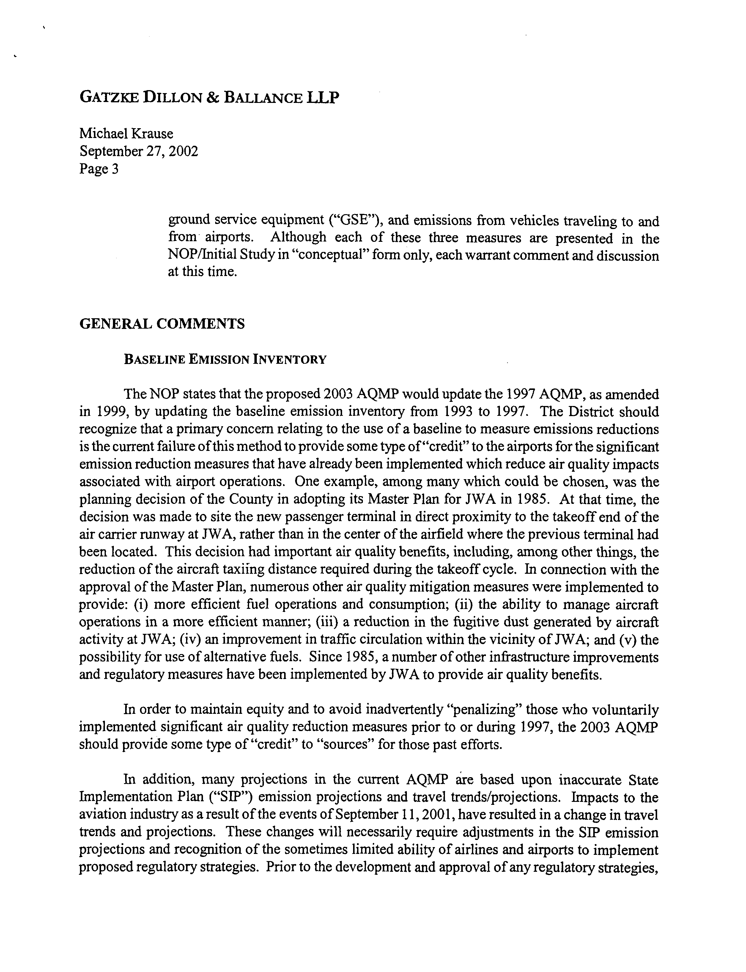
8-8
8-7
8-6
Cont’
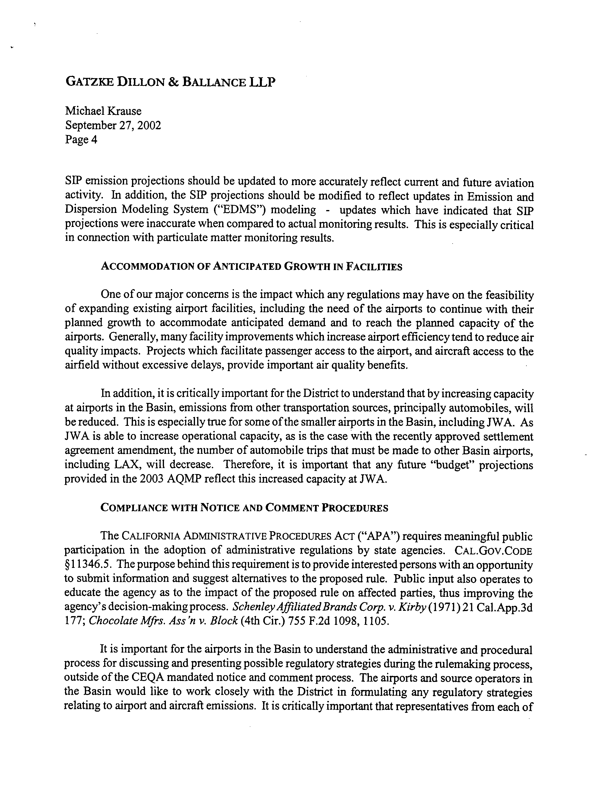
8-8
Cont’d
8-10
8-11
8-9
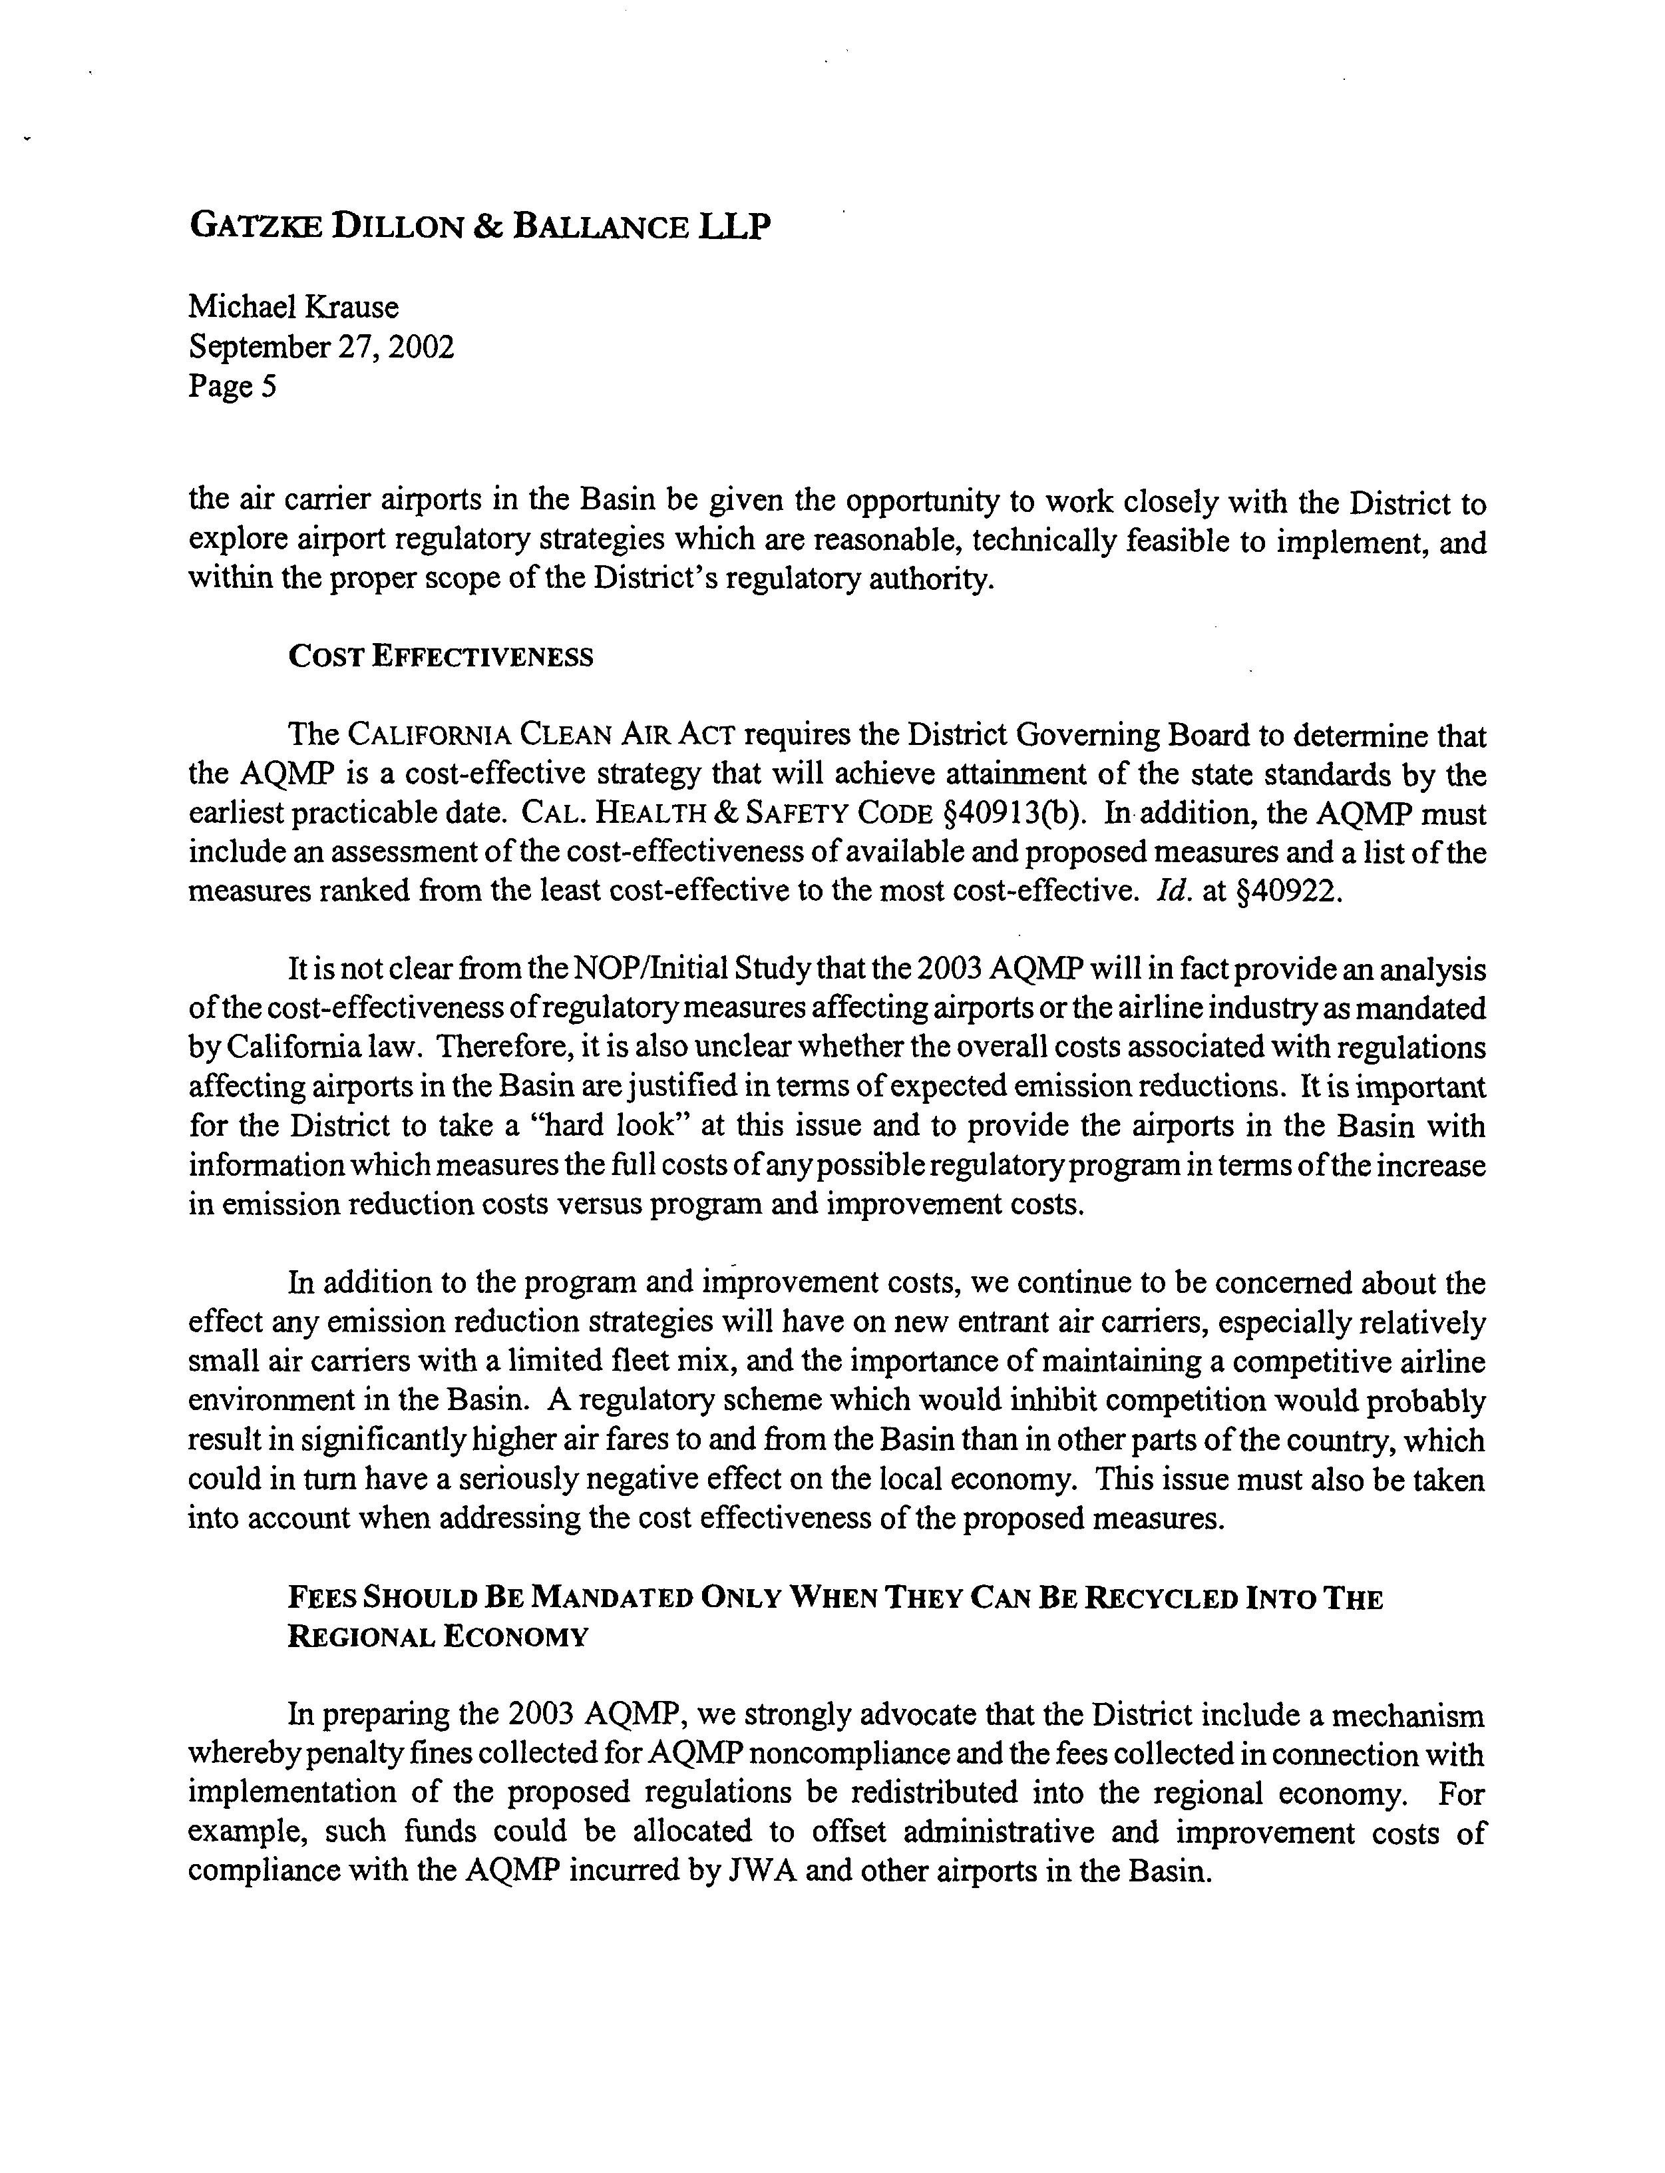
8-15
8-14
8-13
8-12
8-11
Cont’d
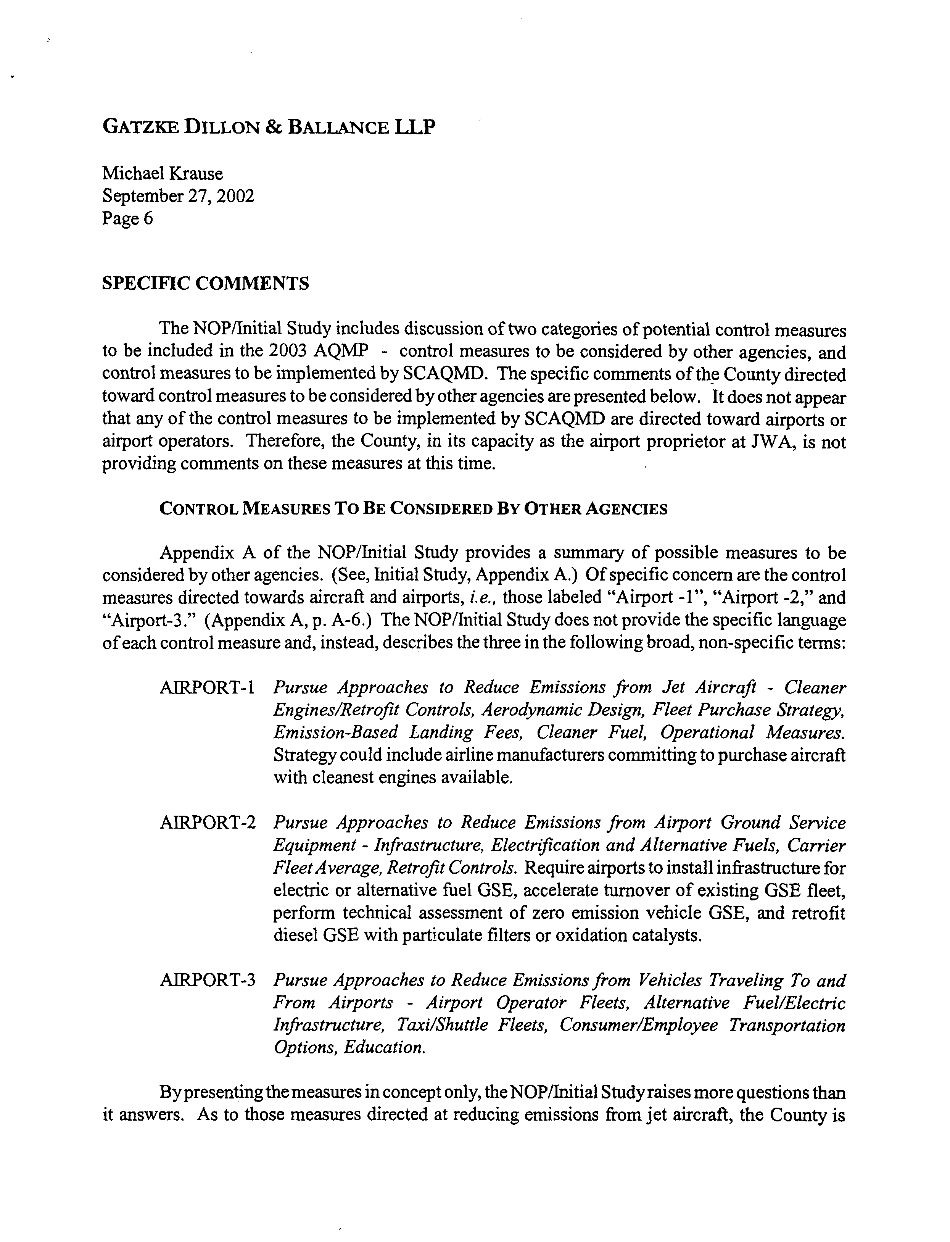
8-16
8-17
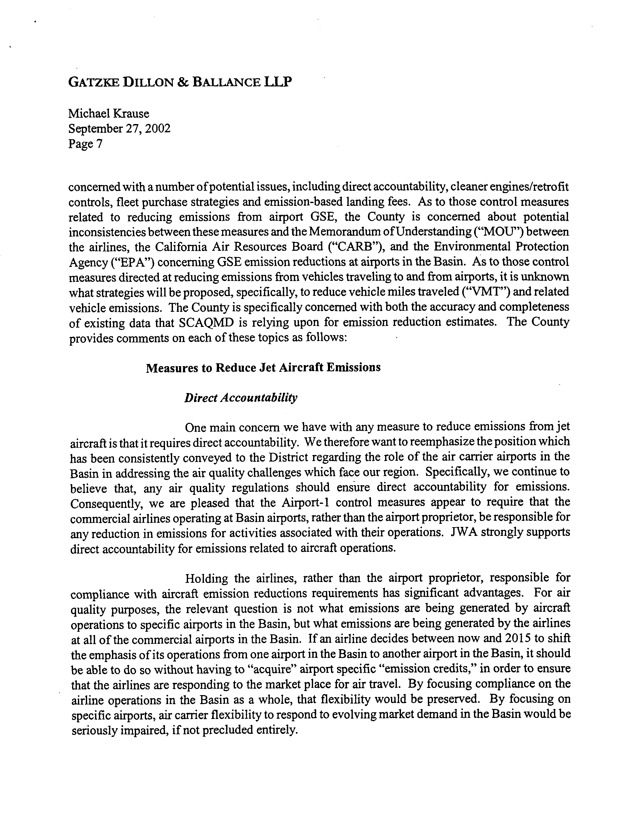
8-18
8-17 Cont’d
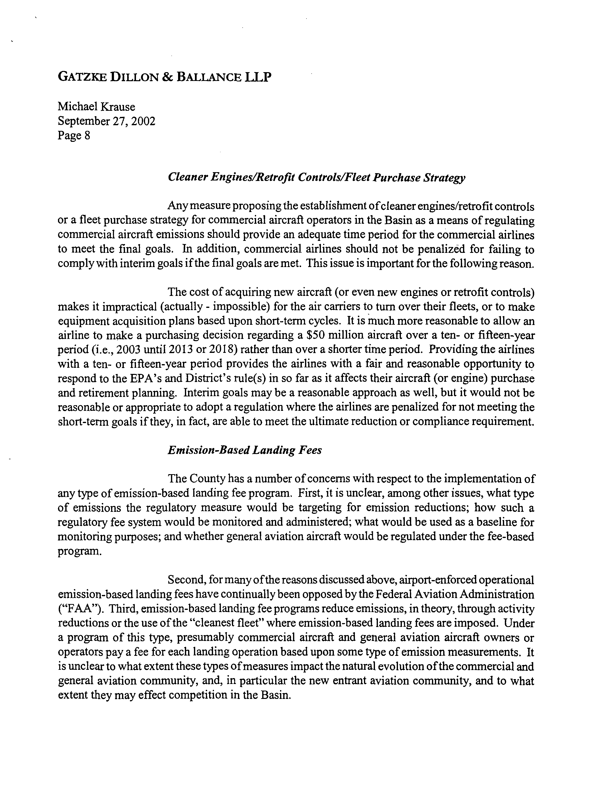
8-21
8-20
8-19
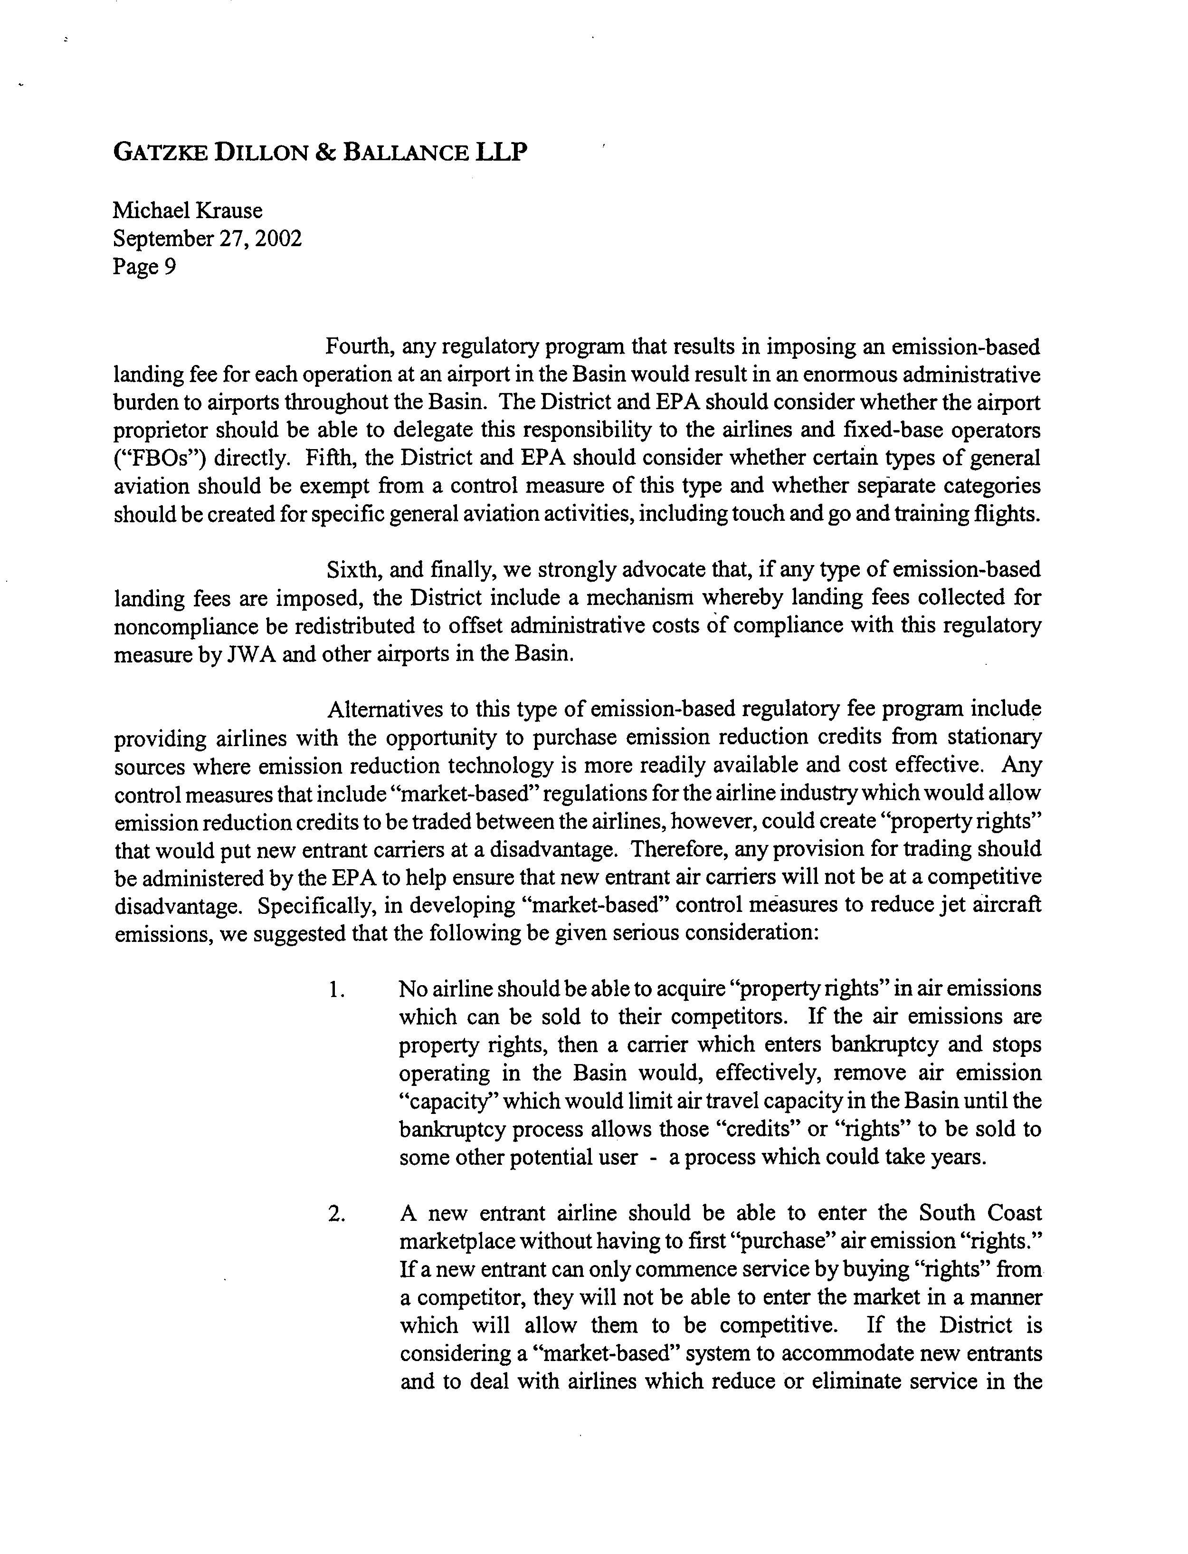
8-26
8-25
8-24
8-23
8-22
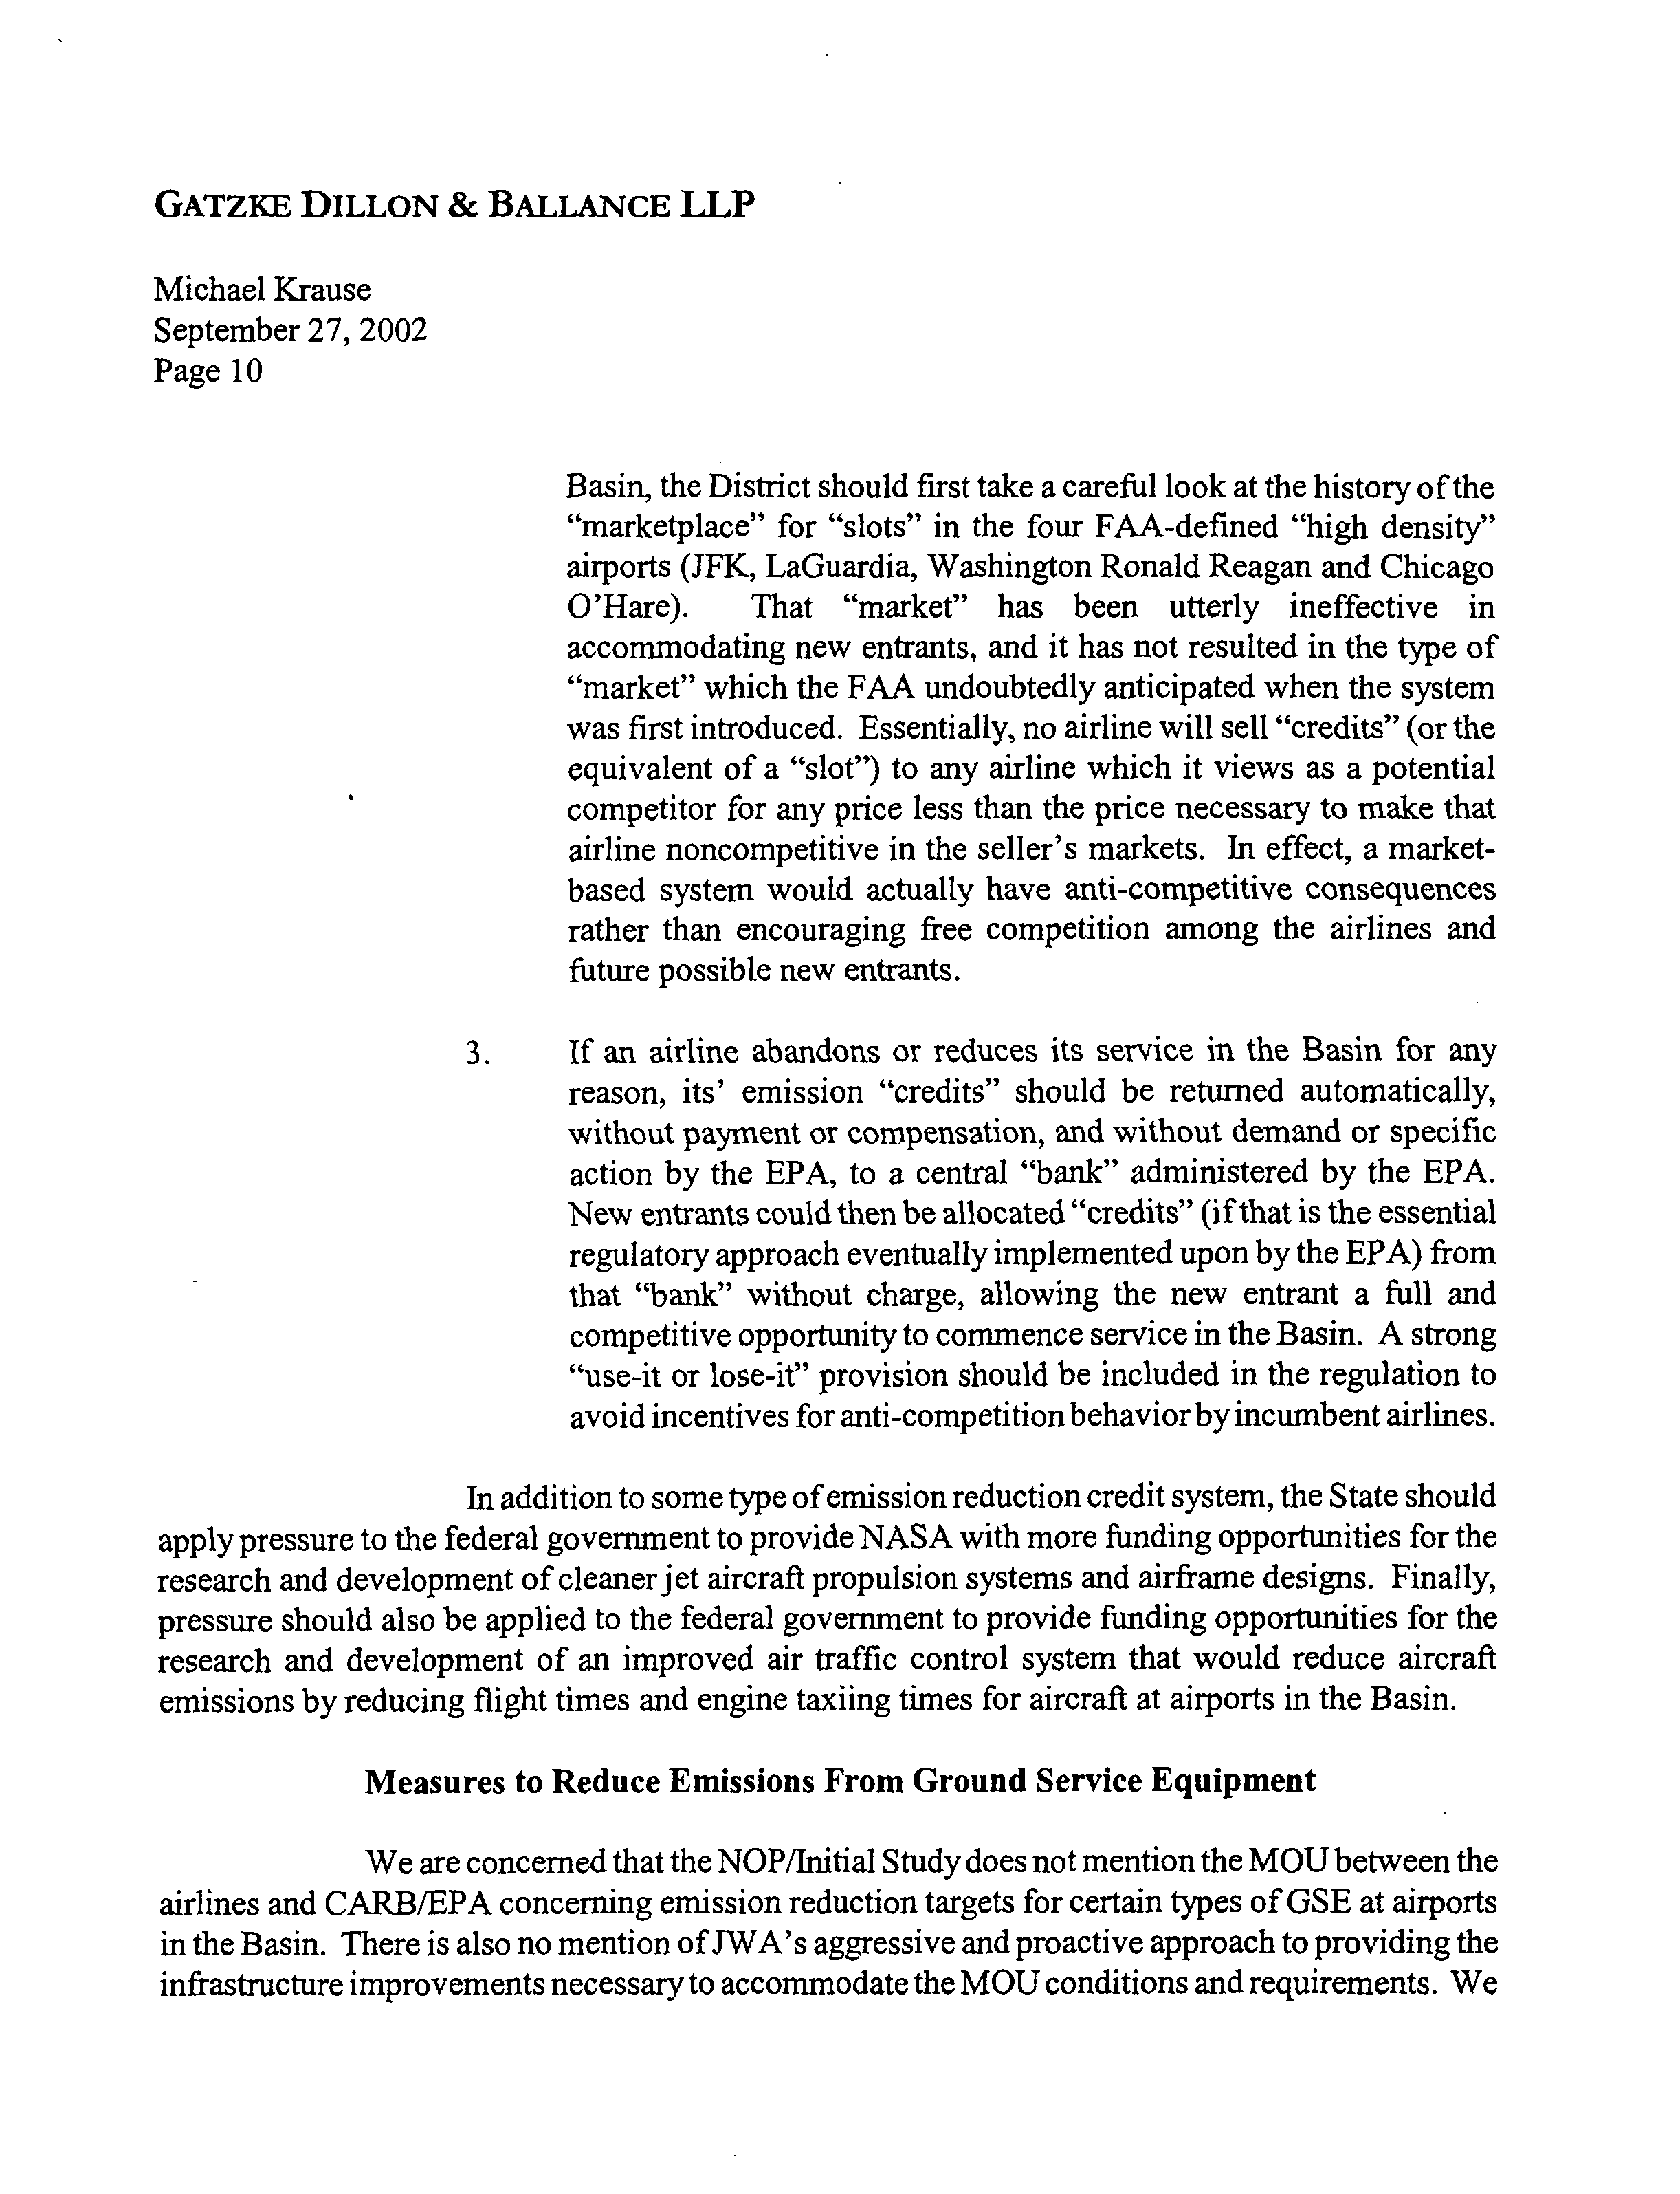
8-29
8-28
8-27
8-26
Cont’d
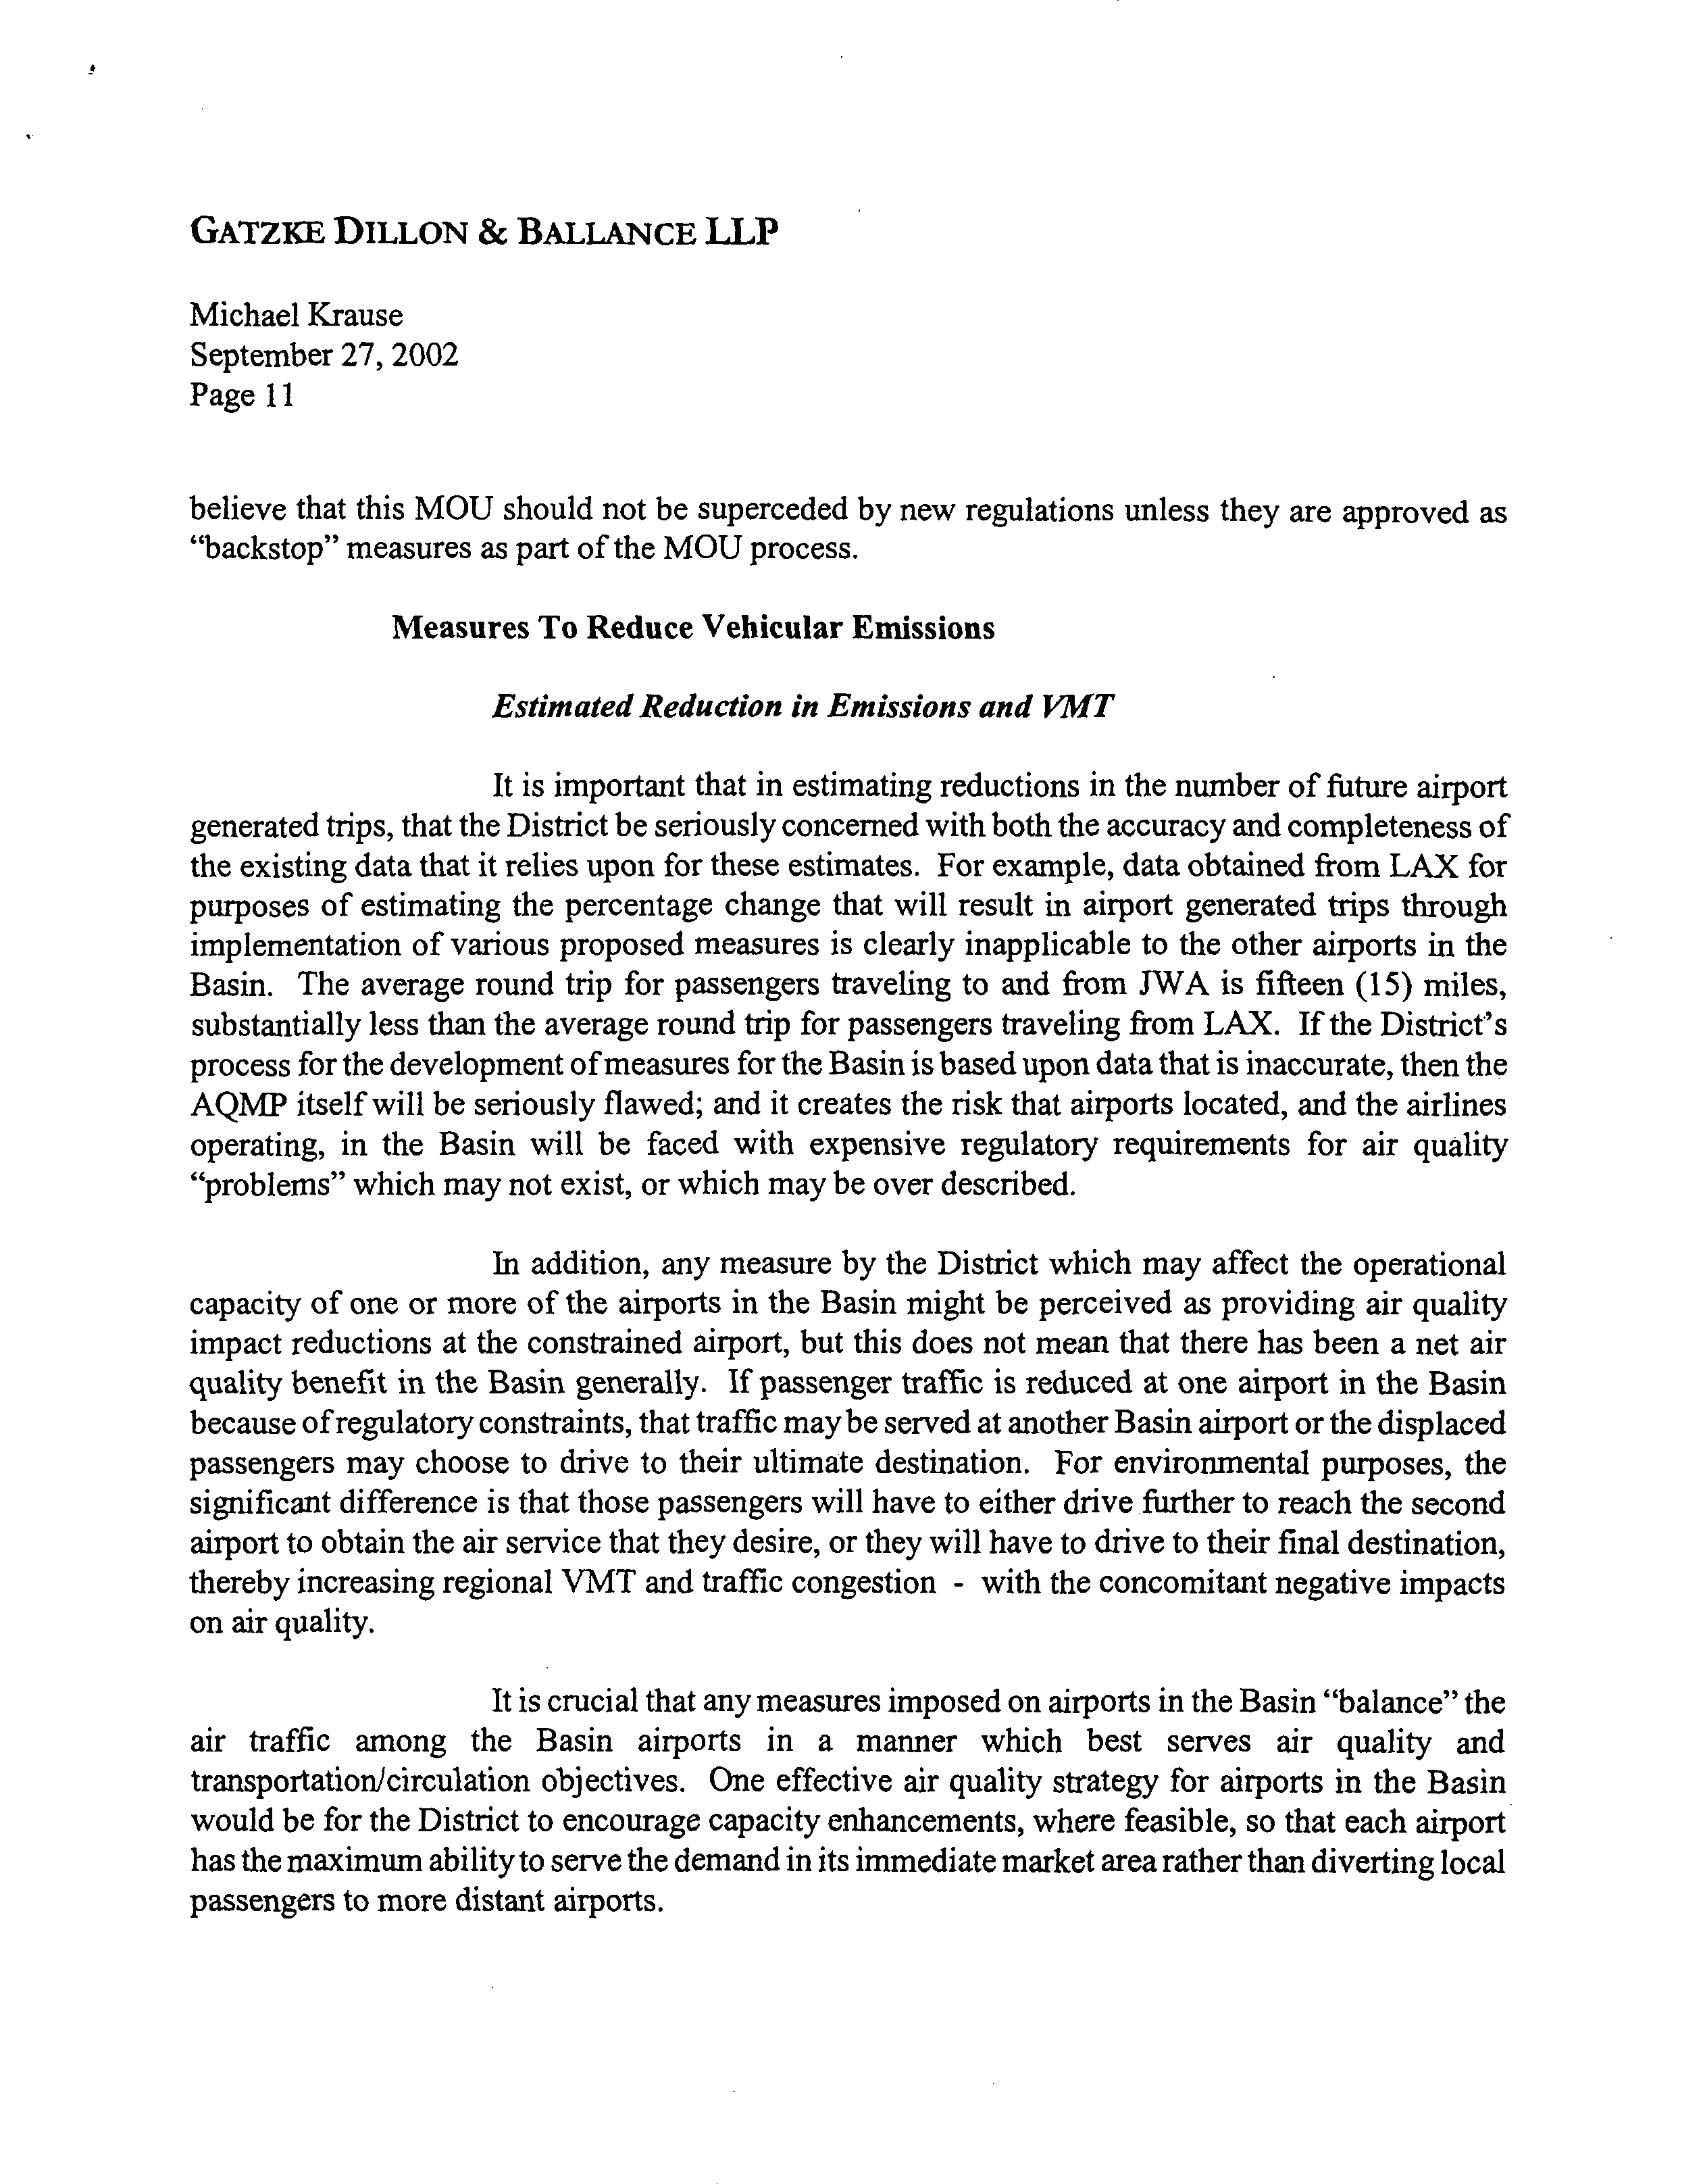
8-31
8-32
8-30
8-29
Cont’d
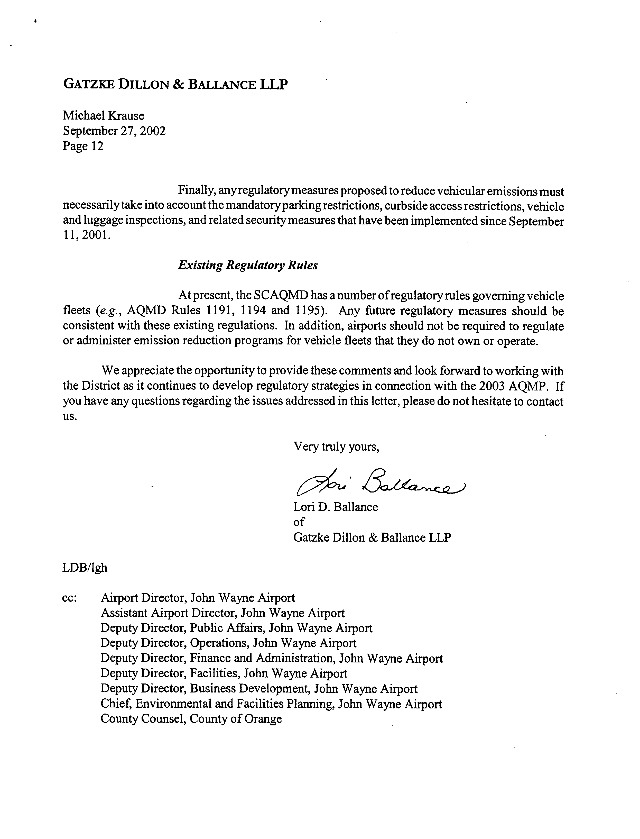
8-34
8-33
COMMENT NO. 8
LETTER FROM GATZKE DILLON & BALANCE LLP

Lori D. Ballance
September 27, 2002

Response 8-1

The SCAQMD understands that your comments are submitted on behalf of the John Wayne Airport.

Response 8-2

The 2003 AQMP provides the project description for the AQMP EIR and provides the general basis for the AQMP.

Response 8-3

Please note that the 2003 AQMP identifies the control measures that need to be implemented by various local, state and federal agencies, including the SCAQMD, the Southern California Association of Governments, the California Air Resources Board and the U.S. Environmental Protection Agency. The AQMP is not limited to stationary sources or to sources within the jurisdiction of the SCAQMD.

Response 8-4

The 2003 AQMP includes estimates of the base (1997) and future year (2008, 200, 2002, 2005, 2006, 2007, 2008, 2010, and 2020) emission inventories (see Appendix III of the AQMP). Information to produce an emission inventory for the Basin is obtained from the SCAQMD, CARB, California Department of Transportation, and SCAG. The SCAQMD develops the point source inventories based on the emissions data reported by point source facilities in the 1996/97 Annual Emissions Reporting (AER) program.

In 1999, an inventory study was conducted for the SCAQMD to develop the 1997 aircraft emissions for commercial, generation aviation and military airports. The aircraft activity data (i.e., number of aircraft operations by air craft types) was obtained from commercial airport operations, and from FAA general aviation reports. The U.S. EPA’s Emissions Dispersion Modeling Systems (EDMS) was used to calculate aircraft emissions. Emissions from commercial aircraft were calculated based on the aircraft type, engine type, number of engines, time-in-mode emission factors, mixing height, and the number of landing and take-off cycles. General aviation aircraft emissions were primarily calculated using AP-42 emission factors. For future years, SCAG’s 2025 project emission inventories for commercial airports and growth factors for general aviation airports were utilized. For intermediate years, emissions for commercial airports were interpolated between 1999 and 2025 based on the passenger level (i.e., million air passengers) specified for each commercial airport in the 2001 Regional Transportation Plan.

Response 8-5

See Response 8-4. The future year inventories included projections for growth as developed by SCAG in the 2001 Regional Transportation Plan. The air traffic in Orange County was estimated to increase by a factor of 1.797 or about an 80 percent increase between 1997 and 2010.

Response 8-6

As noted, the AQMP includes several measures that would be implemented by CARB to control emissions from aircraft and emissions from vehicles traveling to/from airports.

Response 8-7

See Response 8-4. The emission inventory takes into account the rules and regulations adopted by the SCAQMD, CARB and the U.S. EPA between September 20, 1996 and October 31, 2002. The emission inventory provides the basis for the current air quality and provides the basis for the future air emission inventories. In order to demonstrate compliance with ambient air quality standards, an accurate estimate of the current inventory is necessary to assure compliance with the ambient air quality standards. It is not feasible to provide “credit” to all sources that have implemented air quality reductions in the past and ensure that the ambient air quality standards will be achieved in the future. Past control efforts are reflected in the baseline inventory and further reduction potential would be assessed based on technical feasibility and cost-effectiveness.

Response 8-8

See Response 8-4. The 2003 AQMP has used the best inventory data available.

Response 8-9

Your comment is noted and these type of control options could be pursued by CARB under some of its proposed control measures.

Response 8-10

The inventory for mobile sources were based on projections for growth as developed by SCAG in the 2001 Regional Transportation Plan. The overall assumption is that population growth will result in an increase in total vehicle miles traveled in the Basin. Although there maybe a decrease in some vehicle trips traveling to LAX, the overall population growth would still result in an overall increase in total vehicle miles traveled. Also, John Wayne Airport is not an international airport. Therefore, people would still be expected to travel to Los Angeles Airport for international flights.

Response 8-11

Your comment is noted and the SCAQMD is interested in working with all stakeholders in the development of air quality rules and regulations. Please note that the control measures that would impact airports are expected to be adopted by CARB and the applicable notices and input on rulemaking would need to be addressed to CARB.

Response 8-12

A socioeconomic analysis is being prepared that examines the cost of implementation of the control measures in the 2003 AQMP.

Response 8-13

See Response 8-12.

Response 8-14

See Response 8-12.

Response 8-15

The SCAQMD already has a creative penalty policy that can be used to distribute fees collected from violations of its rules. No penalty fees are collected by the SCAQMD for AQMP noncompliance, only for noncompliance with rules and permit conditions. If there are fees beyond those necessary to support the AQMD costs of regulation, such as mitigation fees, these would be used to mitigate emission impacts of airport operations.

Response 8-16

The SCAQMD understands that Gatzke Dillon & Balance have no specific comments on control measures to be implemented by the SCAQMD at this time.

Response 8-17

Please see Chapter 2 of the AQMP EIR and 2003 AQMP, Appendix IV-B – State and Federal Element of the South Coast State Implementation Plan. Chapter G of that document provides a more detailed discussion of the potential control measures that impact airports and jet aircraft. Note that there has been changes to the control measures. Also, please note that some of the details of the control measures will need to be developed during the promulgation of the rules.

Response 8-18

Please see the 2003 AQMP, Appendix IV-B – State and Federal Element of the South Coast State Implementation Plan. Chapter G of that document provides a more detailed discussion of the potential control measures that impact airports and jet aircraft.

Your comments regarding airline operations in the Basin as a whole are noted and such comments are appropriate as more definitive rules and regulations are developed.

Response 8-19

Please see the 2003 AQMP, Appendix IV-B – State and Federal Element of the South Coast State Implementation Plan. Chapter G of that document provides a more detailed discussion of the potential control measures that impact airports and jet aircraft. The time required to implement control measures is considered during the rulemaking process.

Response 8-20

Please see the 2003 AQMP, Appendix IV-B – State and Federal Element of the South Coast State Implementation Plan. Chapter G of that document provides a more detailed discussion of the potential control measures that impact airports and jet aircraft. The details of a fee-based program would need to be developed during the rule development phase.

Response 8-21

See Response 8-20.

Response 8-22

See Response 8-20.

Response 8-23

See Responses 8-20 and 8-15.

Response 8-24

See Response 8-17 regarding control measures applicable to the airline industry. It is premature to discuss the details of emission reductions credits for emissions from aircraft as no such program has been proposed. The details of any specific rule or regulations will be outlined in more detail at the time that the rule/regulation is promulgated. These comments will be forwarded to rulemaking staff at each agency.

Response 8-25

See Response 8-24 regarding emission reductions credits for emissions from aircraft.

Response 8-26

See Response 8-24 regarding emission reductions credits for emissions from aircraft.

Response 8-27

See Response 8-24 regarding emission reductions credits for emissions from aircraft.

Response 8-28

Your comments regarding the need for additional research for cleaner jet engines and improved air traffic control systems are noted.

Response 8-29

Your comments regarding the MOU are noted. However attaining air quality standards may require emissions reductions beyond those already recommended in the MOU. The need for and feasibility of such reductions will be considered in the rulemaking process. Any excess emission reductions are taken into account during updates to the AQMP and considered during the rulemaking process.

Response 8-30

See Response 8-10 regarding the emission inventory for mobile sources.

Response 8-31

CARB is the agency with authority over mobile source emissions within California. It is expected that any CARB or federal rules and regulations adopted will affect all airports or aircraft within California. If the AQMD undertakes any measures affecting specific airports, your comment will be considered.

Response 8-32

Your comments regarding capacity enhancements are noted. The details of any specific rule or regulations will be outlined in more detail at the time that the rule/regulation is promulgated.

Response 8-33

Your comments regarding vehicular emissions are noted. The details of any specific rule or regulations will be outlined in more detail at the time that the rule/regulation is promulgated.

Response 8-34

Your comments regarding the fleet vehicle rules are noted. These rules generally apply to public and private fleet operations with 15 or more vehicles. “Airports” would be regulated by these rules if they were the owners of fleet vehicles with more than 15 vehicles. Please note that additional state and federal regulatory requirements could also affect fleet vehicle owners in the future.
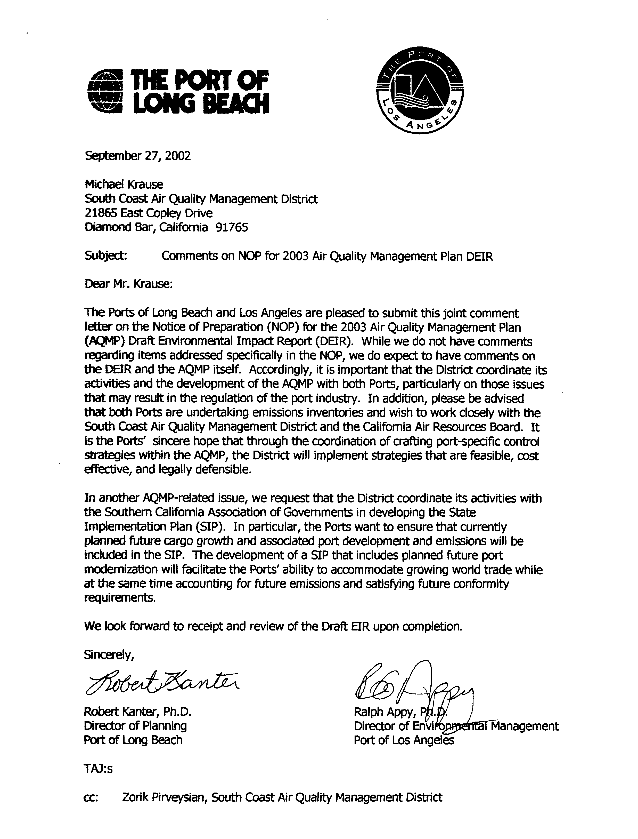
9-1
9-2
9-3
COMMENT NO. 9
LETTER FROM THE PORT OF LONG BEACH

Robert Kanter
Ralph Appy
September 27, 2002

Response 9-1

The SCAQMD understands that the Port of Long Beach does not have any comments on the 2003 AQMP or the Draft EIR for the 2003 AQMP at this time. The SCAQMD will review new data provided regarding emission inventories from the ports. Also, please note that a number of the control strategies in the AQMP that will affect Port operations are proposed by CARB and SCAQMD.

Response 9-2

The 2003 AQMP has been developed in coordination with SCAG and CARB. The emission inventories for the ports are provided in Appendix III of the 2003 AQMP.

Response 9-3

The Port will be notified of the availability of the Draft EIR.

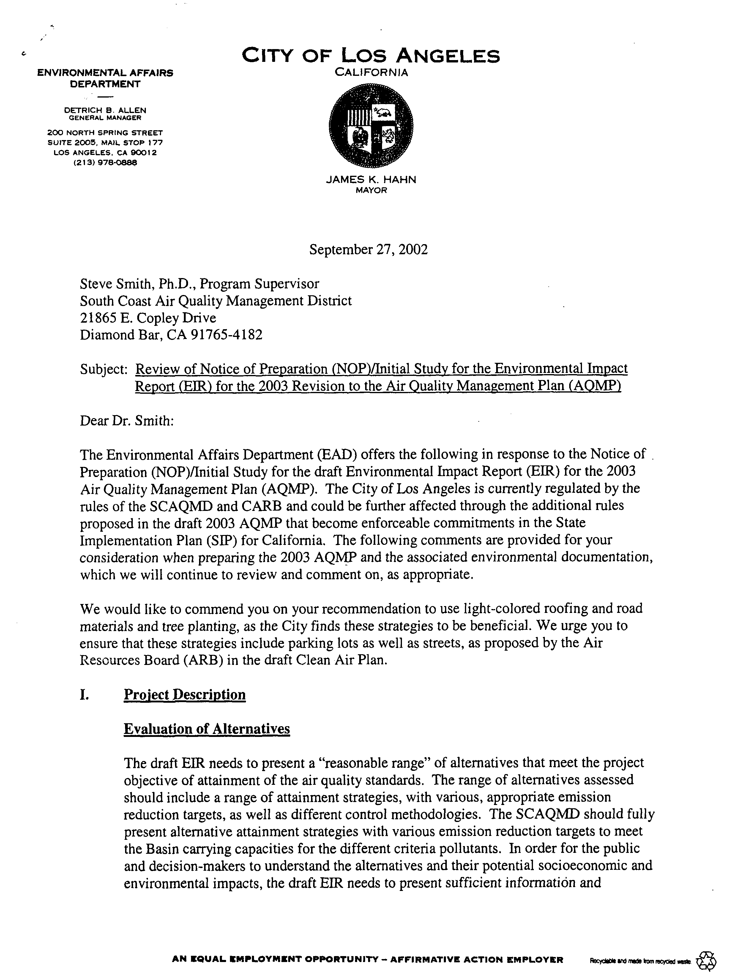
10-1
10-2
10-3
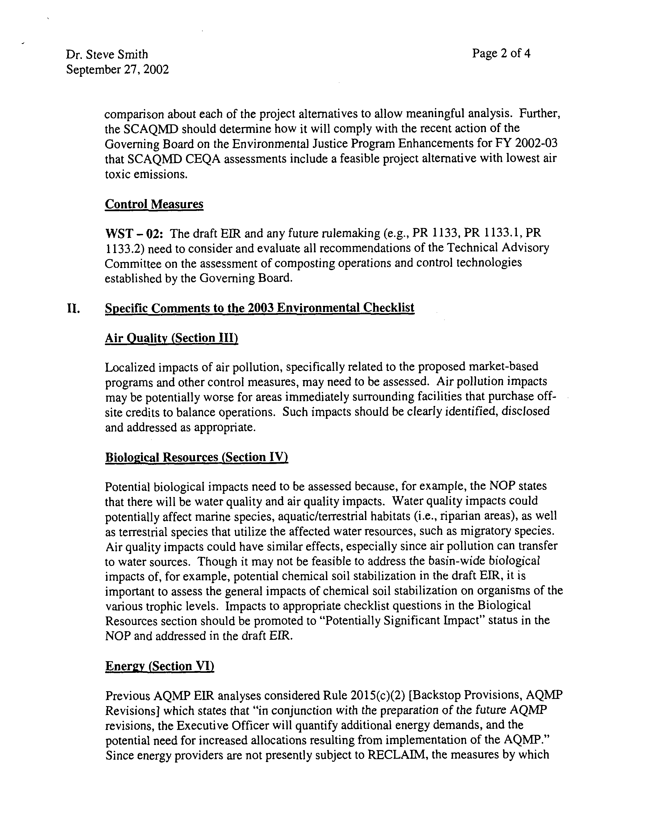
10-3
Cont’d
10-4
10-5
10-6
10-7
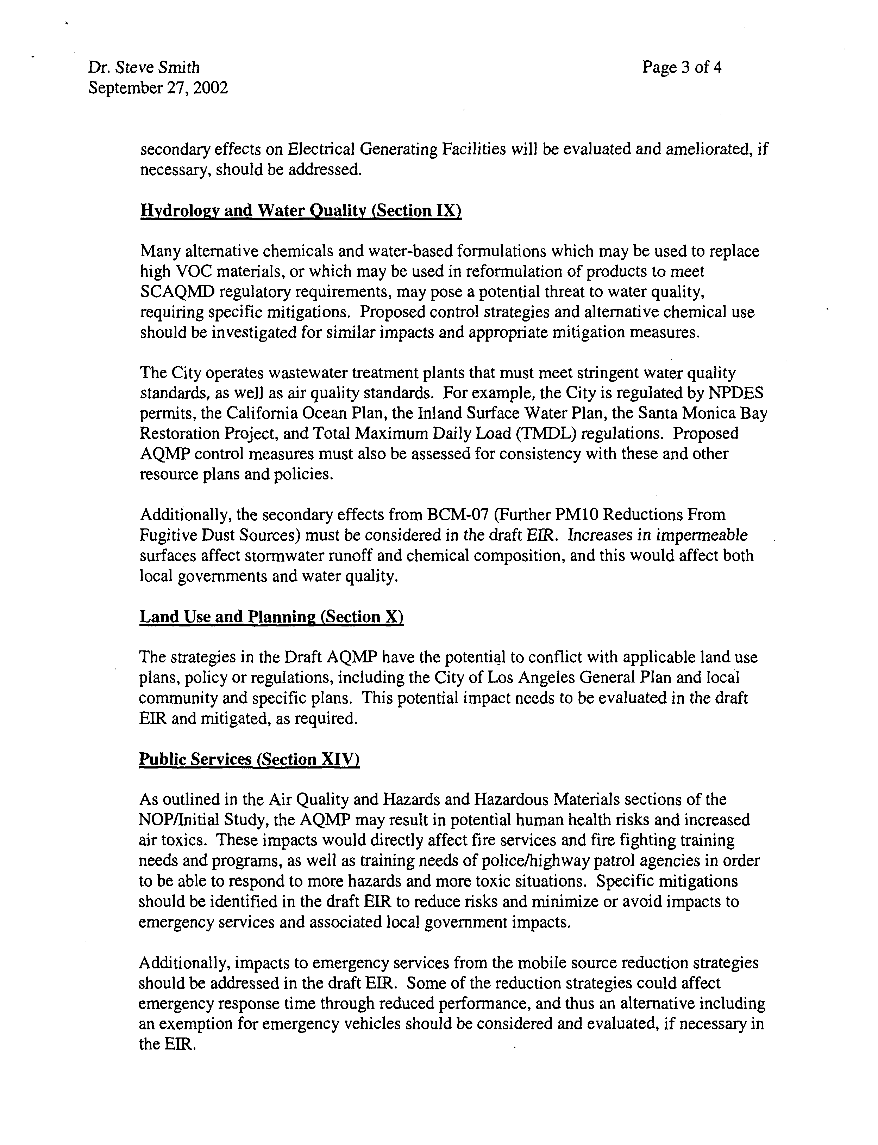
10-7
Cont’d
10-8
10-9
10-10
10-11
10-12
10-13
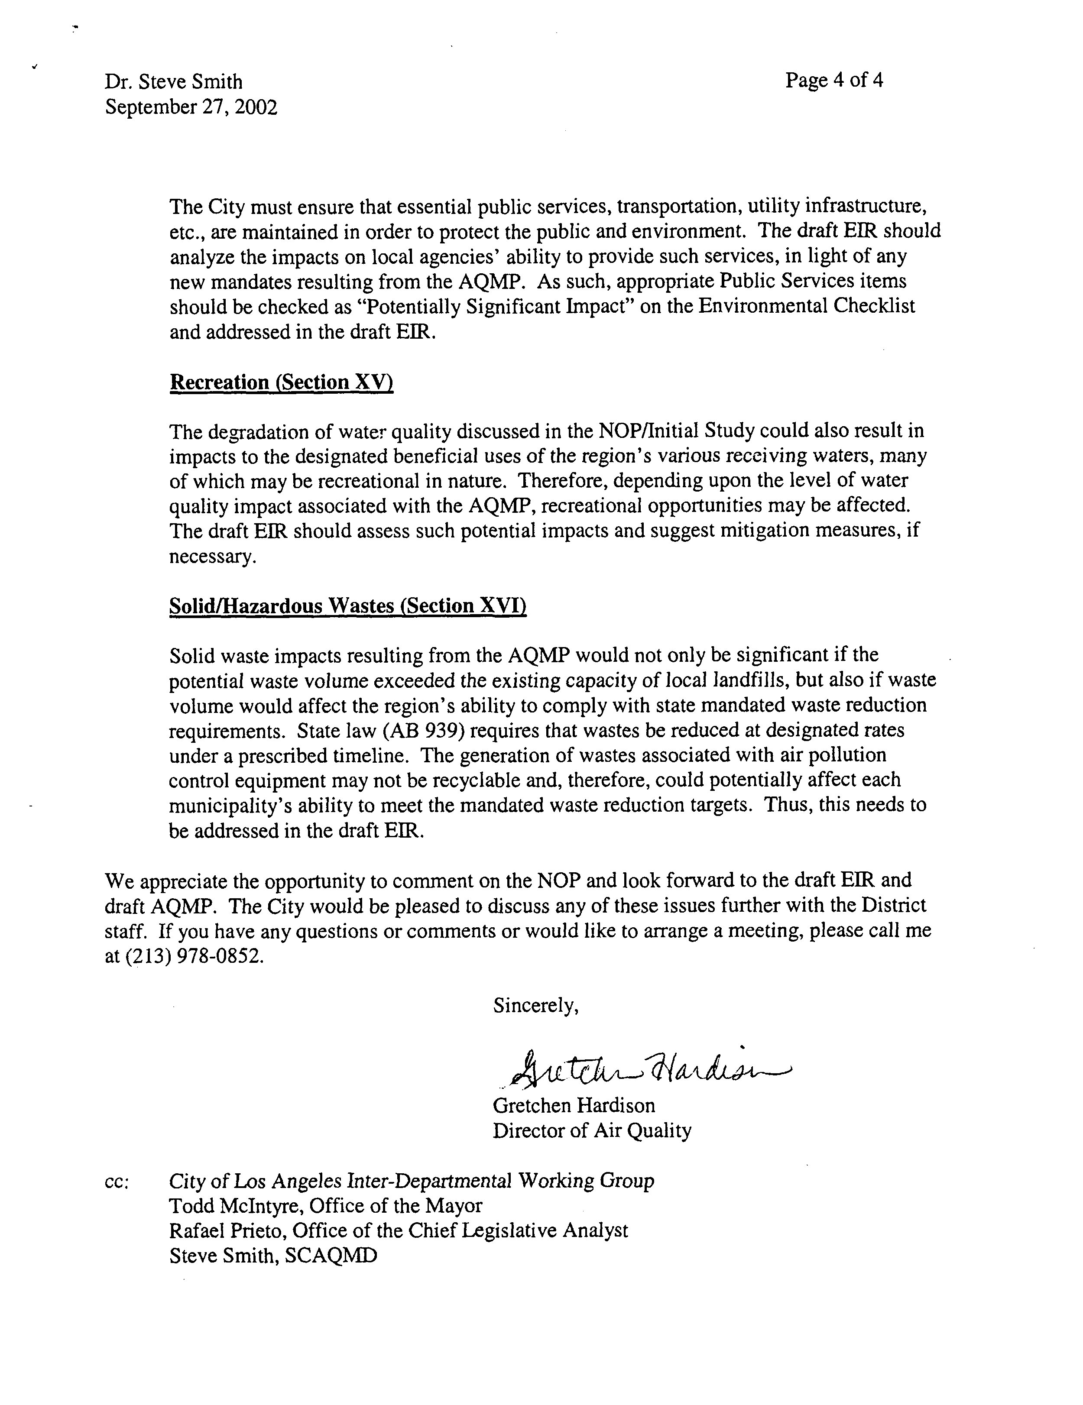
10-17
10-16
10-15
10-14
10-17
10-16
10-15
10-14
COMMENT NO. 10
LETTER FROM THE CITY OF LOS ANGELES

Gretchen Hardison
September 27, 2002

Response 10-1

The SCAQMD understands that the City of Los Angeles is regulated by CARB and the SCAQMD and could be affected by additional regulations through thee 2003 AQMP.

Response 10-2

The 2003 AQMP includes MSC-01, which would include the use of light colored roofing and road materials, and tree planting programs (see 2003 AQMP, Appendix IV-A, pages 42-47. As currently envisioned, the use of lighter colored pavement materials would include a number of urban surfaces including streets, sidewalks, parking lots, school yards, and other similar surfaces.

Response 10-3

The alternatives analysis is presented in Chapter 5 of the 2003 AQMP EIR. A lowest air toxic emission alternative has been included. The 2003 AQMP is designed to show compliance with and federal ambient air quality standards. The environmental justice program enhancements, therefore, are not part of the 2003 AQMP. However, the AQMP will result in overall emission reductions resulting in beneficial impacts to all residents in the Basin.

Response 10-4

Your comment is noted and the available information from PR1133, 1133.1, and 1133.2 has been included in the Draft EIR. Future rulemaking will consider all public comments received, including those of the Technical Advisory Committee.

Response 10-5

The AQMP identifies control measures to reduce air emissions from existing emission sources. No new emission credit trading programs are currently being proposed in the AQMP. However, the rules that implement existing emission credit trading programs place restrictions on the locations that emission trades can be made and place restrictions on the types of pollutants that can be traded to avoid impacting areas surrounding facilities that use off-sets. Existing rules also require ambient air quality analyses to assure that new equipment does not exceed ambient air quality standards for pollutants already in compliance with air quality standards.

Response 10-6

The potential impacts of implementing control measures in the 2003 AQMP water quality are addressed in Chapter 4.4 - Hydrology and Water Quality. Implementation of the control measures in the AQMP are expected to result in a decrease in emissions from a variety of sources in the Basin and decrease the potential for transferring air pollutants into other environmental media. Therefore, no significant impact on biological resources is expected. See Chapter 4.2 of the EIR for a discussion of the air quality benefits associated with implementation of the 2003 AQMP.

Response 10-7

Energy impacts associated with implementing the control measures in the 2003 AQMP are discussed in Chapter 4.2 – Energy of the AQMP EIR. The potential increase in air emission from electric generating facilities is addressed in Chapter 4.1 – Air Quality of the AQMP EIR.

Response 10-8

The potential water quality impacts associated with reformulated coatings, solvents and consumer products are addressed in Chapter 4.4 - Hydrology/Water Quality of the AQMP EIR.

Response 10-9

The potential impacts of the 2003 AQMP control measures on wastewater treatment plants are discussed in Chapter 4.4 – Hydrology/Water Quality of the AQMP EIR.

Response 10-10

The potential impacts of the 2003 AQMP control measures on water quality are discussed in Chapter 4.4 – Hydrology/Water Quality of the AQMP EIR.

Response 10-11

No conflicts with land use plans, policy or regulations were identified during the evaluation of the potential impacts associated with implementation of the AQMP (see Appendix A for the EIR). Further, the commentator does not site any specific potential conflicts between the 2003 AQMP and any land use plans. Therefore, no specific conflicts with any land use plan have been identified.

Response 10-12

Implementation of the AQMP is expected to result in an overall decrease in the use of toxic chemicals and a related decrease in associated emissions and human health impacts. The hazard impacts associated with implementation of the 2003 AQMP are addressed in Chapter 4.3 – Hazards of the EIR.

Response 10-13

Implementation of the control measures in the AQMP is expected to result in a decrease in congestion and vehicle miles traveled, thus theoretically reducing the response times of emergency vehicles. Implementation of the some mobile source control strategies could result in a reduction in energy efficiency of petroleum based fuels. The potential energy impacts associated with these control measures are discussed in Chapter 4.3 – Energy of the AQMP EIR.

Response 10-14

No significant impacts associated with implementation of the 2003 AQMP on public services were identified. (See AQMP EIR Appendix A). However, the impacts associated with the AQMP on water and wastewater were addressed in Chapter 4.4 – Hydrology/Water Quality of the AQMP EIR. The potential energy impacts associated with 2003 AQMP on electricity generators, natural gas suppliers, petroleum supplies, and the use of alternative fuels were discussed in Chapter 4.2 – Energy of the 2003 AQMP EIR. Typically the rulemaking process considers exemptions for emergency services where needed. For example, the statute authorizing fleet rules requires fuel exemptions unless it is determined no alternative fuels are sufficiently viable not to affect fuel services.

Response 10-15

The potential impacts due to implementation of the control measures in the 2003 AQMP on water quality were addressed in Chapter 4.4 – Hydrology/Water Quality of the Draft EIR.

Response 10-16

The potential impacts from implementation of the 2003 AQMP on solid and hazardous wastes are addressed in Chapter 4.5 – Solid/Hazardous Waste of the AQMP EIR, including the impact on state waste reduction requirements.

Response 10-17

The comments on the AQMP Draft EIR are noted.
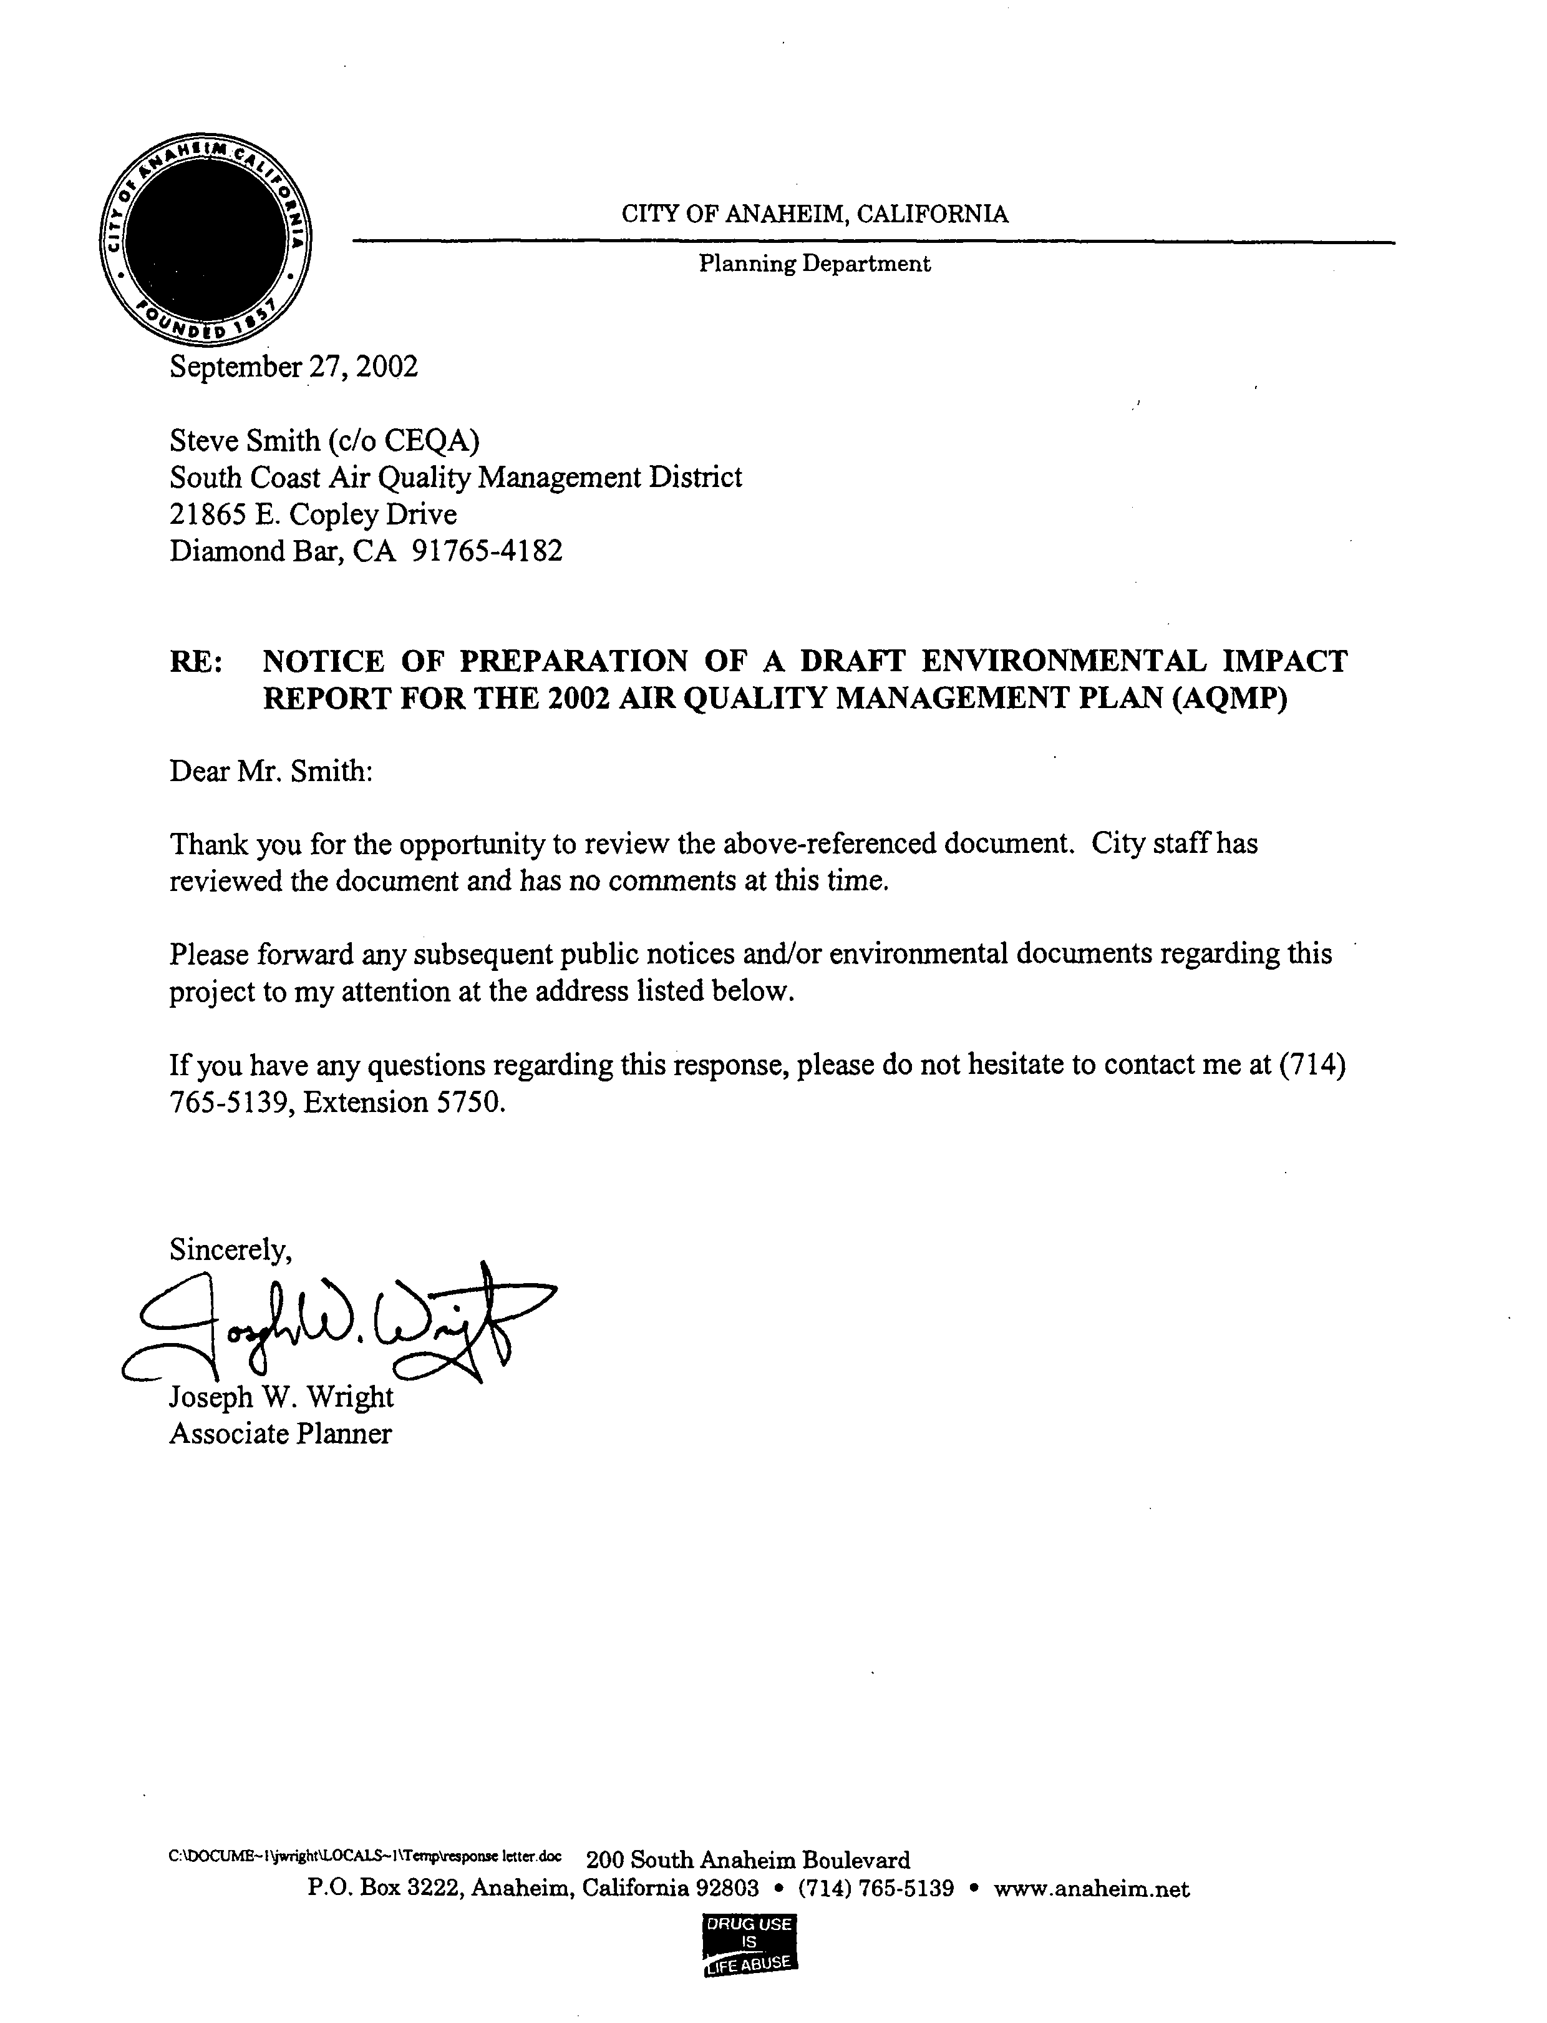
11-1
COMMENT NO. 11
LETTER FROM THE CITY OF ANAHEIM

Joseph W. Wright
September 27, 2002

Response 11-1

The SCAQMD understands that the City of Anaheim wishes to be notified of all public notices and documents regarding the 2003 AQMP Draft EIR.
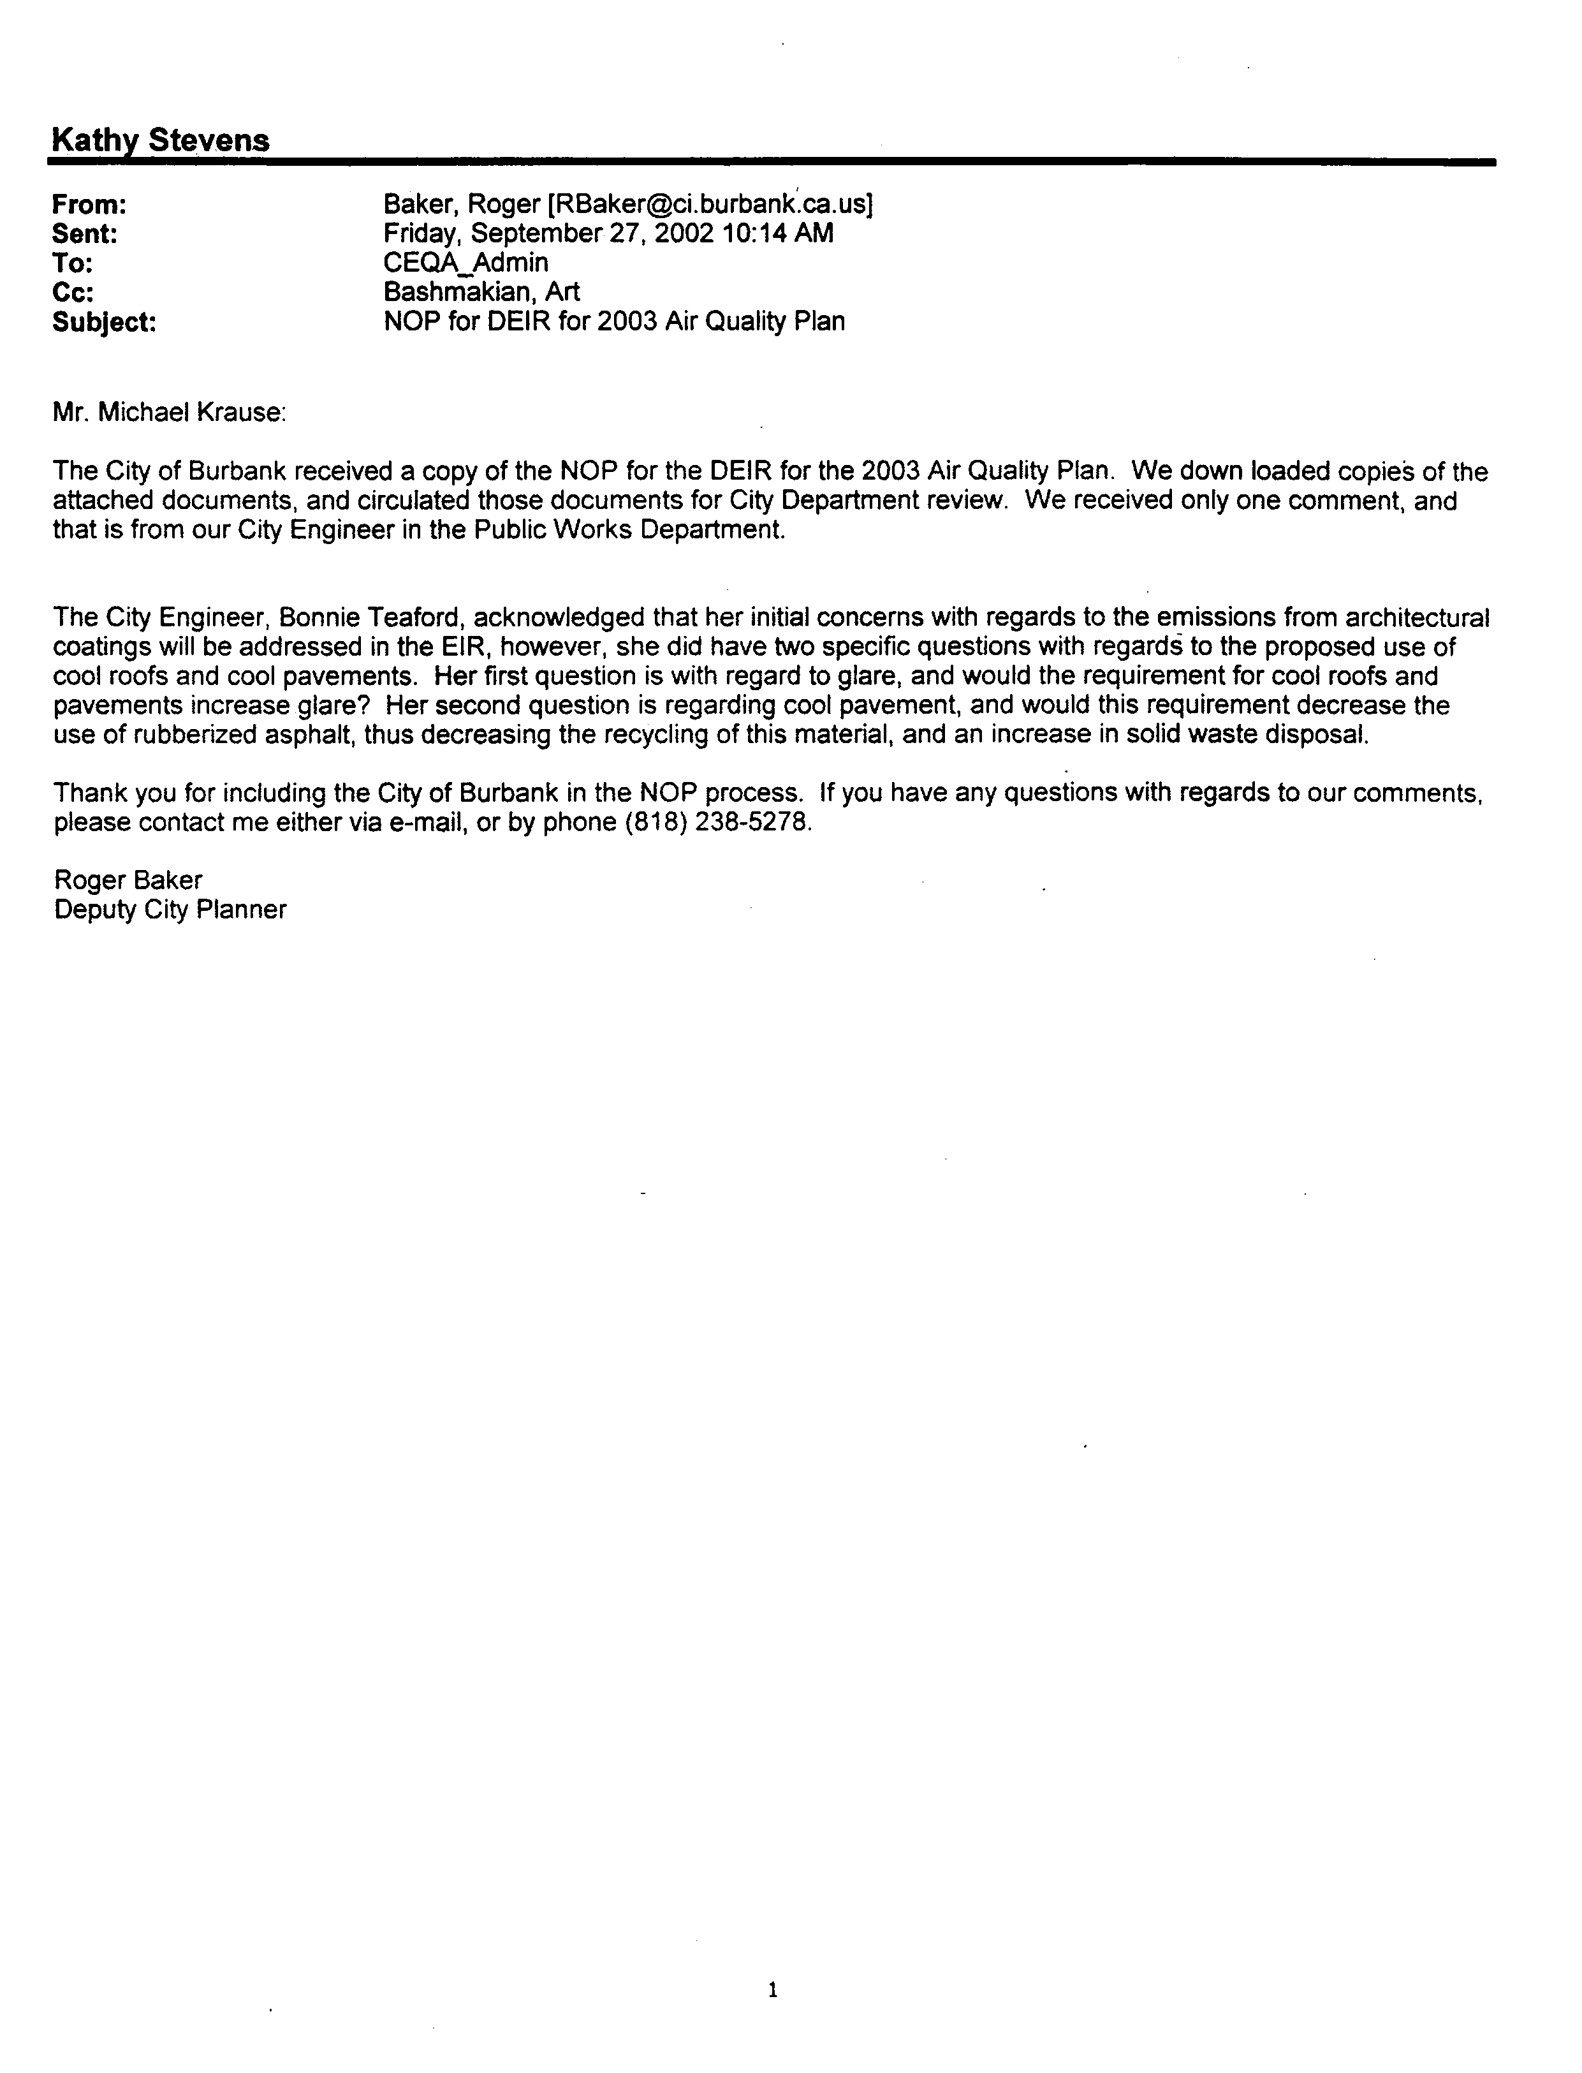
12-1
COMMENT NO. 12
E-MAIL FROM THE CITY OF BURBANK

Roger Baker
September 27, 2002

Response 12-1

The control measure to reduce the heat associated with paved surfaces is not expected to be composed of reflective materials that could cause light and glare impacts. Details on the types of materials that would be used have not yet been determined. Also note that this control measure would also reduce heat by increasing the shade by planting more trees.
COMMENT NO. 12
E-MAIL FROM THE CITY OF BURBANK

Roger Baker
September 27, 2002

Response 12-1

The control measure to reduce the heat associated with paved surfaces is not expected to be composed of reflective materials that could cause light and glare impacts. Details on the types of materials that would be used have not yet been determined. Also note that this control measure would also reduce heat by increasing the shade by planting more trees.
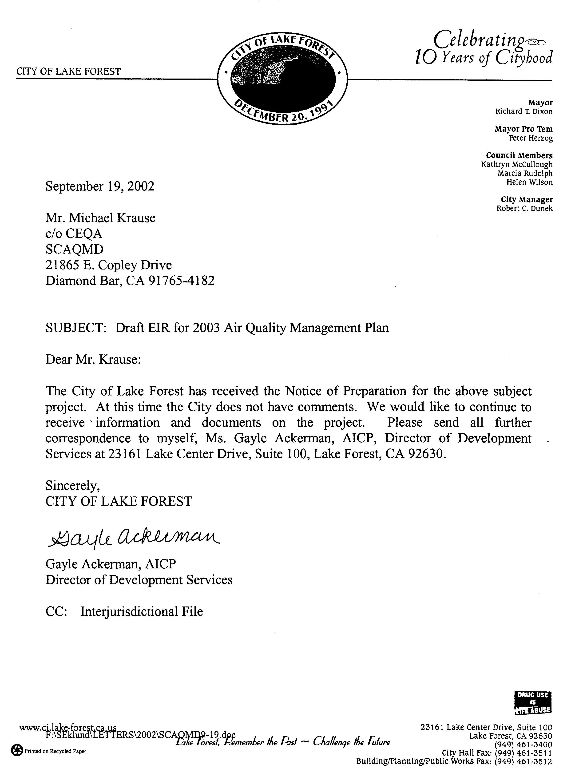
13-1

COMMENT NO. 13
LETTER FROM THE CITY OF LAKE FOREST

Gayle Ackerman
September 19, 2002

Response 13-1

The SCAQMD understands that the City of Lake Forest has no comments at this time but wishes to be notified of all public notices and documents regarding the 2003 AQMP Draft EIR.

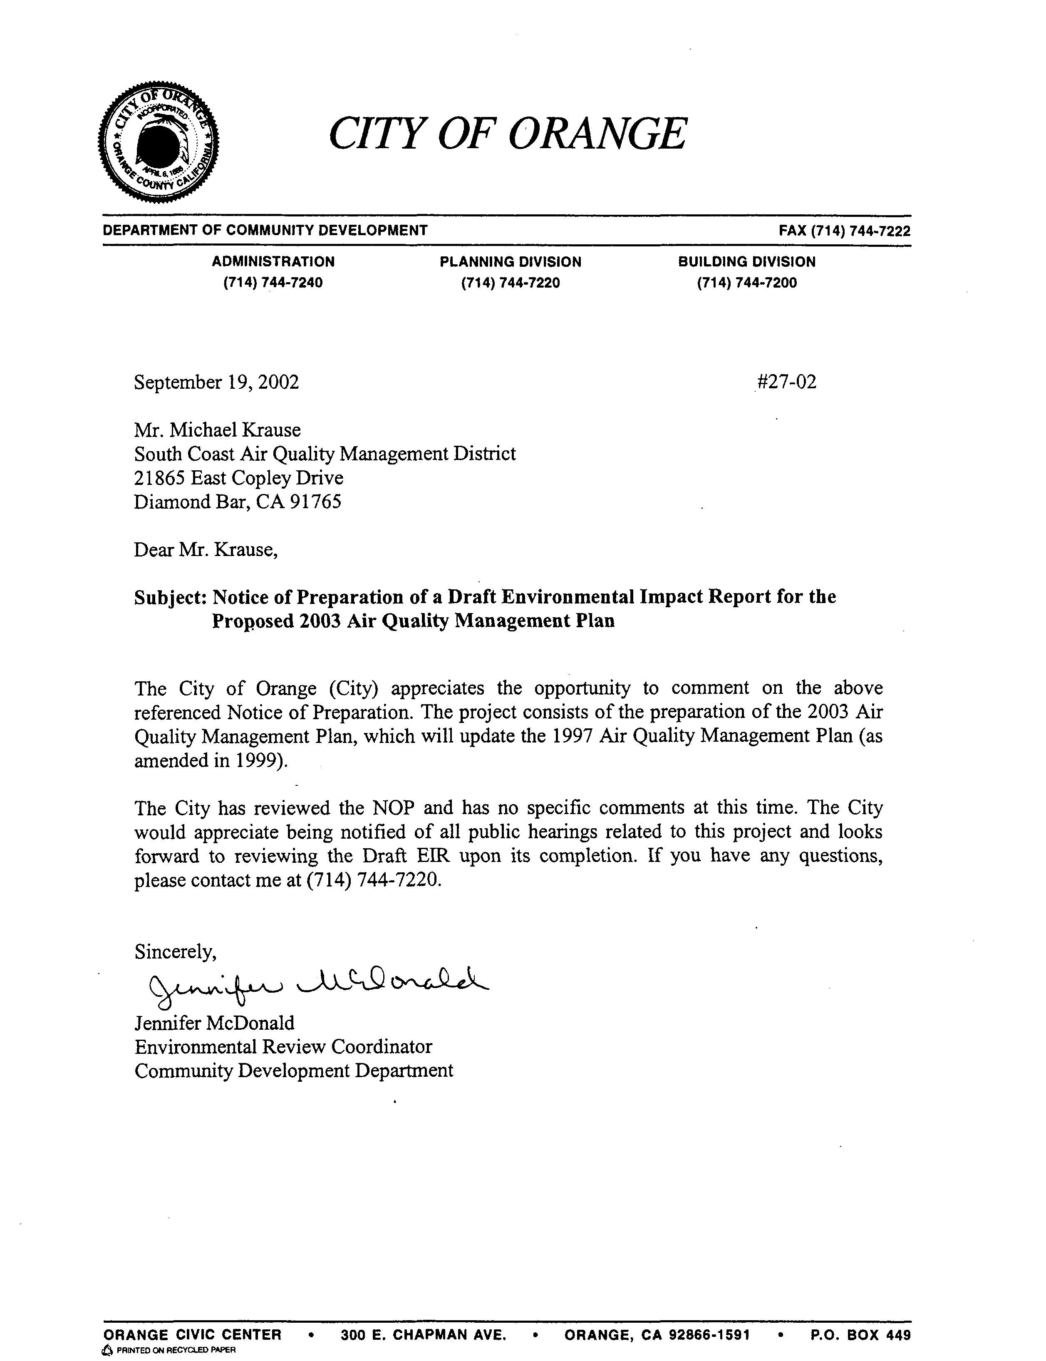
14-1
COMMENT NO. 14
LETTER FROM THE CITY OF ORANGE

Jennifer McDonald
September 19, 2002

Response 14-1

The SCAQMD understands that the City of Orange has no comments at this time but wishes to be notified of all public notices and documents regarding the 2003 AQMP Draft EIR.

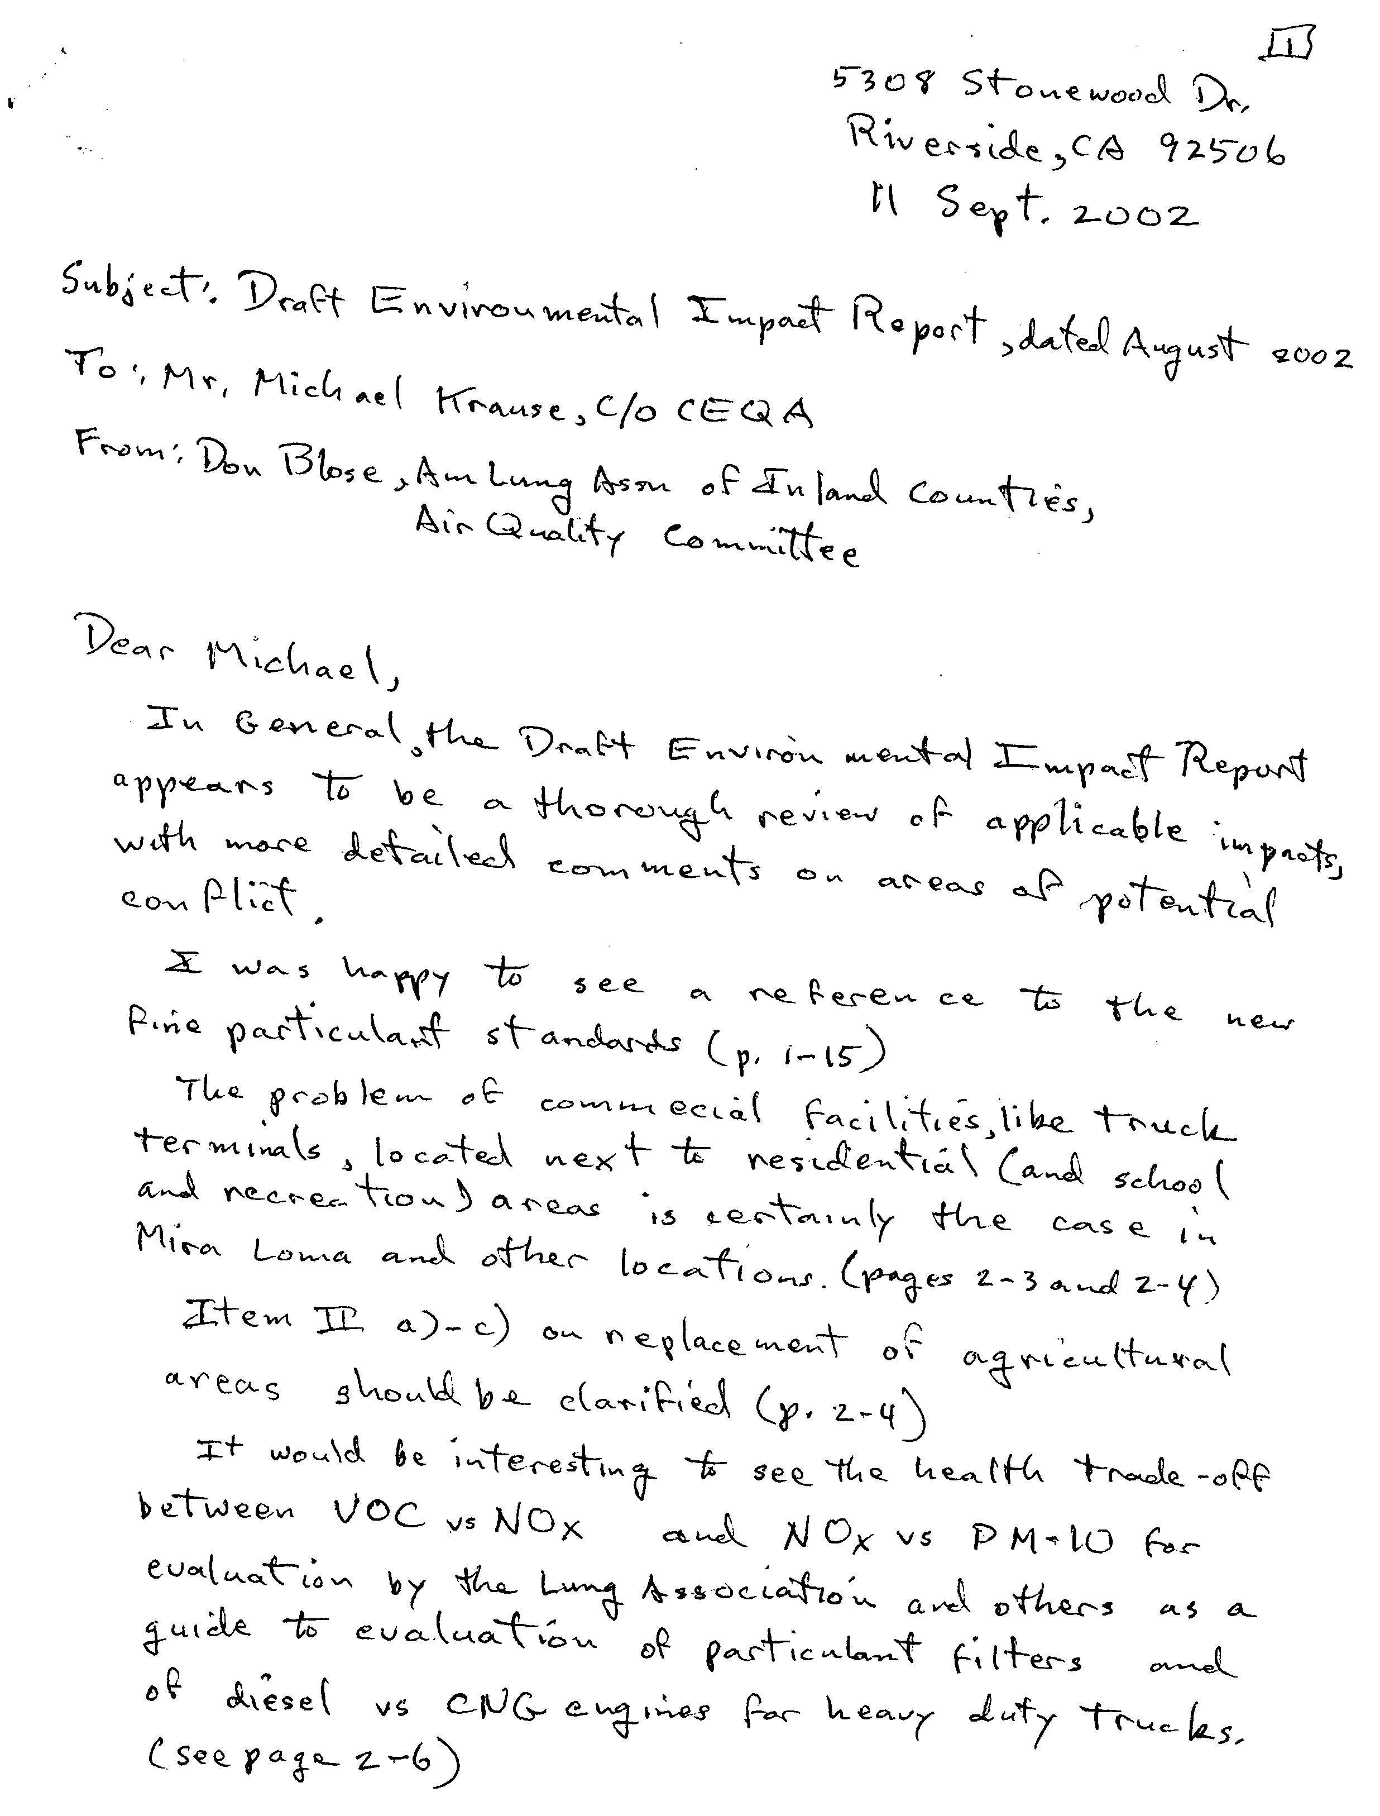
15-1
15-2
15-3
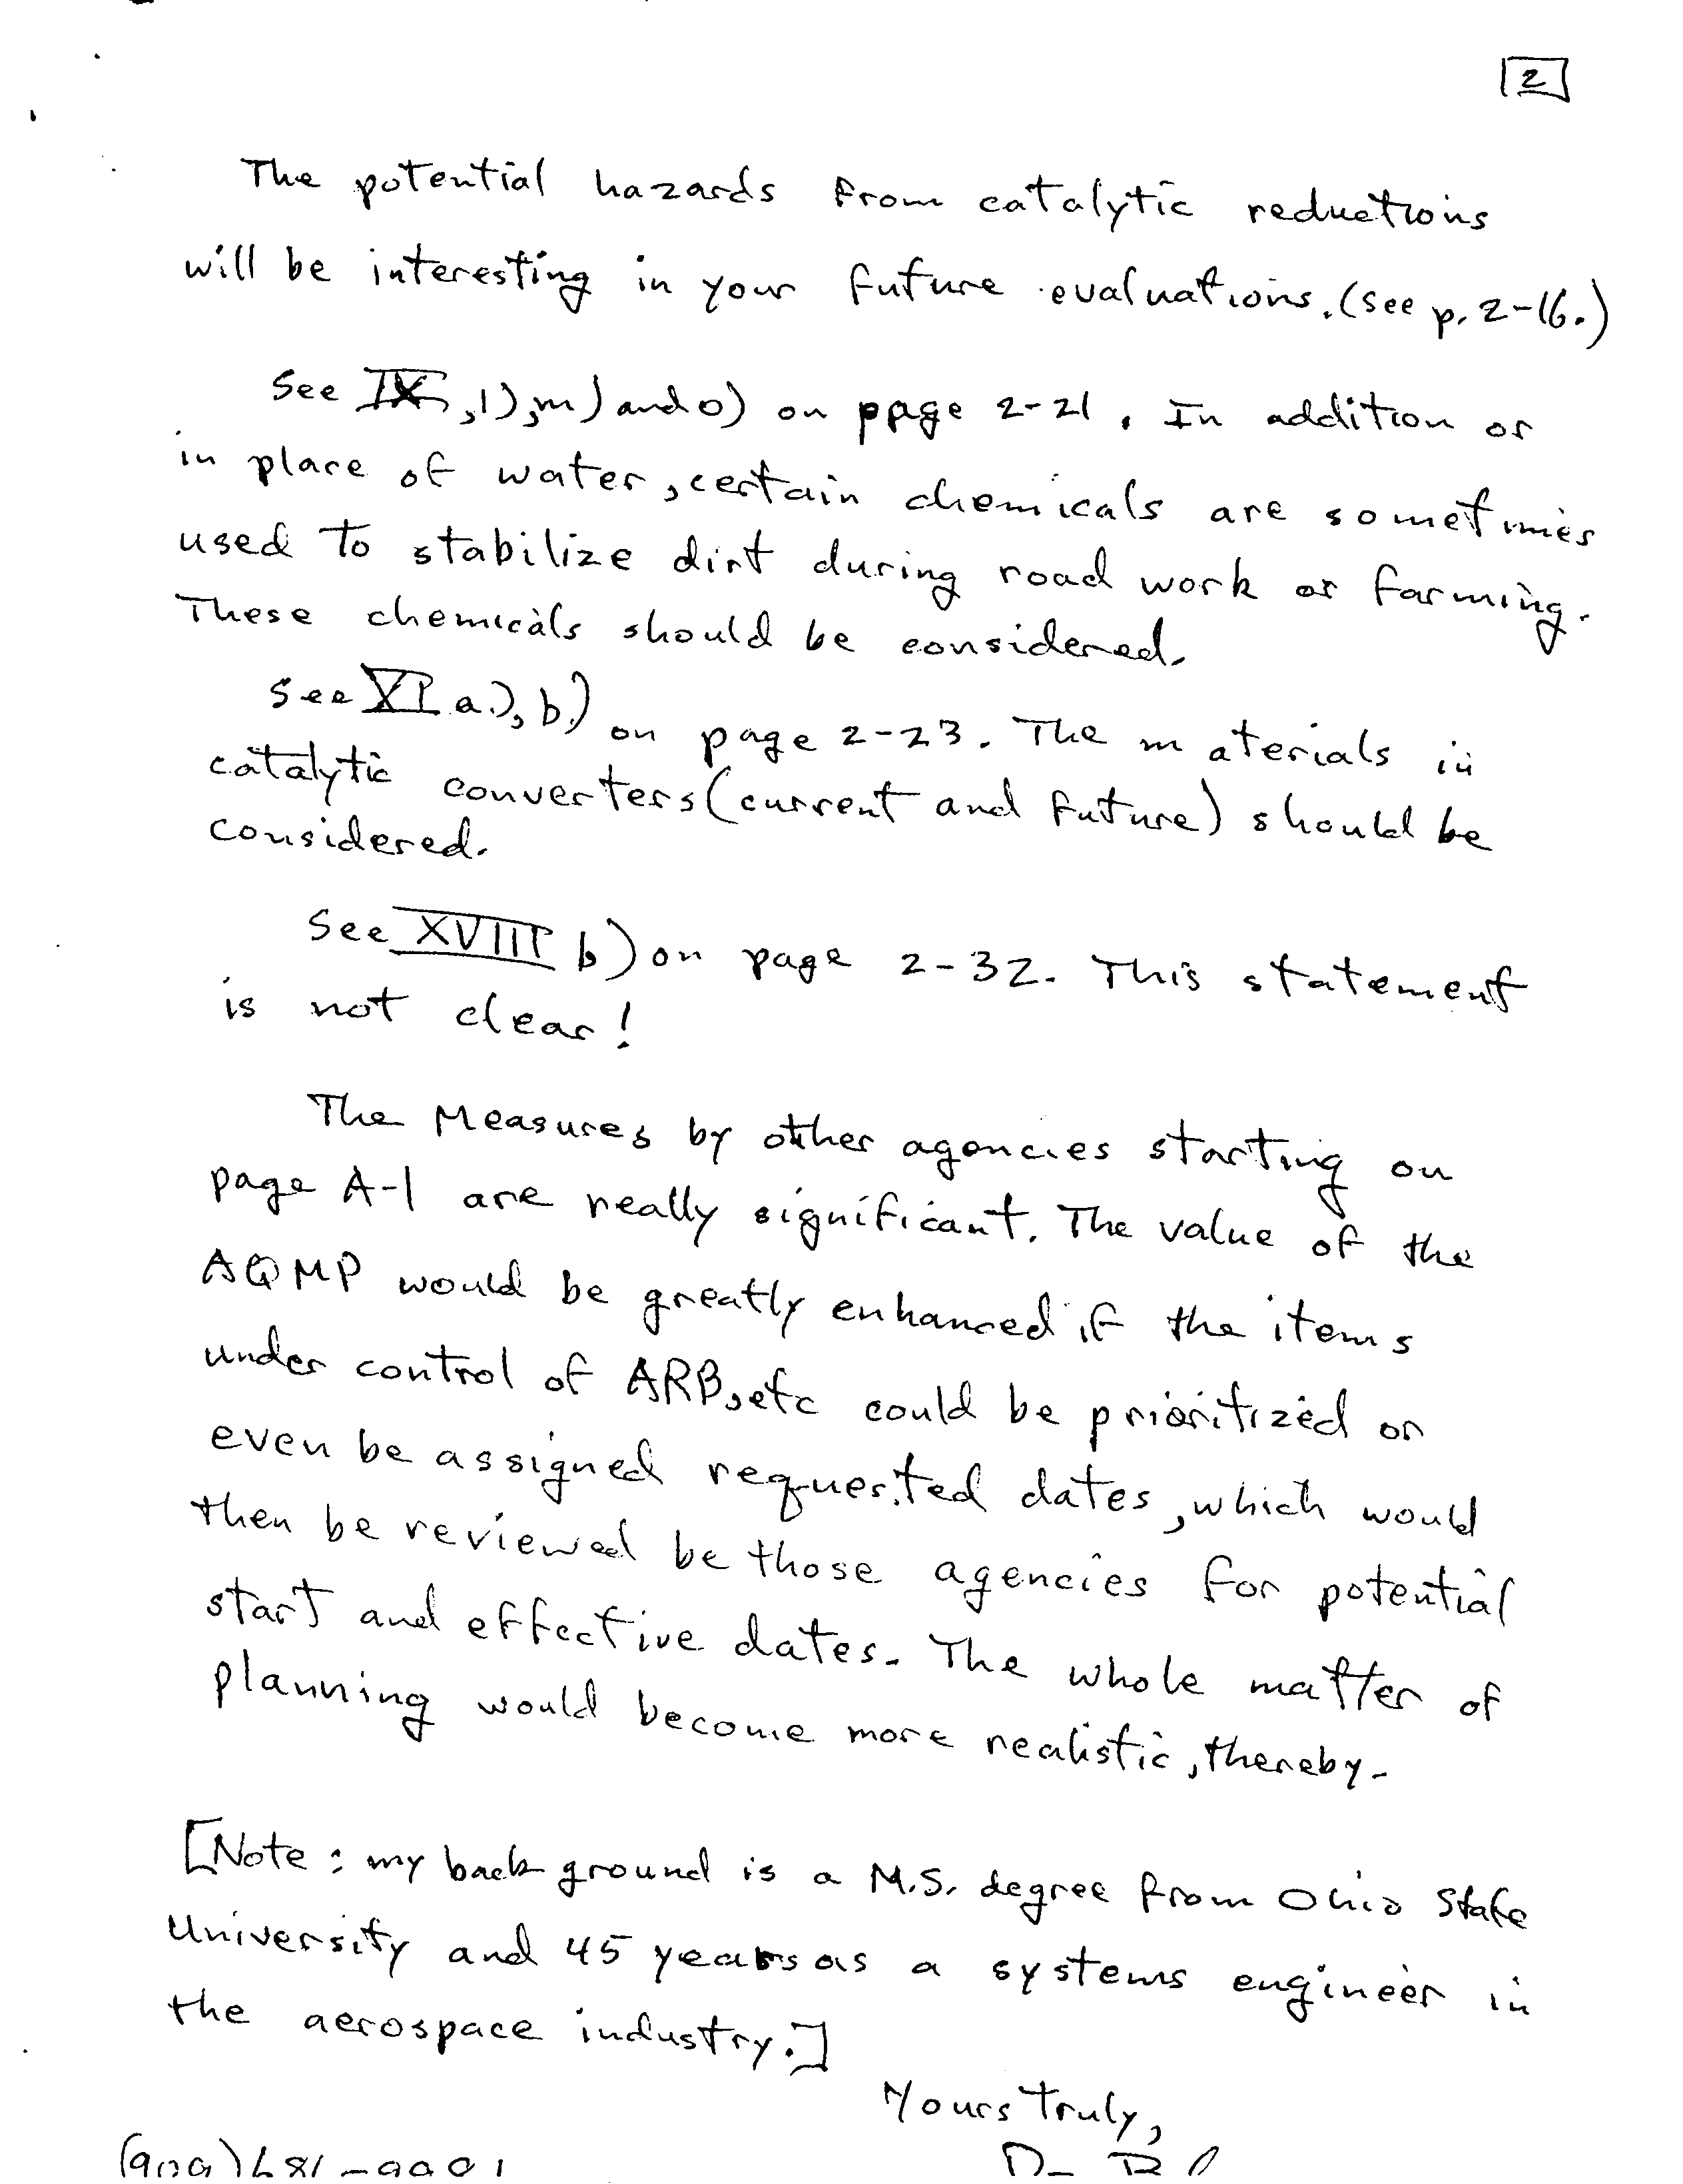
15-8
15-7
15-6
15-5
15-4
COMMENT NO. 15
LETTER FROM THE AMERICAN LUNG ASSOCIATION

Don Blose
September 11, 2002

Response 15-1

Your comments regarding the Draft EIR are noted.

Response 15-2

The 2003 AQMP provides an initial evaluation of compliance with the federal PM2.5 standards.

The 2003 AQMP is a guidance document that establishes an overall control strategy to meet federal and state ambient air quality standards. The AQMP does not regulate land uses.

Implementation of the 2003 AQMP is not expected to result in the conversion of agricultural land uses to other uses.

Response 15-3

CARB reviews the emission increases and decreases associated with control equipment as part of its certification process. Part of its certification process is to determine that the control equipment provides emission benefits without resulting in significant increases in other pollutants.

Response 15-4

See Chapter 4.3 – Hazards/Hazardous Materials of the EIR for a discussion of the hazard impacts associated with the 2003 AQMP.

Response 15-5

The potential impacts on water quality due to the use of dust suppressants are addressed in Chapter 4.4 - Hydrology/Water Quality of the EIR.

Response 15-6

The potential impacts of the use of catalytic converters have been addressed in Chapter 4.5 - Solid/Hazardous Waste of the EIR.

Response 15-7

The statement indicates that cumulative impacts associated with the 2003 AQMP are potentially significant and will be addressed in the 2003 AQMP EIR (see Chapter 4).

Response 15-8

Chapter 2 of the EIR provides the dates by which other agencies have committed to implement the various identified control measures.

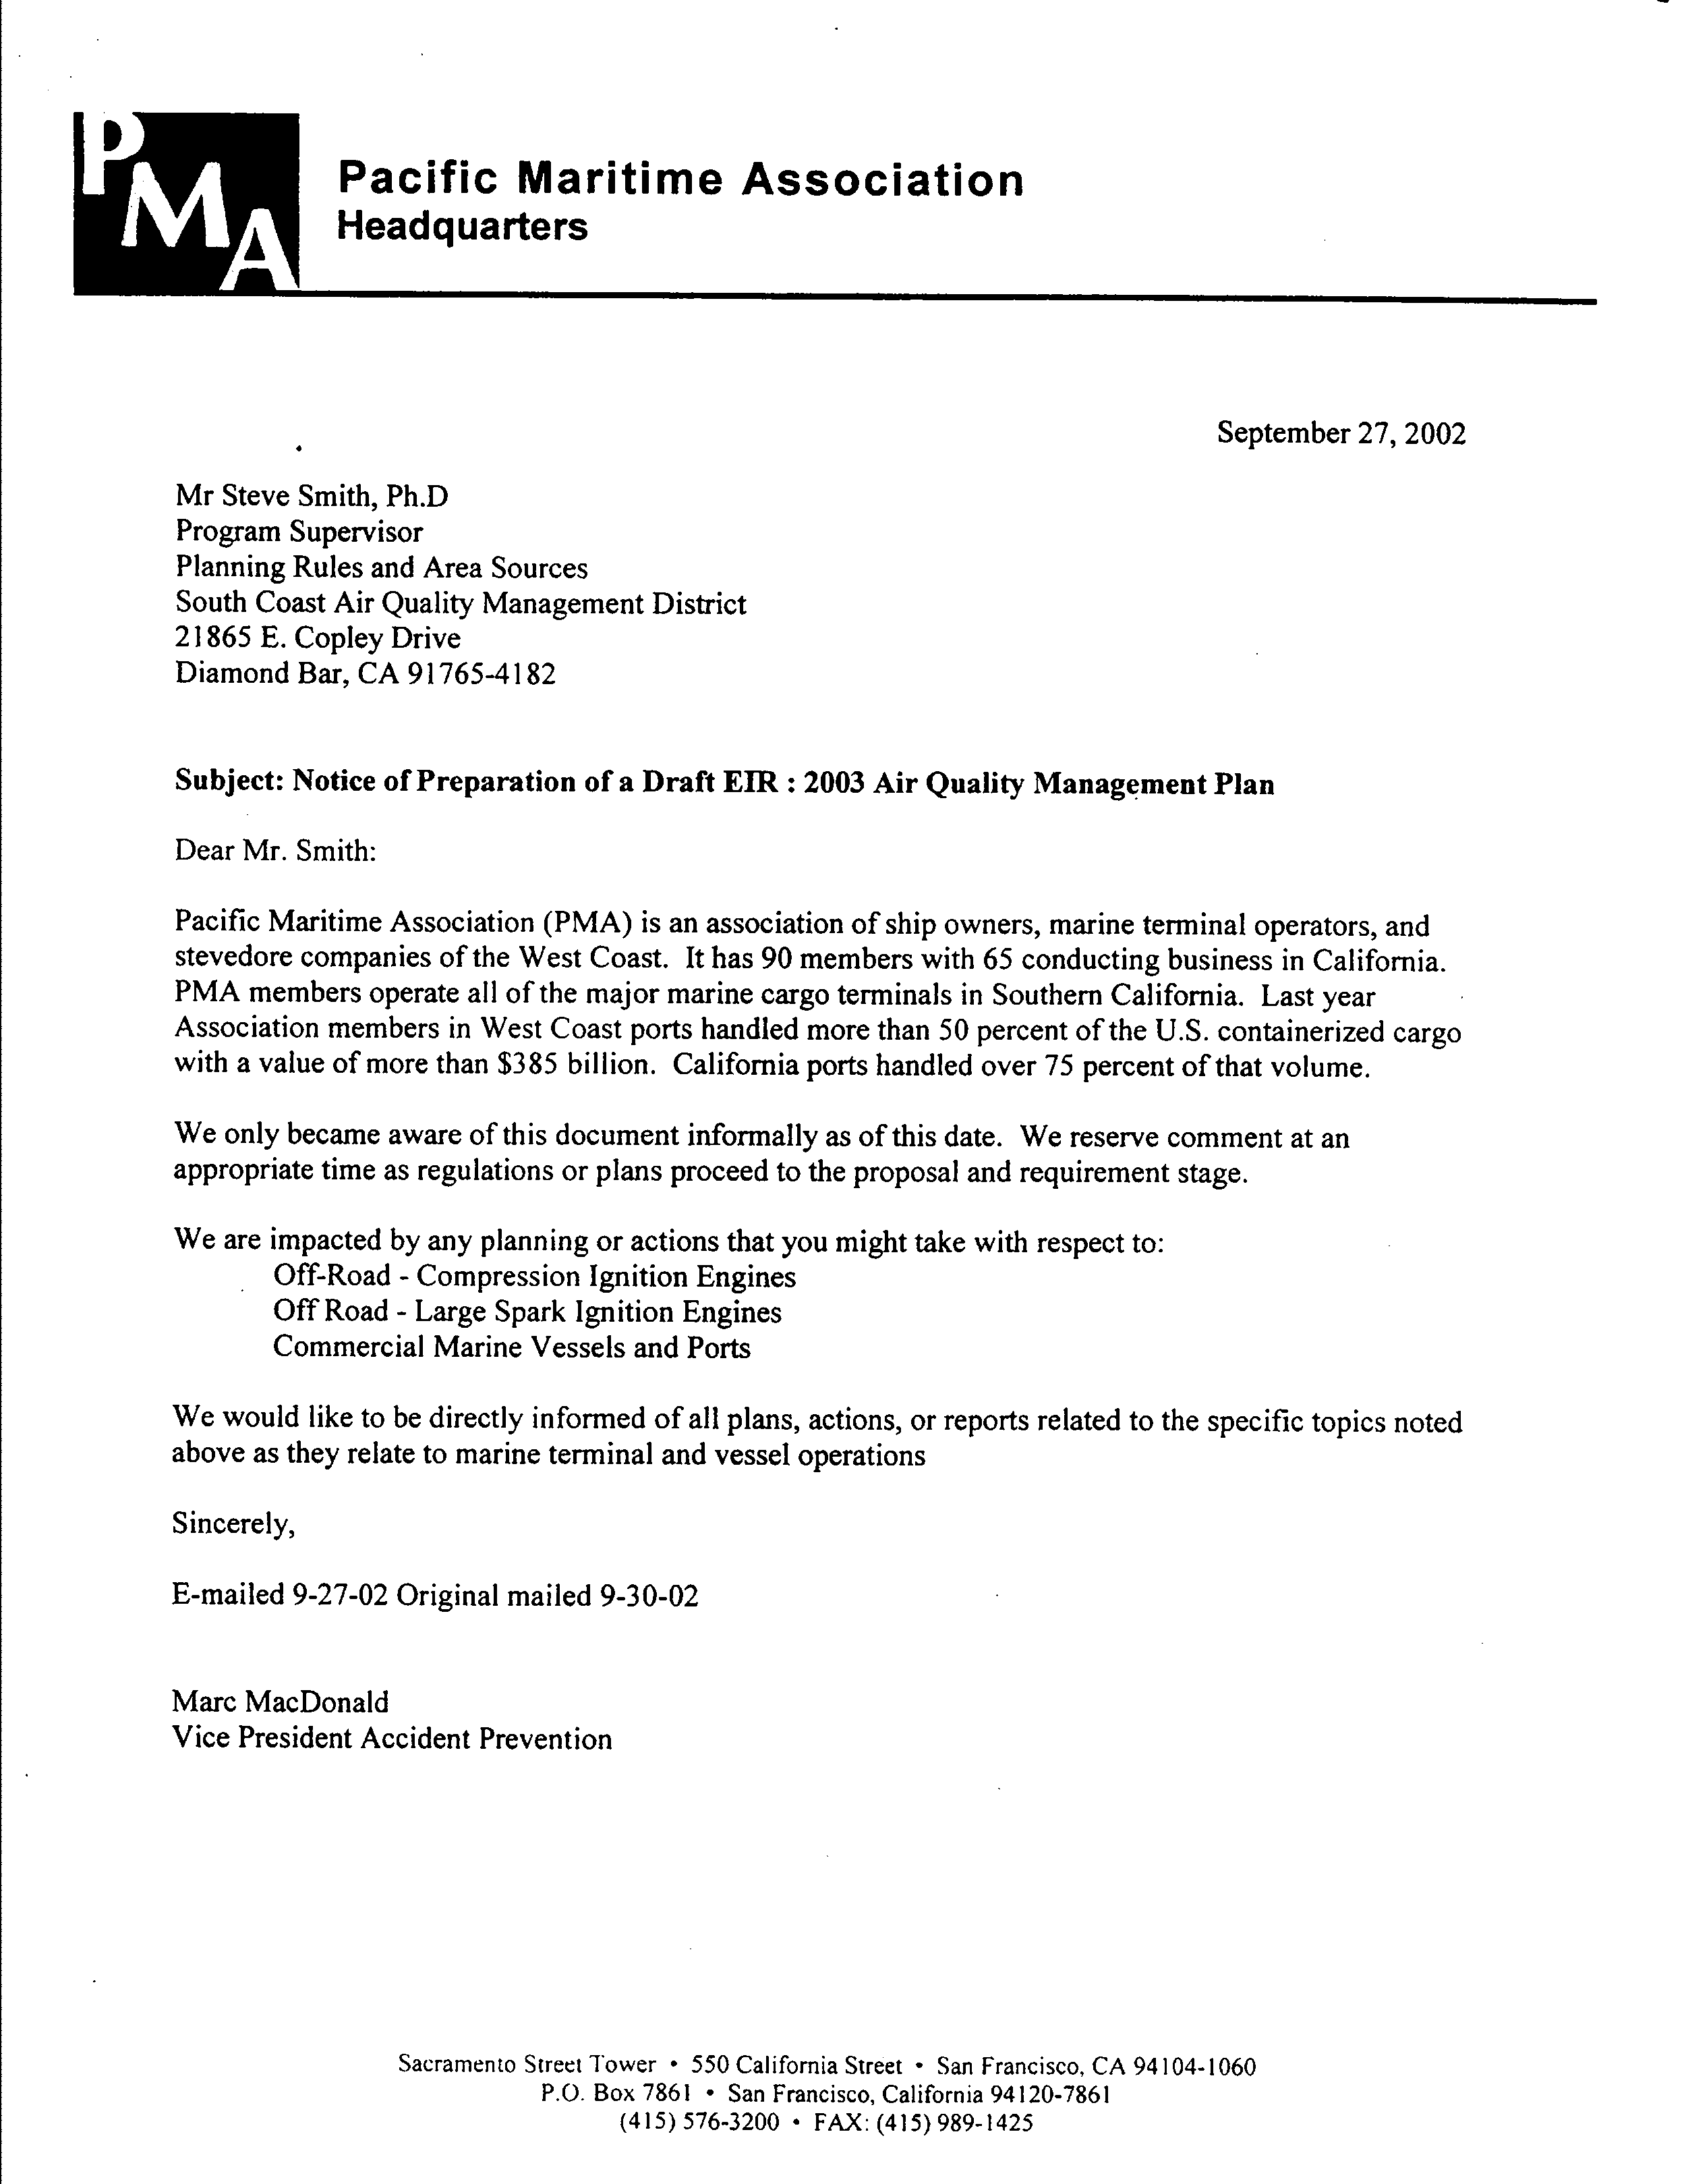
16-1
16-2
COMMENT NO. 16
LETTER FROM THE PACIFIC MARITIME ASSOCIATION

Marc MacDonald
September 27, 2002

Response 16-1

The SCAQMD understands that your association could be impacted by certain control measures in the 2003 AQMP.

Response 16-2

The SCAQMD understands that the Pacific Maritime Association wishes to be notified of all public notices and documents regarding the 2003 AQMP Draft EIR.

