south coast air quality management district

Final Environmental Assessment for:
Proposed Amended Rule 219 - Equipment Not Requiring A Written Permit Pursuant to Regulation II
Proposed Rule 222 - Filing Requirements for Specific Emission Sources Not Requiring a Written Permit Pursuant to Regulation II
Proposed Amended Rule 401 - Visible Emissions
August 14, 1998
SCAQMD No. 980421JDN
Acting Executive Officer
Barry R. Wallerstein, D.Env.
Director
Planning and Policy
Elaine Chang, DrPH
Manager
Planning and Policy
Henry Hogo

Author: Jonathan D. Nadler Air Quality Specialist

Technical Assistance: Cheryl Marshall Assistant Air Quality Specialist
Lisa Mirisola Air Quality Engineer II
Pamela Perryman Air Quality Specialist

Reviewed by: Steve Smith, Ph.D. Program Supervisor
Andrew Lee, PE Senior Air Quality Engineer
Gary Quinn, PE Air Quality Analysis and Compliance Supervisor
Jill Whynot Senior Manager
Jeri Voge Senior Deputy District Counsel
South coast air quality management District

governing board

Chairman: WILLIAM A. BURKE, Ed.D.
Speaker of the Assembly Appointee

Vice Chairman: NORMA J. GLOVER
Councilmember, City of Newport Beach
Cities Representative, Orange County

MEMBERS:

RICHARD ALARCÓN

Councilmember, City of Los Angeles
Cities Representative, Los Angeles County, Western Region

MICHAEL D. ANTONOVICH

Supervisor, Fifth District
Los Angeles County Representative

MEE HAE LEE

Senate Rules Committee Appointee

Ronald O. Loveridge

Mayor, City of Riverside
Cities Representative, Riverside County

JON D. MIKELS

Supervisor, Second District
San Bernardino County Representative

VACANT

Governor's Appointee

LEONARD PAULITZ

Councilmember, City of Montclair
Cities Representative, San Bernardino County

JAMES SILVA

Supervisor, Second District
Orange County Representative

NELL SOTO

Councilmember, City of Pomona
Cities Representative, Los Angeles County, Eastern Region

S. ROY WILSON

Supervisor, Fourth District
Riverside County Representative

ACTING EXECUTIVE OFFICER:

BARRY R. WALLERSTEIN, D.Env.

PREFACE

This document constitutes the Final Environmental Assessment (EA) for proposed amended Rule 219 – Equipment Not Requiring a Written Permit Pursuant to Regulation II, proposed amended Rule 401 – Visible Emissions, and proposed Rule 222 – Filing Requirements for Specific Emission Sources Not Requiring a Written Permit Pursuant to Regulation II. The Draft EA was released for a 30-day review period (July 16 – August 14, 1998). Comments received on the Draft EA and responses to those comments are included in Appendix C. No comments were received which change any of the conclusions reached in the draft document.
Changes from the draft document to the final have been made in italics (additions) and strikethrough (deletions) to facilitate identification. None of the changes alter any conclusions reached in the Draft EA, nor provide new information of substantial importance relative to the environmental analysis.

Table of Contents

Chapter 1 – Executive Summary

Introduction 1-1
Chapter 2 Summary – Project Description 1-1
Chapter 3 Summary – Environmental Assessment 1-2

Chapter 2 – Project Description

Project Location 2-1
Background 2-2
Project Description 2-3

Chapter 3 - Environmental Analysis

Existing Setting 3-1
Potential Environmental Impacts 3-15
Consistency 3-23
Environmental Impacts Found Not to Be Significant 3-24

Appendix A – Initial Study

Appendix B – Proposed Amended Rule 212, Proposed Rule 222, and Proposed
Amended Rule 401

Appendix C – Response to Comments on the Draft Environmental Assessment

List of Figures
Figure 2-1: South Coast Air Quality Management District 2-2

List of TABLES
Table 1-1: Potential Air Quality Effects 1-3
Table 2-1: Summary of Proposal 2-3
Table 3-1: State and Federal Ambient Air Quality Standards 3-2
Table 3-2: 1997 Air Quality Data 3-3
Table 3-3: Potential Air Quality Effects 3-18

C H A P T E R 1

E X EC U T I V E S U M M A R Y

Introduction

Summary of Chapter 2 - Project Description

Summary of Chapter 3 - Environmental Assessment

Introduction
The proposed action considered herein includes amendments to South Coast Air Quality Management District (SCAQMD) Rule 219 - Equipment Not Requiring A Written Permit Pursuant to Regulation II and Rule 401 - Visible Emissions; and adoption of proposed Rule 222 - Filing Requirements for Specific Emission Sources Not Requiring a Written Permit Pursuant to Regulation II. The proposed action is a "project" as defined by the California Environmental Quality Act (CEQA).
CEQA requires that the potential adverse environmental impacts of proposed projects be evaluated and that methods to reduce or avoid identified significant adverse environmental impacts of these projects be implemented if feasible. The purpose of this Draft Environmental Assessment (EA) is to inform the SCAQMD's Governing Board, public agencies, and interested parties of potential adverse environmental impacts that could result from implementing the proposed project.
California Public Resources Code Section 21080.5 allows public agencies with regulatory programs to prepare a plan or other written document in lieu of an environmental impact report once the Secretary of the Resources Agency has certified the regulatory program. The SCAQMD’s regulatory program was certified by the Secretary of the Resources Agency on March 1, 1989, and is codified as SCAQMD Rule 110. Pursuant to Rule 110, SCAQMD has prepared this Draft EA to evaluate potential adverse environmental impacts from amending Rules 219 and 401 and adopting Rule 222.
A document used as a substitute for an EIR or negative declaration in a certified regulatory program must include, in addition to a description of the proposed project, either alternatives to the activity or mitigation measures to avoid or reduce any potentially significant effects, or documentation showing that the proposed project would not have any potentially significant adverse environmental effects and therefore no alternatives or mitigation measures are proposed (CEQA Guidelines §15252).
The initial environmental evaluation of the proposed project indicated that it may result in significant adverse air quality impacts. Therefore, pursuant to the CEQA, a Notice of Preparation of an Environmental Assessment and Initial Study were released for a 30-day public review and comment period. Analysis performed subsequent to the Initial Study and included herein, however, indicates that the adverse effects of the proposed project are below the relevant significance thresholds. Since the analysis shows that the proposed project will not have significant environmental effects, no alternatives or mitigation measures are proposed. Additionally, since the proposed project is not anticipated to result in significant impacts, a 30-day public review period is appropriate for this EA (state CEQA Guidelines §15105).

Summary of Chapter 2 – Project Description
If approved, the proposed project would become effective in the area of the SCAQMD’s jurisdiction, consisting of the four-county South Coast Air Basin (Basin) and the Riverside County portions of the Salton Sea Air Basin (SSAB) and the Mojave Desert Air Basin (MDAB) (both formerly part of the Southeastern Desert Air Basin).
The proposed project consists of amendments to two existing rules and the adoption of one new rule. In general, certain equipment categories would no longer require written SCAQMD permits, though owners/operators of some categories of equipment would still be required to provide to the SCAQMD basic information. Certain other equipment categories would no longer be exempt from permitting requirements. In addition, the opacity standard for uncontrolled under-fired charbroilers used at commercial eating establishments would be modified. See Appendix B for proposed amended Rules 219 and 401 and proposed Rule 222.

Summary of Chapter 3 – Environmental Assessment
The existing air quality setting for the district is presented in Chapter 3. The setting is based on 1997 air quality data.
The only environmental area originally identified that may be adversely affected by the proposed project is air quality. Chapter 3 identifies components of the proposal which have both potentially positive and adverse effects on air quality. Some components may result in forgone future anticipated emission reductions, while some may achieve emission reductions not previously anticipated. Other components of the proposal would not be expected to affect air quality.
Table 1-1 presents the emissions effect of each component of the proposed project. Further discussion, including the assumptions used in determining potential impacts, is presented in Chapter 3. The analysis identifies an initial loss of 98 pounds per day of anticipated future PM10 emission reductions. An additional 10 pounds per day of future PM10 emission reductions are forecasted to be forgone annually from new equipment. The adverse air quality effects are below the relevant threshold and are considered not significant.
Chapter 3 also addresses consistency between the proposed project and relevant regional plans. The proposed project has been determined to be consistent with the relevant regional plans.
TABLE 1-1
Potential Air Quality Effects
Equipment Category | Proposal | Air Quality Effect
Negative Air Machine | Rule 219 exempt equipment  Rule 222 equipment¹ | No Effect
Under-fired Charbroiler | Rule 219 exempt equipment  Rule 222 equipment  Relax opacity standard specified in Rule 401 | 10 pounds per day of future PM10 emission reductions forgone, with an initial 98 pounds PM10 per day loss from pending permits  Speculative unquantifiable PM10 emission reductions may be forgone
Chain-driven Charbroiler | Rule 219 exempt equipment  Rule 222 equipment | No Effect
Specified Cleaning Equipment | Rule 219 exempt equipment | No Effect
Phosphoric Acid Anodizing | Exempt Equipment – Add to Rule 219 | No Effect
Copper Sulfide Plating (Sulfuric Acid) | Exempt Equipment – Add to Rule 219 | No Effect
Laser Sintering of Nylon or Plastic Powder | Exempt Equipment – Add to Rule 219 | No Effect
Ultraviolet/Electron Beam Coating using Low VOC Cleanup Solvents | Exempt Equipment – Add to Rule 219 | No Effect
Rubber Products | Remove from Rule 219 - Written Permit Required | Unquantifiable PM10 emission reductions may be achieved
Wet Gate Printers | Remove from Rule 219 - Written Permit Required | Unquantifiable perchloroethylene emission reductions may be achieved
¹ Those categories of equipment subject to Rule 222 are also included in Rule 219.

C H A P T E R 2

P R O J E C T D E S C R I P T I O N

Project Location

Background

Objective

Project Description

project location
The SCAQMD has jurisdiction over an area of approximately 10,743 square miles (referred to hereafter as the district), consisting of the four-county South Coast Air Basin (Basin) and the Riverside County portions of the Salton Sea Air Basin (SSAB) and the Mojave Desert Air Basin (MDAB) (both formerly part of the Southeastern Desert Air Basin). The Basin, which is a subarea of the district, is bounded by the Pacific Ocean to the west and the San Gabriel, San Bernardino, and San Jacinto Mountains to the north and east. The Basin includes all of Orange County and the nondesert portions of Los Angeles, Riverside, and San Bernardino counties. The Riverside County portions of the SSAB and MDAB are bounded by the San Jacinto Mountains in the west and spans eastward up to the Palo Verde Valley. The federal nonattainment area (known as the Coachella Valley Planning Area) is a subregion of Riverside county and the SSAB that is bounded by the San Jacinto Mountains to the west and the eastern boundary of the Coachella Valley to the east (Figure 2-1).

Figure 2-1
South Coast Air Quality Management District

Background
Historically, the SCAQMD initially concentrated on controlling easily identified, large stationary sources of air pollution and required these large sources to obtain written permits to operate their equipment. Although any process that emits or controls emissions can be required to obtain a written permit to operate, many small sources were not considered to be significant sources of emissions and were exempt from written permit requirements according to Rule 219. In the efforts to achieve state and federal air quality standards, ever smaller sources have been required to control emissions and obtain written permits. The proposed project envisions a different system designed for specific sources to provide basic emissions data to the SCAQMD, without entering the existing permitting system.
As part of this proposal, the project would also consider modifying the SCAQMD’s opacity standard for uncontrolled under-fired charbroilers.

OBJECTIVE
The SCAQMD periodically evaluates small equipment categories to determine their potential to emit. The objective of the proposed project is to reevaluate certain equipment categories and either include or remove them from the Rule 219 list of equipment not requiring a written permit.
Another objective of the proposed project is to relax the opacity restrictions on one category of equipment pending anticipated technological advances which would allow the equipment to meet the existing standard.

Project Description
The proposed project consists of amendments to two existing rules and the adoption of one new rule (Table 2-1). In general, certain equipment categories would no longer require written SCAQMD permits, though some would still be required to provide basic information. Certain other equipment categories would no longer be exempt from permitting. In addition, the opacity standard for uncontrolled under-fired charbroilers used at commercial eating establishments would be modified.
A summary of the proposal is given in the following subsections. See Appendix B for proposed amended Rules 219 and 401 and proposed Rule 222.

TABLE 2-1
Summary of Proposal
Rule | Proposal
219 | Addition and removal of equipment categories requiring a written permit
222 | New administrative rule to gather basic emissions data from certain sources
401 | Relax the opacity requirement for three years for uncontrolled under-fired charbroilers used at commercial eating establishments

Proposed Amended Rule 219
Rule 219 is proposed to be amended to require certain categories of equipment currently exempt from permitting to obtain permits, while certain categories currently requiring permits would now be exempt from that requirement.

Equipment Categories That Would No Longer Require SCAQMD Permits
1. Negative air machines equipped with High Efficiency Particulate Air (HEPA) Filters used to control asbestos emissions from demolition/renovation activities subject to proposed Rule 222;

2. Charbroilers (both under-fired and chain-driven) and associated control equipment subject to proposed Rule 222;

- Equipment used exclusively for surface preparation, passivation, deoxidation, and/or stripping which uses materials containing no more than five percent (50 grams per liter) of VOC by volume (existing Rule 219(l)(4) exempts material containing two percent (20 grams per liter) or less of VOC by volume);

- Unheated, non-conveyorized coating equipment using materials containing no more than five percent (50 grams per liter) of VOC by volume (existing Rule 219(l)(10) exempts material containing two percent (20 grams per liter) or less of VOC by volume);

- Cleaning equipment using only cleaners with a VOC content of 50 grams per liter or less, provided any integrated boiler or heating equipment is exempt pursuant to Rule 219(b)(2), not including any equipment with a capacity more than two gallons (7.6 liters) or any equipment which was designed as a solvent cleaning and drying machine using solvents greater than five percent by weight of perchloroethylene, methylene chloride, carbon tetrachloride, chloroform, 1,1,1-trichloroethane, trichloroethylene, or any combination thereof. (Existing Rule 219 exempts equipment using materials containing two percent (20 grams per liter) or less of VOC by volume).;

- Phosphoric acid anodizing with a bath concentration of 15 percent or less by weight of phosphoric acid and using 20,000 amp hours per day or less of electricity;

- Equipment used exclusively for electrolytic plating using copper sulfide, not greater than four percent by weight, and sulfuric acid, not greater than 20 percent by weight; using 10,000 amp-hours per day or less of electricity;

- Laser sintering equipment used exclusively for the sintering of nylon or plastic powders; and

- Ultraviolet/electron beam (UV/EB) operations which use coatings and cleanup solvents containing 50 grams per liter or less of VOC.

Equipment Categories That Would Require SCAQMD Permits
1. Presses or molds for curing, post curing or forming rubber and composite rubber products processing over 200 pounds or more per day; containing 30 percent or more petroleum extender by weight, and operating at a temperature greater than or equal to 320ºF, and

2. Wet gate printers using perchloroethylene and associated controls.

Proposed Rule 222
Proposed Rule 222 would require operators of specified stationary source equipment to provide emissions information to the SCAQMD and follow standardized operating parameters issued for each source category. The information collected would include a description of the source, data necessary to estimate emissions, and information to determine whether the equipment is operating in compliance with applicable SCAQMD rules.
Charbroilers are currently under consideration for inclusion in proposed Rule 222. Collecting information in a streamlined program pursuant to proposed Rule 222 would exempt charbroilers and associated control equipment from a written permit, but allow the SCAQMD to maintain an emission inventory to facilitate compliance and outreach efforts, and aid future rule development.
Negative air machines are also considered for inclusion in proposed Rule 222. Currently, permits to operate this type of equipment are standardized so consideration of special conditions is not necessary. Information submitted during the permitting process is important for compliance efforts. However, essential information can still be collected without issuing an individual written permit to operate.
Unlike the SCAQMD Annual Emissions Reporting Program which includes all equipment at a facility, the annual compliance checklist for Rule 222 would include only verification of data like company name and address, plus a few questions specific to the equipment subject to Rule 222. The program would offer reduced fees (as set forth in SCAQMD Rule 301) and quicker service to the numerous sources operating these types of equipment. There would also be no emissions based fee associated with Rule 222.

Proposed Amended Rule 401
The proposal would allow charbroilers (excluding chain-driven or those with control equipment) to meet the State’s opacity standard of Ringelmann 2 instead of the SCAQMD’s more stringent standard of Ringelmann 1. Charbroilers in restaurants often do not meet the SCAQMD’s opacity standard, but are expected to be able to meet the state standard. This proposed action is based on the technological and economical unfeasibility to correct an exceedance of Ringelmann 1 standard from under-fired charbroilers. Relaxation of the Ringelmann standard would terminate after three years by which time the SCAQMD anticipates cost-effective control technology for under-fired charbroilers would become available.

C H A P T E R 3

E N V I R O N M E N T A L A S S E S S M E N T

Introduction
Existing Setting
Potential Environmental Impacts
Consistency

existing SETTING
The existing air quality setting for the district is presented below. The setting is based on 1997 air quality data. For a complete discussion of current and projected future air quality in the district, with and without additional control measures, please refer to the Final 1997 AQMP, including its Appendices and the 1997 AQMP Final EIR. In addition, the Final 1997 AQMP EIR contains information on the existing setting for other environmental areas (e.g., water resources, energy, land use, etc.). Copies of the above-referenced documents are available from the SCAQMD's Public Information Center by calling (909) 396-3600.

AIR QUALITY
It is the responsibility of the SCAQMD to ensure that state and federal ambient air quality standards are achieved and maintained. Health-based air quality standards have been established by California and the federal government for the following criteria air pollutants: ozone, carbon monoxide, nitrogen dioxide, particulates, sulfur dioxide, and lead. These standards were established to protect sensitive receptors from adverse health impacts due to exposure to air pollution. The California standards are more stringent than the federal standards and in the case of PM10 and ozone, far more stringent. California has also established standards for sulfate, visibility, hydrogen sulfide and vinyl chloride.
Air quality in the district has shown substantial improvement over the last two decades. Nevertheless, some federal and state air quality standards are still exceeded frequently and by a wide margin. Ozone, CO, and PM10 continue to be the area's most severe air pollution problems. The following subsections briefly summarize air quality in terms of the criteria pollutants identified in Tables 3-1 and 3-2. Table 3-1 lists the ambient air quality standards, while Table 3-2 presents 1997 air quality data for the SCAQMD’s jurisdiction.

Table 3-1
State and Federal Ambient Air Quality Standards
 | STATE STANDARD | FEDERAL PRIMARY STANDARD | most relevant effects
AIR POLLUTANT | CONCENTRATION/  AVERAGING TIME | CONCENTRATION/  AVERAGING TIME
Ozone | 0.09 ppm, 1-hr. avg. > | 0.12 ppm, 1-hr avg.> | (a) Short-term exposures: (1) Pulmonary function decrements and localized lung edema in humans and animals. (2) Risk to public health implied by alterations in pulmonary morphology and host defense in animals; (b) Long-term exposures: Risk to public health implied by altered connective tissue metabolism and altered pulmonary morphology in animals after long-term exposures and pulmonary function decrements in chronically exposed humans; (c) Vegetation damage; (d) Property damage
Carbon Monoxide | 9.0 ppm, 8-hr avg. >  20 ppm, 1-hr avg. > | 9 ppm, 8-hr avg.>  35 ppm, 1-hr avg.> | (a) Aggravation of angina pectoris and other aspects of coronary heart disease; (b) Decreased exercise tolerance in persons with peripheral vascular disease and lung disease; (c) Impairment of central nervous system functions; (d) Possible increased risk to fetuses
Nitrogen Dioxide | 0.25 ppm, 1-hr avg. > | 0.053 ppm, ann. avg.> | (a) Potential to aggravate chronic respiratory disease and respiratory symptoms in sensitive groups; (b) Risk to public health implied by pulmonary and extra-pulmonary biochemical and cellular changes and pulmonary structural changes; (c) Contribution to atmospheric discoloration
Sulfur Dioxide | 0.04 ppm, 24-hr avg.>  0.25 ppm, 1-hr. avg. > | 0.03 ppm, ann. avg.>  0.14 ppm, 24-hr avg.> | (a) Bronchoconstriction accompanied by symptoms which may include wheezing, shortness of breath and chest tightness, during exercise or physical activity in persons with asthma
Suspended Particulate Matter (PM10) | 30 µg/m3, ann. geometric mean >  50 µg/m3, 24-hr average> | 50 µg/m3, annual  arithmetic mean >  150 µg/m3, 24-hr avg.> | (a) Excess deaths from short-term exposures and exacerbation of symptoms in sensitive patients with respiratory disease; (b) Excess seasonal declines in pulmonary function, especially in children
Sulfates | 25 µg/m3, 24-hr avg. >= |  | (a) Decrease in ventilatory function; (b) Aggravation of asthmatic symptoms; (c) Aggravation of cardio-pulmonary disease; (d) Vegetation damage; (e) Degradation of visibility; (f) Property damage
Lead | 1.5 µg/m3, 30-day avg. >= | 1.5 µg/m3, calendar quarter> | (a) Increased body burden; (b) Impairment of blood formation and nerve conduction
Visibility-  Reducing  Particles | In sufficient amount to reduce the visual range to less than 10 miles at relative humidity less than 70%, 8-hour average (10am - 6pm) |  | Visibility impairment on days when relative humidity is less than 70 percent

Table 3-2
1997 Air Quality Data - South Coast Air Quality Management District
Carbon Monoxide
No. Days Standard
Exceeded^{a)}
Federal State
Max. Max. 2nd
Source/ Location No. Conc. Conc. High
Receptor of Days in in Conc. ≤9.5 >9.0 > 20
Area Air Monitoring of ppm ppm ppm ppm ppm ppm
No. Station Data 1-hour 8-hour 8-hour 8-hr. 8-hr. 1-hr
LOS ANGELES COUNTY
1 Central LA 363 9 7.9 6.0 0 0 0
2 NW Coast LA Co 365 7 4.4 4.1 0 0 0
3 SW Coast LA Co 358 12 10.3 8.1 1 1 0
4 S Coast LA Co 365 9 6.7 6.4 0 0 0
6 W Sn Fernan V 362 12 9.8 9.3 1 2 0
7 E Sn Fernan V 353 9 7.4 7.0 0 0 0
8 W Sn Gabrl V 361 8 6.0 5.3 0 0 0
9 E Sn Gabrl V1 356 8 4.3 4.1 0 0 0
9 E Sn Gabrl V2 -- -- -- -- -- -- --
10 Pomona/Wln V1 364 8 5.0 4.9 0 0 0
10 Pomona/Wln V2 -- -- -- -- -- -- --
11 S Sn Gabrl V 346 9 6.2 6.0 0 0 0
12 S Cent LA Co 364 19 17.0 15.0 14 18 0
13 Sta Clarita V 363 7 6.8 6.3 0 0 0
ORANGE COUNTY
16 N Orange Co 361 12 6.0 5.6 0 0 0
17 Cent Orange Co 364 8 5.8 5.6 0 0 0
18 N Coast Orange 364 7 5.8 5.0 0 0 0
19 Saddleback V 365 5 3.6 2.8 0 0 0
RIVERSIDE COUNTY
22 Norco/Corona -- -- -- -- -- -- --
23 Metro Riv Co 1 310* 7* 5.8 5.0* 0* 0* 0*
23 Metro Riv Co 2 364 11 5.0 4.7 0 0 0
24 Perris Valley -- -- -- -- -- -- --
25 Lake Elsinore -- -- -- -- -- -- --
26 Temecula V -- -- -- -- -- -- --
29 San Gorgonio P -- -- -- -- -- -- --
30 Coachella V1** 359 3 1.4 1.4 0 0 0
30 Coachella V2** -- -- -- -- -- -- --
SAN BERNARDINO COUNTY
32 NW SB V -- -- -- -- -- -- --
33 SW SB V -- -- -- -- -- -- --
34 Cent SB V 1 -- -- -- -- -- -- --
34 Cent SB V 2 323* 8* 6.0* 5.4* 0* 0* 0*
35 E SB V -- -- -- -- -- -- --
37 Cent SB Mtns -- -- -- -- -- -- --
ABBREVIATIONS USED IN THE AREA NAMES: LA = Los Angeles, SB = San Bernardino, N = North, S = South, W = West, E = East, V = Valley, P = Pass, Cent = Central
ppm - Parts per million parts of air, by volume.
-- - Pollutant not monitored.
* - Less than 12 full months of data. May not be representative.
** - Salton Sea or Mojave Desert Air Basin
a) - The federal 1-hour standard (1-hour average CO > 35 ppm) was not exceeded.
Table 3-2
1997 Air Quality Data - South Coast Air Quality Management District
Ozone
No. Days Standard
Exceeded^{a)}
Federal State
Max. Max.
Source/ Location No. Conc. Conc.
Receptor of Days in in >0.12 >0.08 > 0.09
Area Air Monitoring of ppm ppm ppm ppm ppm
No. Station Data 1-hour 8-hour 1-hr. 8-hr. 1-hr
LOS ANGELES COUNTY
1 Central LA 365 0.12 0.09 0 3 6
2 NW Coast LA Co 365 0.11 0.09 0 2 6
3 SW Coast LA Co 364 0.11 0.09 0 3 6
4 S Coast LA Co 365 0.10 0.07 0 0 1
6 W Sn Fernan V 365 0.12 0.10 0 3 12
7 E Sn Fernan V 355 0.13 0.11 2 6 15
8 W Sn Gabrl V 365 0.14 0.11 5 16 24
9 E Sn Gabrl V1 357 0.16 0.12 11 18 42
9 E Sn Gabrl V2 365 0.17 0.13 18 26 67
10 Pomona/Wln V1 364 0.16 0.12 7 10 30
10 Pomona/Wln V2 -- -- -- -- -- --
11 S Sn Gabrl V 355 0.13 0.10 6 7 18
12 S Cent LA Co 359 0.08 0.07 0 0 0
13 Sta Clarita V 365 0.16 0.13 13 27 54
ORANGE COUNTY
16 N Orange Co 365 0.13 0.10 1 3 9
17 Cent Orange Co 363 0.10 0.09 0 1 1
- N Coast Orange 365 0.10 0.08 0 0 1
- Saddleback V 365 0.13 0.10 2 2 8
RIVERSIDE COUNTY
22 Norco/Corona -- -- -- -- -- --
23 Metro Riv Co 1 326* 0.19* 0.13* 13* 55* 89*
23 Metro Riv Co 2 332 -- -- -- -- --
24 Perris Valley 360 0.14 0.11 6 41 64
25 Lake Elsinore 356 0.16 0.12 4 38 49
26 Temecula V 118* 0.10* 0.09* 0* 1* 3*
29 San Gorgonio P 365 0.13 0.10 2 9 34
30 Coachella V 1** 339* 0.16* 0.12* 4* 31* 45*
30 Coachella V 2** 365 0.11 0.09 0 2 3
SAN BERNARDINO COUNTY
32 NW SB V 361 0.19 0.13 12 30 69
33 SW SB V -- -- -- -- -- --
34 Cent SB V 1 365 0.17 0.13 10 33 65
34 Cent SB V 2 365 0.20 0.14 32 65 102
35 E SB V 363 0.20 0.14 35 79 108
37 Cent SB Mtns 351 0.21 0.14 29 74 92
ABBREVIATIONS USED IN THE AREA NAMES: LA = Los Angeles, SB = San Bernardino, N = North, S = South, W = West, E = East, V = Valley, P = Pass, Cent = Central
ppm - Parts per million parts of air, by volume.
-- - Pollutant not monitored.
* - Less than 12 full months of data. May not be representative.
** - Salton Sea or Majave Desert Air Basin.
Table 3-2
1997 Air Quality Data - South Coast Air Quality Management District
Nitrogen Dioxide
Average
Compared to No. Days
Federal Std. Exc'd
Standard^{b)} State
Max.
Source/ Location No. Conc.
Receptor of Days in AAM > .25
Area Air Monitoring of ppm in ppm
No. Station Data 1-hour ppm 1-hour

LOS ANGELES COUNTY
1 Central LA 342 0.20 0.0430 0
2 NW Coast LA Co 365 0.14 0.0285 0
3 SW Coast LA Co 355 0.17 0.0280 0
4 S Coast LA Co 364 0.20 0.0333 0
6 W Sn Fernan V 365 0.20 0.0260 0
7 E Sn Fernan V 343 0.20 0.0424 0
8 W Sn Gabrl V 360 0.17 0.0341 0
9 E Sn Gabrl V 1 356 0.16 0.0338 0
9 E Sn Gabrl V 2 365 0.13 0.0300 0
10 Pomona/Wln V 1 364 0.15 0.0433 0
10 Pomona/Wln V 2 -- -- -- --
11 S Sn Gabrl V 351 0.15 0.0363 0
12 S Cent LA Co 344 0.20 0.0428 0
13 Sta Clarita V -- -- -- --
ORANGE COUNTY
16 N Orange Co 361 0.15 0.0329 0
17 Cent Orange Co 363 0.13 0.0332 0
18 N Coast Orange 362 0.12 0.0199 0
19 Saddleback V -- -- -- --
RIVERSIDE COUNTY
22 Norco/Corona -- -- -- --
23 Metro Riv Co 1 322* 0.12* 0.0262* 0*
23 Metro Riv Co 2 -- -- -- --
24 Perris Valley -- -- -- --
25 Lake Elsinore 308* 0.11* 0.0165* 0*
26 Temecula V -- -- -- --
29 San Gorgonio P -- -- -- --
30 Coachella V 1** 312* 0.07* 0.0158* 0*
30 Coachella V 2** -- -- -- --
SAN BERNARDINO COUNTY
32 NW SB V 327* 0.15* 0.0341* 0*
33 SW SB V -- -- -- --
34 Cent SB V 1 347 0.14 0.0365 0
34 Cent SB V 2 347 0.14 0.0353 0
35 E SB V -- -- -- --
37 Cent SB Mtns -- -- -- --
ABBREVIATIONS USED IN THE AREA NAMES: LA = Los Angeles, SB = San Bernardino, N = North, S = South, W = West, E = East, V = Valley, P = Pass, Cent = Central
ppm - Parts per million parts of air, by volume.
AAM - Annual arithmetic mean.
-- - Pollutant not monitored.
* - Less than 12 full months of data. May not be representative.
** - Salton Sea or Majave Desert Air Basin.
b) - The federal standard is annual arithmetic mean NO² greater than 0.0534 ppm. No location exceeded this standard.
Table 3-2
1997 Air Quality Data - South Coast Air Quality Management District
Sulfur Dioxide
Average
Compared
to Federal
Max. Max. Standard^{d)}
Source/ Location No. Conc. Conc.
Receptor of Days in in AAM
Area Air Monitoring of ppm ppm in
No. Station Data 1-hour^{c)} 24-hour ^{c)} ppm
LOS ANGELES COUNTY
1 Central LA 365 0.02 0.011 0.0007
2 NW Coast LA Co -- -- -- --
3 SW Coast LA Co 364 0.10 0.015 0.0014
4 S Coast LA Co 365 0.04 0.011 0.0024
6 W Sn Fernan V -- -- -- --
7 E Sn Fernan V 323* 0.04* 0.008* 0.0003*
8 W Sn Gabrl V -- -- -- --
9 E Sn Gabrl V 1 -- -- -- --
9 E Sn Gabrl V 2 -- -- -- --
10 Pomona/Wln V 1 -- -- -- --
10 Pomona/Wln V 2 -- -- -- --
11 S Sn Gabrl V -- -- -- --
12 S Cent LA Co -- -- -- --
13 Sta Clarita V -- -- -- --
ORANGE COUNTY
16 N Orange Co -- -- -- --
17 Cent Orange Co -- -- -- --
18 N Coast Orange 365 0.03 0.010 0.0003
19 Saddleback V -- -- -- --
RIVERSIDE COUNTY
22 Norco/Corona -- -- -- --
23 Metro Riv Co 1 333* 0.04* 0.007* 0.0003*
23 Metro Riv Co 2 -- -- -- --
24 Perris Valley -- -- -- --
25 Lake Elsinore -- -- -- --
26 Temecula V -- -- -- --
29 San Gorgonio P -- -- -- --
30 Coachella V 1** -- -- -- --
30 Coachella V 2** -- -- -- --
SAN BERNARDINO COUNTY
32 NW SB V -- -- -- --
33 SW SB V -- -- -- --
34 Cent SB V 1 365 0.01 0.001 0.0000
34 Cent SB V 2 -- -- -- --
35 E SB V -- -- -- --
37 Cent SB Mtns -- -- -- --
ABBREVIATIONS USED IN THE AREA NAMES: LA = Los Angeles, SB = San Bernardino, N = North, S = South, W = West, E = East, V = Valley, P = Pass, Cent = Central
ppm - Parts per million parts of air, by volume. AAM - Annual arithmetic mean.
* - Less than 12 full months of data. -- - Pollutant not monitored.
May not be representative. ** - Salton Sea or Majave Desert Air Basin.
c) - The federal standard standard is annual arithmetic mean SO² greater than 80 μg/m3 (0.03 ppm). No . location exceeded this standard. The other federal standards (3-hour haverage > 0.50 ppm, and 24-hour average > 0.14 ppm) were not exceeded either.
d) - The other state standard (24-hour average > 0.04 ppm) was not exceeded either.
Table 3-2
1997 Air Quality Data - South Coast Air Quality Management District
Suspended Particulates PM10^{e)}
No. (%) Samples
Exceeding Annual
Standard Averages^{g)}
Source/ Location No. Max. Federal State
Receptor of Days Conc. AAM AGM
Area Air Monitoring of in µg/m3 >150 µg/m3 >50 µg/m3 Conc. Conc.
No. Station Data 24-hour 24-hour 24-hour µg/m3 µg/m3
LOS ANGELES COUNTY
1 Central LA 60 102 0 15(25.0) 42.5 39.2
2 NW Coast LA Co -- -- -- -- -- --
3 SW Coast LA Co 55* 79* 0* 4(7.3)* 35.5* 33.8*
4 S Coast LA Co 57 87 0 10(17.5)* 40.5 38.2
6 W Sn Fernan V -- -- -- -- -- --
7 E Sn Fernan V 56* 92* 0* 17(30.4)* 44.8* 41.9*
8 W Sn Gabrl V -- -- -- -- -- --
9 E Sn Gabrl V 1 60 116 0 24(40.0) 45.9 40.8
9 E Sn Gabrl V 2 -- -- -- -- -- --
10 Pomona/Wln V 1 -- -- -- -- -- --
10 Pomona/Wln V 2 34* 67* 0* 6(17.6)* 39.6* 38.0*
11 S Sn Gabrl V -- -- -- -- -- --
12 S Cent LA Co -- -- -- -- -- --
13 Sta Clarita V 59 67 0 5(8.5) 32.9 30.5
ORANGE COUNTY
16 N Orange Co -- -- -- -- -- --
17 Cent Orange Co 60 91 0 11(18.3) 38.9 36.3
18 N Coast Orange -- -- -- -- -- --
19 Saddleback V 56* 86* 0* 4(7.1)* 34.5* 32.5*
RIVERSIDE COUNTY
22 Norco/Corona 60 158 1(1.7) 25(41.7) 49.6 44.2
23 Metro Riv Co 1 59 163 1(1.7) 41(69.5) 64.9 56.3
23 Metro Riv Co 2 -- -- -- -- -- --
24 Perris Valley 60 139 0 19(31.7) 44.5 38.5
25 Lake Elsinore -- -- -- -- -- --
26 Temecula V -- -- -- -- -- --
29 San Gorgonio P 57 227 1(1.8) 14(24.6) 38.2 30.1
30 Coachella V 1** 59 63 0 1(1.8) 26.4 23.6
30 Coachella V 2** 54* 144*^{i)} 0^{* i)} 23(42.6)* ^{i)} 49.1* ^{i)} 44.2* ^{i)}
SAN BERNARDINO COUNTY
32 NW SB V -- -- -- -- -- --
33 SW SB V 59 208 1(1.7) 21(35.6) 51.3 44.8
34 Cent SB V 1 61 122 0 29(47.5) 53.7 47.6
34 Cent SB V 2 60 108 0 27(45.0) 51.4 45.6
35 E SB V 60 103 0 23(38.3) 43.2 35.4
37 Cent SB Mtns 58 47 0 0 23.8 20.8
ABBREVIATIONS USED IN THE AREA NAMES: LA = Los Angeles, SB = San Bernardino, N = North, S = South, W = West, E = East, V = Valley, P = Pass, Cent = Central
µg/m3 - Micrograms per cubic meter of air.
AAM - Annual arithmetic mean. AGM - Annual geometric mean.
-- - Pollutant not monitored.
* - Less than 12 full months of data. May not be representative.
** - Salton Sea or Majave Desert Air Basin.
e) - PM10 samples were collected every 6 days using the size-selective inlet high volume sampler with quartz filter media
g) - Federal PM10 standard is AAM > 50 µg/m3; state standard is AGM > 30 µg/m3
i) - The data for the two samples collected on high-wind-days (157 µg/m3 on 3/17/97 and 182 µg/m3 on 4/28/97) were excluded according to the EPA’s Natural Events Policy.
Table 3-2
1997 Air Quality Data - South Coast Air Quality Management District
Particulates TSP^{f)}
Annual
Averages
Source/ Location No. Max.
Receptor of Days Conc. AAM
Area Air Monitoring of in µg/m3 Conc.
No. Station Data 24-hour µg/m 3
LOS ANGELES COUNTY
1 Central LA 61 154 70.0
2 NW Coast LA Co 56* 98* 50.2*
3 SW Coast LA Co 52* 122* 56.7*
4 S Coast LA Co 60 117 60.3
6 W Sn Fernan V -- -- --
7 E Sn Fernan V -- -- --
8 W Sn Gabrl V 60 106 51.6
9 E Sn Gabrl V 1 57 195 90.7
9 E Sn Gabrl V 2 -- -- --
10 Pomona/Wln V 1 -- -- --
10 Pomona/Wln V 2 -- -- --
11 S Sn Gabrl V 56* 124* 79.0*
12 S Cent LA Co 55* 163* 86.4*
13 Sta Clarita V -- -- --
ORANGE COUNTY
16 N Orange Co -- -- --
17 Cent Orange Co -- -- --
18 N Coast Orange -- -- --
19 Saddleback V -- -- --
RIVERSIDE COUNTY
22 Norco/Corona -- -- --
23 Metro Riv Co 1 59 495 122.4
23 Metro Riv Co 2 62 155 80.1
24 Perris Valley -- -- --
25 Lake Elsinore -- -- --
26 Temecula V -- -- --
29 San Gorgonio P -- -- --
30 Coachella V 1** -- -- --
30 Coachella V 2** -- -- --
SAN BERNARDINO COUNTY
32 NW SB V 61 159 69.3
33 SW SB V -- -- --
34 Cent SB V 1 60 212 99.8
34 Cent SB V 2 60 182 96.1
35 E SB V -- -- --
37 Cent SB Mtns -- -- --
µg/m3 - Micrograms per cubic meter of air.
AAM - Annual arithmetic mean. AGM - Annual geometric mean.
-- - Pollutant not monitored.
* - Less than 12 full months of data. May not be representative.
** - Salton Sea or Majave Desert Air Basin.
f) - Total supended particulates, lead, and sulfate were determined from samples collected every 6 days by the high volume sampler method, on glass fiber filter media. Federal TSP standard superseded by PM10 standard, July 1, 1987.
Table 3-2
1997 Air Quality Data - South Coast Air Quality Management District
Lead^{f)}
Quarters/Months
Exceeding
Standard^{h)}
Source/ Location Max. Max. Federal State
Receptor of Mo. Qtrly.
Area Air Monitoring Conc. Conc. >1.5 µg/m3 >=1.5 µg/m3
No. Station µg/m3 µg/m3 Qtrly. Avg. Mo. Avg.
LOS ANGELES COUNTY
1 Central LA .0.07 0.07 0 0
2 NW Coast LA Co -- -- -- --
3 SW Coast LA Co 0.06* 0.05* 0* 0*
4 S Coast LA Co 0.05 0.03 0 0
6 W SN Fernan V -- -- -- --
7 E Sn Fernan V -- -- -- --
8 W Sn Gabrl V -- -- -- --
9 E Sn Gabrl V 1 -- -- -- --
9 E Sn Gabrl V 2 -- -- -- --
10 Pomona/Wln V 1 -- -- -- --
10 Pomona/Wln V 2 -- -- -- --
11 S Sn Gabrl V 0.08* 0.06* 0* 0*
12 S Cent LA Co 0.07* 0.07* 0* 0*
13 Sta Clarita V -- -- -- --
ORANGE COUNTY
16 N Orange Co -- -- -- --
17 Cent Orange Co -- -- -- --
18 N Coast Orange -- -- -- --
19 Saddleback V -- -- -- --
RIVERSIDE COUNTY
22 Norco/Corona -- -- -- --
23 Metro Riv Co 1 0.07 0.04 0 0
23 Metro Riv Co 2 0.07 0.04 0 0
24 Perris Valley -- -- -- --
25 Lake Elsinore -- -- -- --
26 Temecula V -- -- -- --
29 San Gorgonio P -- -- -- --
30 Coachella V 1** -- -- -- --
30 Coachella V 2** -- -- -- --
SAN BERNARDINO COUNTY
32 NW SB V 0.04 0.04 0 0
33 SW SB V -- -- -- --
34 Cent SB V 1 -- -- -- --
34 Cent SB V 2 0.04* 0.04* 0* 0*
35 E SB V -- -- -- --
37 Cent SB Mtns -- -- -- --
µg/m3 - Micrograms per cubic meter of air.
-- - Pollutant not monitored.
* - Less than 12 full months of data. May not be representative.
** - Salton Sea or Majave Desert Air Basin.
f) - Total supended particulates, lead, and sulfate were determined from samples collected every 6 days by the high lume sampler method, on glass fiber filter media. Federal TSP standard superseded by M10 standard, July 1, 1987.
h) - Special monitoring immediately downwind of stationary sources of lead was carried out at several locations in 1996. The maximum monthly average concentration was 1.82 µg/m3 and the maximum quarterly average concentration was 0.71 µg/m3 , both recorded in Area 5, Southeast Los Angeles County.
Table 3-2
1997 Air Quality Data - South Coast Air Quality Management District
Sulfate^{f)}
No. (%) Samples
Exceeding
Standard
Source/ Location Max. State
Receptor of Conc.
Area Air Monitoring in µg/m3 >=25 µg/m3
No. Station 24-hour 24-hour
LOS ANGELES COUNTY
1 Central LA 14.3 0
2 NW Coast LA Co 14.0* 0*
3 SW Coast LA Co 14.4* 0*
4 S Coast LA Co 11.4 0
6 W Sn Fernan V -- --
7 E Sn Fernan V -- --
8 W Sn Gabrl V 11.6* 0
9 E Sn Gabrl V 1 12.7* 0*
9 E Sn Gabrl V 2 -- --
10 Pomona/Wln V 1 -- --
10 Pomona/Wln V 2 -- --
11 S Sn Gabrl V 13.1* 0*
12 S Cent LA Co 11.4* 0*
13 Sta Clarita V -- --
ORANGE COUNTY
16 N Orange Co -- --
17 Cent Orange Co -- --
18 N Coast Orange -- --
19 Saddleback V -- --
RIVERSIDE COUNTY
22 Norco/Corona -- --
23 Metro Riv Co 1 13.1 0
23 Metro Riv Co 2 10.4 0
24 Perris Valley -- --
25 Lake Elsinore -- --
26 Temecula V -- --
29 San Gorgonio P -- --
30 Coachella V 1** -- --
30 Coachella V 2** -- --
SAN BERNARDINO COUNTY
32 NW SB V 9.7 0
33 SW SB V -- --
34 Cent SB V 1 10.2 0
34 Cent SB V 2 9.1 0
35 E SB V -- --
37 Cent SB Mtns -- --
µg/m3 - Micrograms per cubic meter of air.
-- - Pollutant not monitored.
* - Less than 12 full months of data. May not be representative.
** - Salton Sea or Majave Desert Air Basin.
f) - Total supended particulates, lead, and sulfate were determined from samples collected every 6 days
by the high volume sampler method, on glass fiber filter media. Federal TSP standard superseded by
PM10 standard, July 1, 1987.

Air Quality and Health Effects

Ozone
Unlike primary criteria pollutants that are emitted directly from an emission source, ozone is a secondary pollutant. It is formed in the atmosphere through a photochemical reaction of VOC, NO_{x}, and other hydrocarbon materials with sunlight. Ozone is a deep lung irritant, causing air passages to become inflamed and swollen. Exposure to ozone produces alterations in respiration, the most characteristic of which is shallow, rapid breathing and a decrease in pulmonary performance. Ozone reduces the respiratory system's ability to fight infection and to remove foreign particles. People who suffer from respiratory diseases such as asthma, emphysema, and chronic bronchitis are more sensitive to ozone's effects. In severe cases, ozone is capable of causing death from pulmonary edema. Early studies suggested that long-term exposure to ozone results in adverse effects on morphology and function of the lung and acceleration of lung-tumor formation and aging. Ozone exposure also increases the sensitivity of the lung to bronchoconstrictive agents such as histamine, acetylcholine, and allergens.
The federal ozone air quality standard is exceeded far more frequently in the district than any other area in the United States. Ozone levels exceeded the federal standard by the widest margin compared to other criteria pollutants, with a maximum concentration in 1997 that was 175 percent of the standard. Ozone concentrations exceeded the state standard at all but one monitored locations in 1997.
In 1997, the USEPA new federal air quality standards for ozone. The ARB and local air districts will be developing State Implementation Plans (SIP) to reduce unhealthful levels of ozone in areas violating the new federal standard. California has previously developed a SIP for the current ozone standard. The new federal ozone air quality standard will be analyzed in the 2000 AQMP. A new SIP will be prepared by 2003.

Carbon Monoxide
CO is a colorless, odorless gas formed by the incomplete combustion of fuels. CO competes with oxygen, often replacing it in the blood, thus reducing the blood's ability to transport oxygen to vital organs in the body. The ambient air quality standard for carbon monoxide is intended to protect persons whose medical condition already compromises their circulatory system's ability to deliver oxygen. These medical conditions include certain heart ailments, chronic lung diseases, and anemia. Persons with these conditions have reduced exercise capacity even when exposed to relatively low levels of CO. Fetuses are at risk because their blood has an even greater affinity to bind with CO. Smokers are also at risk from ambient CO levels because smoking increases the background level of CO in their blood.
The CO standard was monitored at 20 locations in 1997. The federal and state 8-hour CO standards were each exceeded at three locations. Source/Receptor Area No. 12, South Central Los Angeles County, reported by far the greatest number of the exceedances of the federal and state CO standards (14 and 18 days, respectively) in 1997.

Nitrogen Dioxide
Nitrogen dioxide (NO₂) is a brownish gas that is formed in the atmosphere through a rapid reaction of the colorless gas nitric oxide (NO) with atmospheric oxygen. NO and NO₂ are collectively referred to as NO_{x}. NO₂ can cause health effects in sensitive population groups such as children and people with chronic lung diseases. It can cause respiratory irritation and constriction of the airways, making breathing more difficult. Asthmatics are especially sensitive to these effects. People with asthma and chronic bronchitis may also experience headaches, wheezing and chest tightness at high ambient levels of NO₂. NO₂ is suspected to reduce resistance to infection, especially in young children.
NO_{x} emissions not only contribute to elevated ozone and NO₂ levels, but they also play an important role in PM10 formation, visibility degradation, and acid deposition, including acid fogs which have been shown to occur in the Basin (Winer, 1988). NO₂ is also a precursor to numerous other compounds which may result in adverse health effects. These effects include ammonium nitrate particles, which are the major components of secondary respirable particulates, peroxyacetyl nitrate (PAN), nitrosamines, nitropolycyclic aromatic hydrocarbons (nitro-PAH), and other toxic compounds. Laboratory evidence indicates that none of the preceding compounds are emitted directly from combustion sources; they are formed in the atmosphere from reactions involving NO_{x} emissions from man-made combustion sources.
NO_{x} emissions typically result from the incomplete combustion of fuels. Sources include passenger vehicles and freight vehicles, residential and recreational sources, manufacturing sources, petroleum production/marketing sources, electric power generation, and other miscellaneous commercial industries. Mobile sources represent approximately 84 percent of all NO_{x} emissions. The 1997 AQMP includes control measures to reduce NO_{x} emissions from both stationary and mobile sources.
By 1991, exceedances of the federal standard were limited to one location in Los Angeles County. The Basin is the only area in the United States classified as nonattainment for the federal NO₂ standard. No location in the area of SCAQMD’s jurisdiction exceeded the federal standard from 1992 to present. The state NO₂ standard has been met each year since 1994. Despite declining NO_{x} emissions over the last decade, further NO_{x} emissions reductions are necessary because NO_{x} is a PM10 and ozone precursor.

Particulate Matter (PM10)
PM10 is defined as suspended particulate matter 10 microns or less in diameter and includes a complex mixture of man-made and natural substances including sulfates, nitrates, metals, elemental carbon, sea salt, soil, organics and other materials. PM10 may have adverse health impacts because these microscopic particles are able to penetrate deeply into the respiratory system. In some cases, the particulates themselves may cause actual damage to the alveoli of the lungs or they may contain adsorbed substances that are injurious. Children can experience a decline in lung function and an increase in respiratory symptoms from PM10 exposure. People with influenza, chronic respiratory disease and cardiovascular disease can be at risk of aggravated illness from exposure to fine particles. Increases in death rates have been statistically linked to corresponding increases in PM10 levels.
In areas close to major sources, particulate concentrations are generally higher in the winter when more fuel is burned and meteorological conditions favor the build-up of directly-emitted particulates. In areas remote from major sources but subject to photochemical smog and dry, dust-producing conditions, particulate concentrations are higher during summer months.
In 1997, PM10 was monitored at 20 locations. The federal 24-hour standard was exceeded at four locations, and the state 24-hour standard was exceeded at 19 locations.
In 1997, the USEPA established new federal air quality standards for PM2.5. The PM2.5 standards complement existing federal and state standards that target the full range of inhalable PM10. Efforts to characterize PM2.5 and comply with the federal standards will provide further progress towards attaining California’s own PM10 standards. The ARB and local air districts will be developing SIPs to reduce unhealthful levels of PM2.5 in areas violating the new federal standards. These standards will be analyzed in the 2000 AQMP. A new SIP for PM2.5 will be prepared by 2006.

Sulfur Dioxide
Sulfur dioxide (SO₂) is a colorless, pungent gas formed primarily by the combustion of sulfur-containing fossil fuels. Health effects include acute respiratory symptoms and difficulty in breathing for children. Though SO₂ concentrations have been reduced to levels well below state and federal standards, further reductions in SO₂ emissions are needed because SO₂ is a precursor to sulfate and PM10.

Sulfates
Sulfates are a group of chemical compounds containing the sulfate group, which is a sulfur atom with four oxygen atoms attached. Though not exceeded in 1993, 1996, and 1997, the state sulfate standard was exceeded at three locations in 1994 and one location in 1995. There are no federal air quality standards for sulfate.

Lead
Lead concentrations once exceeded the state and federal air quality standards by a wide margin, but have not exceeded state or federal standards at any regular monitoring station since 1982. Though special monitoring sites immediately downwind of lead sources recorded very localized violations of the state standard in 1994, no violations were recorded at these stations since that time.

Visibility
Since deterioration of visibility is one of the most obvious manifestations of air pollution and plays a major role in the public’s perception of air quality, the state of California has adopted a standard for visibility or visual range. Until 1989, the standard was based on visibility estimates made by human observers. The standard was changed to require measurement of visual range using instruments that measure light scattering and absorption by suspended particles.
It has been determined that the calibration of the instruments used to measure visibility was faulty, and no reliable data is available for 1997.

Volatile Organic Compounds (VOC)
It should be noted that there are no state or federal ambient air quality standards for VOCs because they are not classified as criteria pollutants. VOCs are regulated, however, because a reduction in VOC emissions reduces certain chemical reactions which contribute to the formation of ozone. VOCs are also transformed into organic aerosols in the atmosphere, contributing to higher PM10 and lower visibility levels.
Although health-based standards have not been established for VOCs, health effects can occur from exposures to high concentrations of VOC because of interference with oxygen uptake. In general, ambient VOC concentrations in the atmosphere are suspected to cause coughing, sneezing, headaches, weakness, laryngitis, and bronchitis, even at low concentrations. Some hydrocarbon components classified as VOC emissions are thought or known to be hazardous. Benzene, for example, one hydrocarbon component of VOC emissions, is known to be a human carcinogen.

Potential ENVIRONMENTAL IMPACTS

CEQA Requirements
CEQA Guidelines require environmental documents to identify and focus on the significant adverse environmental effects that may result from a proposed project [CEQA Guidelines Section 15126(a)]. If significant adverse environmental impacts are identified, CEQA requires a discussion of measures that could either avoid or reduce those impacts to the greatest extent feasible [CEQA Guidelines Section 15126(c)].
The CEQA Guidelines recognize that the degree of specificity required in a CEQA document will depend on the type of project being proposed (CEQA Guidelines Section 15146). It is recognized that the detail of the environmental analysis for certain types of projects cannot be as great as for other types of projects. CEQA also recognizes that the identification of potential environmental impacts for proposed projects requires a degree of forecasting. CEQA Guidelines, Section 15144, states "while foreseeing the unforeseeable is not possible, an agency must use its best efforts to find out and disclose all that it reasonably can."
Environmental topics in a CEQA document that are evaluated for adverse impacts from a proposed project are established by the California Environmental Quality Act, Public Resources Code, Section 21000 et seq., and the state CEQA Guidelines as promulgated by the Secretary for Resources. The CEQA Guidelines recommend an analysis of impacts from a project for approximately 15 environmental categories. Projects are evaluated against these environmental impact categories in an Initial Study. Those environmental categories that could be adversely affected by the proposed project, based upon a preliminary analysis in the Initial Study (Environmental Checklist), are carried forward for analysis in the draft and final environmental document.
A Notice of Preparation and Initial Study, which includes an environmental checklist, was prepared for the proposed project and can be found in Appendix A of this document. Of the 15 potential environmental impact categories, only air quality was originally determined to be potentially adversely affected by the implementation of the proposed amendments. The following sections discuss how air quality may be affected by the proposed project.

Air Quality Impacts

Significance Criteria for Air Quality
The project will be considered to have a significant impact on the environment if emissions associated with the proposal:
- are greater than the daily emission significance thresholds established by the SCAQMD in the CEQA Air Quality Handbook (SCAQMD November 1993). The daily significance thresholds are as follows: 55 pounds of VOC; 55 pounds of NO_{x}; 550 pounds of CO; 150 pounds of PM10; and 150 pounds of SO_{x}.
- violate or make a substantial contribution to an existing or projected exceedance of an air quality standard.
- are toxic air contaminants that exceed a maximum individual cancer risk of 10 in one million (10 x 10⁻⁶).
- result in hazardous air pollutant emissions from a source which results in a hazard index greater than 1.0.
- result in hazardous air pollutant emissions from a source which results in a facility-wide hazard index greater than 5.0.

Analysis of Potential Air Quality Impacts
PROJECT-SPECIFIC IMPACTS: The proposal includes components which are anticipated to have both potentially positive and adverse effects on air quality. Some effects of the proposed project include forgoing future anticipated emission reductions, while other effects may include achieving emission reductions not previously anticipated. Other components of the proposal would not be expected to affect air quality. A detailed description of the potential emission effects of the proposed project are provided in the following paragraphs.
It should be noted that the proposed amendments to Rule 219 and proposed Rule 222 would not in themselves have air quality impacts, but rather would affect the applicability of SCAQMD Regulation XIII - New Source Review (NSR), to the equipment categories in question. Regulation XIII specifies “best available control technology” (BACT) and emissions offset requirements for new, modified, or relocated sources. BACT is not required for equipment which emits one pound per day or less of any criteria pollutant. State NSR provisions require a “no net increase” in emissions from new, modified, or relocated emission sources. Thus, the proposed project may indirectly affect future air quality due to the changes in the equipment categories subject to Regulation XIII.
The potential adverse effect on future air quality is calculated by forecasting the number of new equipment which would have been subject to BACT and offset requirements if the proposed project was not implemented. Future emission reductions forgone would then be calculated based on emission reductions that would have otherwise occurred if BACT had been installed or emission offsets had been acquired. Conversely, the potential positive air quality effect is calculated by forecasting the number of new equipment and emission reductions expected to occur as a result of installing BACT and obtaining offsets if the proposed project is implemented.
It should be noted that BACT has not yet been specified for some of the equipment categories proposed to be added to Rule 219. Further, some of the operations associated with the equipment categories proposed to be added to Rule 219 emit less than one pound of emissions per day and, thereby, are exempt from the Regulation XIII requirements for BACT and offsets. Removing such equipment from the permit system and NSR review would have no affect on emissions.
Table 3-3 presents the emissions effect of each component of the proposed project.
Table 3-3
Potential Air Quality Effects
Equipment Category | Proposal | Air Quality Effect
Negative Air Machine | Rule 219 exempt equipment  Rule 222 equipment¹ | No Effect
Under-fired Charbroiler | Rule 219 exempt equipment  Rule 222 equipment  Relax opacity standard specified in Rule 401 | 10 pounds per day of future PM10 emission reductions forgone, with an initial 98 pounds PM10 per day loss from pending permit applications  Speculative unquantifiable PM10 emission reductions may be forgone
Chain-driven Charbroiler | Rule 219 exempt equipment  Rule 222 equipment | No Effect
Specified Cleaning Equipment | Exempt Equipment – Add to Rule 219 | No Effect
Phosphoric Acid Anodizing | Exempt Equipment – Add to Rule 219 | No Effect
Copper Sulfide Plating (Sulfuric Acid) | Exempt Equipment – Add to Rule 219 | No Effect
Laser Sintering of Nylon or Plastic Powder | Exempt Equipment – Add to Rule 219 | No Effect
UV/EB Coatings using Low VOC Cleanup Solvents | Exempt Equipment – Add to Rule 219 | No Effect
Rubber Products | Remove from Rule 219 - Written Permit Required | Unquantifiable PM10 emission reductions may be achieved
Wet Gate Printers | Remove from Rule 219 - Written Permit Required | Unquantifiable perchloroethylene emission reductions may be achieved
¹ Those categories of equipment subject to Rule 222 are also included in Rule 219.

The following provides information regarding the potential air quality impact of each equipment category included in the proposed project.
Negative Air Machines
Negative air machines are a control device used to remove asbestos emissions from residential or commercial abatement projects by passing asbestos containing air from an isolated work area by means of negative air pressure to a high efficiency particulate air (HEPA) filtration system. HEPA means a high efficiency particulate air filter which is capable of trapping and retaining at least 99.97 percent of all monodispersed particles of 0.3 micrometer in diameter or larger.
There are no emissions from negative air machines. Thus, permits to operate this type of equipment are standardized so consideration of special permit conditions is not necessary. Exempting negative air machines from written permits would have no effect on emissions or emission reductions. Furthermore, parameters for the operation of this equipment are specified in Rule 1403 – Asbestos Emissions from Demolition/Renovation Activities. Applicable sources must continue to comply with Rule 1403 whether or not a written permit is required.
Charbroilers
Charbroilers can be characterized as either under-fired or chain-driven. Chain-driven (conveyorized) charbroilers have conveyor belts to carry the meat through the flame area. They may also have a belt to carry buns through the appliance. Typically, flames broil the meat on the top and bottom simultaneously. Most chain-driven charbroilers burn natural gas. This equipment normally produces lower PM and VOC emissions than under-fired charbroilers.
Under-fired charbroilers consist of three main components: a heating source, a high temperature radiant surface, and a slotted grill. The grill holds the meat or other food while exposing it to the radiant heat. When grease from the meat falls onto the high temperature radiant surface, both PM and VOC emissions occur. Most under-fired charbroilers burn natural gas; however, solid fuels, such as charcoal or wood with or without the addition of ceramic stones are sometimes used. This category includes broilers, grill charbroilers, flamebroilers, and direct-fired barbecues.
During the December 1996 amendment to Rule 219, a request was made to exempt all charbroilers from written permit. Evaluation of this request was placed on hold, pending development of Rule 1138 - Control of Emissions from Restaurant Operations. Recently adopted Rule 1138 partially implements Control Measure PRC-03 of the 1997 AQMP by requiring installation of catalysts or equivalent controls or methods on chain-driven charbroilers. Cost-effective controls for the vast majority of under-fired charbroilers have not yet been identified. Rule 1138 contains language committing the SCAQMD to further rule development and the pursuit of emission reductions from under-fired charbroilers and potentially other commercial restaurant cooking equipment. The SCAQMD is currently performing research to identify a cost-effective control technology suitable for use on under-fired charbroilers, through a contract with University of California at Riverside, College of Engineering, Center for Environmental Research and Technology (CE-CERT).
Incorporating charbroilers into Rule 219 would remove this equipment category from the NSR requirements specified in Regulation XIII. As discussed above, the NSR review process is used, in part, to determine BACT and offset requirements for new, modified, or relocated permit units which emit greater than one pound per day of any criteria pollutant.
It has been determined that a charbroiler cooking 125 pounds of meat per day results in one pound of PM10 emissions. Therefore, the adverse air quality effects of exempting charbroilers from written permits (and thus NSR review) would be the loss of future emission reductions associated with the application of BACT for those charbroilers cooking greater than 125 pounds of meat per day. Removing charbroilers from the NSR process and its offset requirement would not, however, result in adverse air quality impacts. Individual permit units equipped with BACT emit less than one pound per day and, thus, are currently exempt from the offset requirement.
BACT for chain-driven charbroilers is catalytic oxidization. SCAQMD Rule 1138 requires the use of this equipment, thus, compliance with the rule means compliance with the BACT requirement in Regulation XIII. As discussed above, each permit unit emits less than one pound per day and is exempt from the Regulation XIII offset requirement. Considering that chain-driven charbroilers require the use of BACT regardless of NSR and do not currently require offsets, incorporating this equipment into Rule 219 will have no adverse effect on air quality.
There are currently pending approximately 100 permit applications for under-fired charbroilers cooking greater than 125 pounds of meat per day. These charbroilers each cook approximately of 200 pounds of meat per day, each generating an estimated 1.4 pounds of PM10 emissions per day (one pound of cooked meat produces 0.007 pounds of PM10 emissions) which is 140 pounds of PM10 per day in total. BACT for this equipment (i.e., electrostatic precipitator) is estimated to reduce emissions by 70 percent. Therefore, the emission reductions which would be forgone from the 100 units as a result of incorporating them into Rule 219 (and thereby removing the Regulation XIII BACT) requirement would be approximately 98 pounds per day.
In addition to the pending permit applications, it is assumed that the SCAQMD receives approximately 10 applications per year for under-fired charbroilers cooking greater than 125 pounds of meat per day. Assuming each unit cooks 200 pounds of meat per day, ten units would produce approximately 14 pounds of PM10 per day. Assuming a BACT efficiency of 70 percent, additional annual forgone emission reductions would be approximately 10 pounds of PM10 per day.
It should again be noted that no individual under-fired charbroiler would be required to offset emissions after application of BACT since Regulation XIII requires offsets only for emissions greater than one pound per day. After application of BACT, the emissions from each unit would be approximately 0.42 pounds of PM10 per day (1.4 pounds PM10 per unit per day x 0.3 = 0.42 pounds per day).
In summary, the PM10 emission reductions conservatively estimated to be forgone by the proposal to incorporate charbroilers into Rule 219 are an initial 98 pounds per day, with a projected additional 10 pounds per day forgone per year from new equipment. These forgone emission reductions are not significant since they are below the applicable PM10 significance threshold of 150 pounds per day.
Though considered insignificant, the potentially forgone emission reductions would be accounted for in the attainment strategy set forth in the 2000 AQMP. It is also anticipated that Rule 1138 be amended to control emissions from under-fired charbroilers when appropriate control technology is identified.
It should also be noted that the since the initial listing of electrostatic precipitators as BACT for under-fired charbroilers, several issues have been raised which make this equipment infeasible for this industry. These issues are: safety (three fires), excess maintenance problems, lower actual control efficiency than initially cited, excessive, cost to small businesses, and restrictive permitting from city entities due to safety issues. Though the use of ESP for under-fired charbroilers is concluded to be infeasible by SCAQMD staff, and no satisfactory control equipment has yet been identified, the air quality analysis herein conservatively considers an exemption from the Regulation XIII BACT requirement to be a relaxation of a standard and the emission reductions associated with the control equipment to be forgone.
Solvent Cleaning Equipment
Rule 1122 - Solvent Degreasers, and Rule 1171 - Solvent Cleaning Operations, were amended to specify a maximum solvent VOC content limit of 50 grams per liter (g/l), a reduction to the solvent content limits previously set forth in the rules. It was determined during each rule amendment process that 50 g/l is the lowest reliably detectable VOC concentration based on existing test methods.
Prior to the detailed research conducted during promulgation of Rules 1122 and 1171, it was assumed that a VOC concentration of 20 g/l was detectable. It is for this reason Rule 219 currently exempts from written permits equipment which uses materials with a VOC content of 20 g/l or less. The current proposal would better reflect the accuracy of measuring low VOC concentrations and would achieve consistency between the rules by changing the Rule 219 exemption level to 50 g/l.
In theory, the potential adverse impact associated with this proposal would be the loss of future emission reductions due to the exemption from NSR review (i.e., BACT and offsets) of that equipment using cleaning materials with a VOC content between 20 and 50 g/l. It is expected, however, that there would be no actual emissions reduction loss as a result of the proposed action for the following reasons. Since current VOC detection methodology is reliable only to 50 g/l, the accuracy of data below 50 g/l may be questioned. Furthermore, SCAQMD planning inventories are based on the 50 g/l limits in Rules 1122 and 1171, not the 20 g/l limit listed in Rule 219.
Phosphoric Acid Anodizing
Incorporating this equipment category into Rule 219 as proposed would mean that Regulation XIII requirements would no longer be applicable. However, the emissions associated with phosphoric acid anodizing with a bath concentration of 15 percent or less by weight of phosphoric acid and using 20,000 amp-hours per day or less of electricity are estimated to be below that which requires BACT and offsets.
Because emissions are not expected to trigger BACT and offset requirements, this component of the proposal is not expected to increase emissions or adversely affect air quality.
Copper Sulfide Plating Using Sulfuric Acid
The emissions associated with electrolytic plating using copper sulfide and sulfuric acid not greater than four and 20 percent by weight, respectively, using 10,000 amp-hours per day or less of electricity are estimated to be below that which requires BACT and offsets. Thus, incorporating this equipment category into Rule 219 is not expected to adversely affect air quality for the same reasons identified for phosphoric acid anodizing.
Laser Sintering Equipment for Nylon or Plastic Powders
Laser sintering of nylon or plastic powders has been observed by SCAQMD staff to have essentially no emissions. Consequently, BACT has not been established for this equipment category, offsets have never been required, and its incorporation into Rule 219 would not affect emissions.
Ultraviolet/Electron Beam Coatings using Low VOC Cleanup Solvents
Rule 219 currently exempts from permit requirements ultraviolet/electron beam coating (UV/EB) equipment where the total amount of coatings, adhesives and/or, organic solvent (including cleanup) used in such equipment are six gallons per day or less. The Rule 219 exemption for this equipment is proposed to be extended to include an unlimited amount of coating if low VOC cleanup solvents (i.e., 50 grams of VOC per liter or less) are used.
UV/EB coatings are intrinsically low in VOCs. The VOC content of the solvents used in the cleaning process of these operations, however, tends to be quite high. The proposed amendment would have a beneficial environmental effect if it encourages the use of low VOC cleanup solvents by owners or operators of UV/EB equipment.
Wet Gate Printers
Wet gate printers would be incorporated into the permit system and, thus, would be subject to Regulation XIII. An estimate of the perchloroethylene emission reduction benefit of this component of the proposed project cannot be estimated at this time.
Since this category of equipment is not currently subject to Regulation XIII, permits are not required and BACT has not been established. Potential secondary adverse effects which may accrue from control of the emissions from this equipment, if any, cannot be appraised at this time as the type of control has not yet been determined.
Rubber Presses or Molds
Presses or molds used for curing, post curing or forming rubber products and composite rubber products processing greater than 200 pounds per day, containing greater than 30 percent petroleum extender by weight , and operating at lower than 320ºF would be incorporated into the permit system and thereby subject to Regulation XIII.
As with wet gate printers, the emission reduction benefit of this component of the proposed project and the potential for secondary adverse environmental effects cannot be estimated at this time.
Proposed Amended Rule 401
The proposal would allow charbroilers (excluding chain-driven or those with control equipment) to meet the State’s opacity standard of Ringelmann 2 instead of the SCAQMD’s more stringent standard of Ringelmann 1. Charbroilers in restaurants often do not meet the SCAQMD’s opacity standard, but could meet the state standard. This action is proposed since it is technologically and economically infeasible to correct an exceedance of Ringelmann 1 standard from under-fired charbroilers. Relaxation of the Ringelmann standard would terminate after three years.
The air quality effects of temporarily relaxing the opacity standard are unknown. Studies conducted by CE-CERT and the U.S Environmental Protection Agency have shown no correlation between opacity and emissions (i.e., PM10). Thus, any adverse air quality impact assumed by this component of the proposal would be considered speculative and is not discussed further.
Project-Specific Impact Summary
The SCAQMD finds that the proposed project could result in an initial loss of 98 pounds per day of anticipated PM10 emission reductions, with an additional 10 pounds per day of PM10 emission reductions annually forgone thereafter. This potential air quality impact is below the established 150 pound per day PM10 significance threshold and is not considered significant.
PROJECT-SPECIFIC MITIGATION: None required.
CUMULATIVE IMPACTS: The proposed amendments were evaluated with regard to their potential for contributing to significant adverse cumulative impacts. Since the proposed project does not generate significant adverse project-specific impacts, it is anticipated that the proposed project will not contribute to significant adverse cumulative impacts. The reason for this conclusion is that in addition to the rules and regulations currently being enforced to reduce emissions of both criteria pollutants and toxic air contaminants, there are numerous control measures included in the 1997 AQMP which will further reduce emissions in the future. This conclusion is consistent with the conclusion regarding cumulative air quality impacts contained in the 1997 AQMP Final EIR. Furthermore, the attainment strategy in the 2000 AQMP would account for any adverse emission effects of the proposed project. Additionally, a commitment was made during the development of Rule 1138 to amend the rule to reduce emissions associated with under-fired charbroilers when a cost-effective control technology is identified.
CUMULATIVE IMPACTS MITIGATION: None required.

consistency
The Southern California Association of Governments (SCAG) and the SCAQMD have developed guidance on how to assess consistency within the existing general development planning process in the district. Pursuant to the development and adoption of its Regional Comprehensive Plan Guide (RCPG), SCAG has developed an Intergovernmental Review Procedures Handbook (June 1, 1995). The SCAQMD also adopted criteria for assessing consistency with regional plans and the AQMP in its CEQA Air Quality Handbook (Handbook). The following paragraphs address consistency between the proposed project and relevant regional plans pursuant to the SCAG Handbook and SCAQMD Handbook.
The RCPG provides the primary reference for SCAG’s project review activity. The RCPG serves as a regional framework for decision making for the growth and change that is anticipated during the next 20 years and beyond. The Growth Management Chapter (GMC) of the RCPG contains population, housing, and jobs forecasts, which are adopted by SCAG’s Regional Council and reflect local plans and policies. These forecasts are used by SCAG in all phases of implementation and review for consistency of projects in its six county area. There is nothing contained in the proposed project that would be inconsistent with the goals and findings of the RCPG.
SCAG’s Growth Management goals are to develop urban forms that enable individuals to spend less income on housing cost, that minimize public and private development costs, and that enable firms to be more competitive, strengthen the regional strategic goal to stimulate the regional economy. The proposed project will not interfere with the achievement of such goals, nor would it interfere with any powers exercised by local land use agencies. In fact, the proposed project may enhance the regional economy because it would result in a reduced regulatory burden on industry.
The Growth Management goals also include attaining mobility and clean air goals and developing urban forms that enhance quality of life, accommodate a diversity of life styles, preserve open space and natural resources, are aesthetically pleasing, preserve the character of communities, and enhance the regional strategic goal of maintaining the regional quality of life. The proposed project would not interfere with any of these goals in any way.

environmental impacts found not to be significant
A Notice of Preparation of a Draft Environmental Assessment and an Initial Study were previously made available for a 30-day public review period. The Initial Study, included herein as Appendix A, analyzed 15 environmental categories. Of the 15 potential environmental impact categories, only air quality was determined to be potentially affected by the implementation of the proposed project. No comment letters were received on analysis contained in the Initial Study.
The reader is referred to Appendix A for the discussion of the following environmental areas relative to the proposed project:
- Land Use and Planning | - Noise
- Population and Housing | - Public Services
- Geophysical | - Solid or Hazardous Waste
- Water | - Aesthetics
- Transportation/Circulation | - Cultural Resources
- Biological Resources | - Recreation
- Energy and Mineral Resources | - Economics

A P P E N D I X A

I N I T I A L S T U D Y

south coast air quality management district

Initial Study for: Proposed Amended Rule 219 - Equipment Not Requiring A Written Permit Pursuant to Regulation II; Proposed Rule 222 - Filing Requirements for Specific Emission Sources Not Requiring a Written Permit Pursuant to Regulation II; Proposed Rule 312 - Filing Fees for Sources Subject to Rule 222, and Proposed Amended Rule 401 - Visible Emissions

April 21, 1998
SCAQMD No. 980421JDN

Acting Executive Officer
Barry R. Wallerstein, D.Env.
Director
Planning and Policy
Elaine Chang, Dr. PH
Manager
Planning and Policy
Henry Hogo

Author: Jonathan D. Nadler Air Quality Specialist

Technical Assistance: Lisa Mirisola Air Quality Engineer II

Reviewed by: Steve Smith, Ph.D. Program Supervisor
Andrew Y. Lee, P.E. Senior Air Quality Engineer
Gary Quinn, P.E. Air Quality Analysis & Compliance Supervisor
Jeri Voge Senior Deputy District Counsel
South coast air quality management District
governing board

Chairman: WILLIAM A. BURKE, Ed.D.
Speaker of the Assembly Appointee

Vice Chairman: NORMA J. GLOVER
Councilmember, City of Newport Beach
Cities Representative, Orange County

MEMBERS:

RICHARD ALARCÓN
Councilmember, City of Los Angeles
Cities Representative, Los Angeles County, Western Region

MICHAEL D. ANTONOVICH
Supervisor, Fifth District
Los Angeles County Representative

MEE HAE LEE
Senate Rules Committee Appointee

Ronald O. Loveridge
Mayor, City of Riverside
Cities Representative, Riverside County

JON D. MIKELS
Supervisor, Second District
San Bernardino County Representative

WAYNE NASTRI
Governor's Appointee

LEONARD PAULITZ
Councilmember, City of Montclair
Cities Representative, San Bernardino County

JAMES SILVA
Supervisor, Second District
Orange County Representative

NELL SOTO
Councilmember, City of Pomona
Cities Representative, Los Angeles County, Eastern Region

S. ROY WILSON
Supervisor, Fourth District
Riverside County Representative

ACTING EXECUTIVE OFFICER:

BARRY R. WALLERSTEIN, D.Env.

Table of Contents

Chapter 1 - Project Description

Introduction 1-1
Project Location 1-1
Background 1-2
Project Description 1-3
Alternatives 1-8
Initial Environmental Evaluation 1-9

Chapter 2 - Environmental Checklist Form

Introduction 2-1
General Information 2-1
Potentially Significant Impact Areas 2-1
Determination 2-2
Environmental Checklist and Discussion 2-3

List of Figures
Figure 1-1: South Coast Air Quality Management District 1-2

List of TABLES
Table 1-1: Summary of Proposal 1-3
Table 2-1: Potential Air Quality Effects 2-7

C H A P T E R 1

P R O J E C T D E S C R I P T I O N

Introduction
Project Location
Background
Project Description
Alternatives
Initial Environmental Evaluation

Introduction
The proposed action considered herein includes amendments to South Coast Air Quality Management District (SCAQMD) Rule 219 - Equipment Not Requiring A Written Permit Pursuant to Regulation II, and Rule 401 - Visible Emissions; and adoption of proposed Rule 222 - Filing Requirements for Specific Emission Sources Not Requiring a Written Permit Pursuant to Regulation II, and proposed Rule 312 - Filing Fees for Sources Subject to Rule 222. The proposed action is a "project" as defined by the California Environmental Quality Act (CEQA). California Public Resources Code Section 21080.5 allows public agencies with regulatory programs to prepare a plan or other written document in lieu of an environmental impact report once the Secretary of the Resources Agency has certified the regulatory program. The AQMD’s regulatory program was certified by the Secretary of the Resources Agency on March 1, 1989, and is codified as SCAQMD Rule 110. Pursuant to Rule 110 (the rule which implements the SCAQMD's certified regulatory program), SCAQMD will prepare a Draft Environmental Assessment (EA) to evaluate potential adverse impacts from amending Rules 219 and 401 and adopting Rules 222 and 312.
CEQA requires that the potential adverse environmental impacts of proposed projects be evaluated and that methods to reduce or avoid identified significant adverse environmental impacts of these projects be implemented if feasible. The purpose of the Draft EA is to inform the SCAQMD's Governing Board, public agencies, and interested parties of potential adverse environmental impacts that could result from implementing the proposed project.
This Initial Study is intended to provide information about the proposed project to other public agencies and interested parties prior to the release of the Draft EA. The Initial Study is being released for a 30-day review period. Written comments on the scope of the environmental analysis and possible project alternatives received by the SCAQMD during the 30-day review period will be considered when preparing the Draft EA.

Project Location
The SCAQMD has jurisdiction over an area of 10,473 square miles (referred to hereafter as the district), consisting of the four-county South Coast Air Basin (Basin) and the Riverside County portions of the Salton Sea Air Basin (SSAB) and the Mojave Desert Air Basin (MDAB). The Basin, which is a subarea of the district, is bounded by the Pacific Ocean to the west and the San Gabriel, San Bernardino, and San Jacinto Mountains to the north and east. The 6,745 square mile Basin includes all of Orange County and the nondesert portions of Los Angeles, Riverside, and San Bernardino counties. The Riverside County portion of the SSAB and MDAB is bounded by the San Jacinto Mountains in the west and spans eastward up to the Palo Verde Valley. The federal nonattainment area (known as the Coachella Valley Planning Area) is a subregion of both Riverside County and the SSAB and is bounded by the San Jacinto Mountains to the west and the eastern boundary of the Coachella Valley to the east (Figure 1-1).
Figure 1-1
South Coast Air Quality Management District

Background and objective
The SCAQMD initially concentrated on controlling easily identified, large stationary sources of air pollution and required these large sources to obtain written permits to operate their equipment. Although any process that emits or controls emissions can be required to obtain a written permit to operate, many small sources were not considered to be significant sources of emissions and were exempt from written permit requirements according to Rule 219. In the goal to achieve state and federal air quality standards, ever smaller sources have been required to control emissions and obtain written permits. Several attempts have been and continue to be made to streamline the SCAQMD’s permitting process and help small businesses obtain permits to operate their equipment. The proposed project envisions a different system designed for specific sources to provide basic emissions data to the SCAQMD, without entering the existing permitting system.

As part of this proposal, the project would also consider modifying the SCAQMD’s opacity standard for under-fired charbroilers.

Project Description
The proposed project consists of amendments to two existing rules and the adoption of two new rules (Table 1-1). In general, certain equipment categories would no longer require SCAQMD permits, though some would still be required to provide basic data information. Certain other equipment categories would no longer be exempt from permitting. In addition, the opacity standard for uncontrolled under-fired charbroilers used at commercial eating establishments would be modified.
TABLE 1-1
Summary of Proposal
Rule | Proposal
219 | Addition and removal of equipment categories requiring a written permit
222 | New administrative rule to gather basic emissions data from certain sources
312ª | New administrative rule to collect fees for sources subject to Rule 222
401 | Temporarily change opacity requirement from Ringelmann 1 to Ringelmann 2 for uncontrolled under-fired charbroilers used at commercial eating establishments

ª Propose Rule 312 may be included as part of a separate fee-related rulemaking effort. In that event, appropriate CEQA documentation will be prepared (fee-related rules are typically exempt from CEQA pursuant to CEQA Guidelines § 15273).

Proposed Amended Rule 219
Rule 219 is proposed to be amended to require certain categories of equipment currently exempt from permitting to obtain permits, while certain categories currently requiring permits would now be exempt from that requirement.

Equipment Categories That Would No Longer Require SCAQMD Permits
1. Negative air machines equipped with High Efficiency Particulate Air (HEPA) Filters used to control asbestos emissions from demolition/renovation activities;

2. Charbroilers (both under-fired and chain-driven) and associated control equipment subject to proposed Rule 222;

3. Equipment used exclusively for surface preparation, passivation, deoxidation, and/or stripping which uses materials containing no more than five percent (50 grams per liter) of VOC by volume (existing Rule 219 exempts material containing two percent (20 grams per liter) or less of VOC by volume);

4. Cleaning equipment using only cleaners with a VOC content of 50 grams per liter or less, not including any equipment with a capacity more than two gallons (7.6 liters) or any equipment which was designed as a solvent cleaning and drying machine using solvents greater than five percent by weight of perchloroethylene, methylene chloride, carbon tetrachloride, chloroform, 1,1,1-trichloroethane, trichloroethylene, or any combination thereof;

5. Phosphoric acid anodizing; and

6. Copper sulfide plating using sulfuric acid.

Equipment Categories That Would Require SCAQMD Permits
1. Presses or molds for curing, post curing or forming rubber and composite rubber products processing over 200 pounds per day; and

2. Hand lay, brush and roll up resin operations conducted outside control enclosures, using more than three gallons per day of material, including cleanup solvents.

Proposed Rule 222
Proposed Rule 222 would require operators of specified emission sources to provide emissions information to the SCAQMD and follow standardized operating parameters issued for each source category. The information collected would include a description of the source, data necessary to estimate emissions, and information to determine whether the equipment is operating in compliance with applicable SCAQMD rules.

Equipment included in Proposed Rule 222 would be limited to specified sources, which could include small sources at facilities subject to Regulation XX - RECLAIM or Regulation XXX - Title V Permits, if the sources are not listed on the facility permit.

Charbroilers are currently under consideration for inclusion in proposed Rule 222. During the amendment process for the December 1996 amendment to Rule 219, a request was made to exempt all charbroilers from written permit. Evaluation of this request was delayed, pending development of Rule 1138 - Control of Emissions from Restaurant Operations. Recently adopted Rule 1138 partially implements Control Measure PRC-03 of the 1997 Air Quality Management Plan to require installation of cost-effective catalysts or equivalent controls or methods on chain-driven charbroilers. However, cost-effective controls for the vast majority of under-fired charbroilers have not yet been identified, pending results from additional research in progress. Rule 1138 contains language committing the SCAQMD to further rule development and the pursuit of emission reductions from under-fired charbroilers and potentially other commercial restaurant cooking equipment.

For equity, both under-fired charbroilers and chain-driven charbroilers would be included in proposed Rule 222. Collecting information in a streamlined program pursuant to proposed Rule 222 would exempt charbroilers and associated control equipment from a written permit, but allow the SCAQMD to maintain an emission inventory to facilitate compliance and outreach efforts, and aid future rule development.

Negative air machines would also be considered for inclusion in proposed Rule 222. Currently, permits to operate this type of equipment are very standardized and no individual evaluation of the equipment is done. Information submitted during the permitting process is important for compliance efforts. However, essential information can still be collected without issuing an individual written permit to operate.

Standardized operating parameters would be issued by source category, instead of on an individual basis. Criteria for Enforceable Procedures would be included in Rule 222, although the actual procedures would be contained in companion documents.

Unlike the SCAQMD Annual Emissions Reporting Program which includes all equipment at a facility, the annual compliance checklist for Rule 222 would include only verification of data like company name and address, plus a few questions specific to the equipment subject to Rule 222. The program would offer reduced fees and quicker service to the numerous sources operating these types of equipment. There would also be no emissions based fee associated with Rule 222.

It should be noted that equipment categories in addition to charbroilers and negative air machines may be considered for inclusion in proposed Rule 222 as appropriate.

Proposed Rule 312
Registration and annual renewal fees would be assessed for equipment subject to Rule 222. The fees would be lower than the permit fees which would otherwise be assessed.

Proposed Amended Rule 401
The proposal would allow charbroilers (excluding chain-driven or those with control equipment) to meet the State’s opacity standard of Ringelmann 2 instead of the AQMD’s more stringent standard of Ringelmann 1. Charbroilers in restaurants often do not meet the AQMD’s opacity standard, but could meet the state standard. This proposed action is based on the technological and economical unfeasibility to correct an exceedance of Ringelmann 1 standard from under-fired charbroilers. Relaxation of the Ringelmann standard would terminate after a specified period of time (currently proposed to be three years).

Alternatives
If required pursuant to CEQA, the Draft EA will discuss and compare alternatives to the proposed project. Alternatives must include realistic measures for attaining the basic objectives of the proposed project and provide a means for evaluating the comparative merits of each alternative. In addition, the range of alternatives must be sufficient to permit a reasoned choice and need not include every conceivable project alternative. The key issue is whether the selection and discussion of alternatives fosters informed decision making and public participation. A CEQA document need not consider an alternative whose effect cannot be reasonably ascertained and whose implementation is remote and speculative.
SCAQMD Rule 110 does not impose any greater requirements for a discussion of project alternatives in an environmental assessment than is required for an environmental impact report under CEQA.
Alternatives will be developed, if necessary, based in part on the major components of the proposed project. The rationale for selecting alternatives rests on CEQA's requirement to present "realistic" alternatives; that is, alternatives that can actually be implemented. CEQA also requires an evaluation of a "No Project Alternative." Written suggestions on potential project alternatives received during the comment period for the Initial Study will be considered when preparing the Draft EA.

Initial Environmental Evaluation
Chapter 2 of this Initial Study contains an environmental checklist which was used to identify potentially significant adverse environmental impacts and the scope of the analysis of the Draft EA. Items checked as having a “Potentially Significant Impact” will be analyzed further in the Draft EA.

C H A P T E R 2

E N V I R O N M E N T A L C H E C K L I S T

Introduction
General Information
Potentially Significant Impact Areas
Determination
Environmental Checklist and Discussion

INTRODUCTION
The environmental checklist provides a standard evaluation tool to identify a project's adverse environmental impacts. This checklist identifies and evaluates potential adverse environmental impacts that may be created by the proposed project.

GENERAL INFORMATION
Name of Proponent: | South Coast Air Quality Management District
Address of Proponent: | 21865 E. Copley Drive  Diamond Bar, CA 91765
Lead Agency: | South Coast Air Quality Management District
Contact Person: | Jonathan D. Nadler (909) 396-3071
Name of Project: | Proposed Amended Rule 219 - Equipment Not Requiring A Written Permit Pursuant To Regulation II; Proposed Rule 222 - Filing Requirements for Specific Emission Sources Not Requiring a Written Permit Pursuant to Regulation II; Proposed Rule 312 - Filing Fees for Sources Subject to Rule 222, and Proposed Amended Rule 401 - Visible Emissions

POTENTIALLY SIGNIFICANT IMPACT AREAS
The following environmental impact areas have been assessed to determine their potential to be affected by the proposed project. As indicated by the checklist on the following pages, environmental topics marked with an "✓" may be adversely affected by the proposed project. An explanation relative to the determination of impacts can be found following the checklist for each area.
◻ | Land Use and Planning | ◻ | Transp./Circ. | ◻ | Public Services
◻ | Pop./Housing | ◻ | Biological Resources | ◻ | Solid/Hazardous Waste
◻ | Geophysical | ◻ | Energy/Mineral Resources | ◻ | Aesthetics
◻ | Water | ◻ | Hazards | ◻ | Cultural Resources
☑ | Air Quality | ◻ | Noise | ◻ | Recreation
 |  |  |  | ☑ | Mandatory Findings

DETERMINATION
On the basis of this initial evaluation:
◻ | I find the proposed project, in accordance with those findings made pursuant to CEQA Guideline Section 15252, could NOT have a significant effect on the environment, and that an ENVIRONMENTAL ASSESSMENT with no significant impacts will be prepared.
◻ | I find that although the proposed project could have a significant effect on the environment, there will NOT be significant effects in this case because the mitigation measures described on an attached sheet have been added to the project. an ENVIRONMENTAL ASSESSMENT with no significant impacts will be prepared.
☑ | I find that the project MAY have a significant effect(s) on the environment, and an ENVIRONMENTAL ASSESSMENT will be prepared.

Date: April 21, 1998 Signature:
Steve Smith, Ph.D.
Program Supervisor

ENVIRONMENTAL CHECKLIST AND DISCUSSION

 | Potentially Significant Impact | No Impact
I. LAND USE AND PLANNING. Would the proposal:

a) Conflict with general plan designation or zoning? | ◻ | ☑
b) Conflict with applicable environmental plans or  policies adopted by agencies with jurisdiction over  the project? | ◻ | ☑
c) Affect agricultural resources or operations (e.g.  impacts to soils or farmlands, or impacts from  incompatible land uses)? | ◻ | ☑
d) Disrupt or divide the physical arrangements of an  established community (including a low-income or  minority community)? | ◻ | ☑

The proposed project is mainly administrative rulemaking relating to the permitting of certain sources of air pollution. The proposal’s two main components would: 1) identify equipment which qualifies, or no longer qualifies, as SCAQMD Rule 219 equipment (i.e., does not require a written permit), and 2) establish an information reporting rule for specified equipment categories(i.e., proposed Rule 222).
Thus, the proposed project would not adversely effect present or planned land uses in the jurisdiction of the SCAQMD because the proposal is not related in anyway to land use planning, local general plans, or agricultural operations. Land use and other planning considerations are determined by local governments and no land use or planning requirements would be altered by the proposed project.

 | Potentially Significant Impact | No Impact
II. POPULATION AND HOUSING. Would the proposal:

a) Cumulatively exceed official regional or local  population projections? | ◻ | ☑
b) Induce substantial growth in an area either  directly or indirectly (e.g. through projects in  an undeveloped area or extension of major  infrastructure)? | ◻ | ☑
c) Displace existing housing, especially affordable  housing? | ◻ | ☑

The proposed project would have no adverse effects on population for the same reason discussed under “Land Use and Planning.” Human population within the jurisdiction of the SCAQMD is anticipated to grow regardless of implementing the proposed project. Further, the proposed project is not expected to result in the creation of any industry that would affect population growth or distribution, or directly or indirectly induce the construction of single- or multiple-family units.

 | Potentially Significant Impact | No Impact
III. GEOPHYSICAL. Would the proposal result in or expose people to potential impacts involving:

a) Seismicity: fault rupture, ground shaking, seiche or  tsunami? | ◻ | ☑
b) Landslides or mudslides? | ◻ | ☑
c) Erosion, changes in topography or unstable soil conditions from excavation, grading or fill? | ◻ | ☑
d) Subsidence of land? | ◻ | ☑

The proposed project would have no adverse geophysical effect for the same reason discussed under “Land Use and Planning.” The proposed project does not call for the disruption or overcovering of soil, changes in topography or surface relief features, the erosion of beach sand, or a change in existing siltation rates. In addition, the proposed project would not expose people or property to geological hazards such as earthquakes, landslides, mudslides, ground failure, or other natural hazards.

 | Potentially Significant Impact | No Impact
IV. WATER. Would the proposal result in:

a) Changes in adsorption rates, drainage patterns, or  the rate and amount of surface runoff? | ◻ | ☑
b) Exposure of people or property to water related  hazards such as flooding? | ◻ | ☑
c) Discharge into surface waters or other alteration  of surface water quality (e.g. temperature,  dissolved oxygen or turbidity)? | ◻ | ☑
d) Changes in the amount of surface water in any water body? | ◻ | ☑
e) Changes in currents, or the course or direction of  water movements? | ◻ | ☑
f) Change in the quantity of ground waters, either  through direction additions or withdrawals, or  through interception of an aquifer by cuts or  excavations? | ◻ | ☑
g) Altered direction or rate of flow of groundwater | ◻ | ☑
h) Impacts to groundwater quality? | ◻ | ☑
i) Substantial reduction in the amount of water otherwise available for public water supplies? | ◻ | ☑
j) A need for new water treatment, distribution, sewer  or storm water drainage systems? | ◻ | ☑

The proposed project would not adversely affect water resources. The proposal does not require the use of water or materials that would adversely affect water quality. In fact, potential effects on water quality and demand would be avoided if charbroilers were not subject to best available control technology (BACT) requirements. Currently, BACT for under-fired charbroilers includes electrostatic precipitators (ESPs). Additionally, wet scrubbers are considered an equivalent control technology. Some ESPs utilize water to clean the collected particles, creating wastewater requiring disposal. Likewise, wet scrubbers utilize water and the effluent generated by the cleaning process requires disposal. However, based on the composition of the collected particles from charbroiler operations, it is unlikely that the solutions generated by either air pollution control equipment would require special treatment prior to disposal.

 | Potentially Significant Impact | No Impact
V. AIR QUALITY. Would the proposal:

a) Violate any air quality standard or contribute to an  existing or projected air quality violation? | ◻ | ☑
b) Expose sensitive receptors to pollutants? | ◻ | ☑
c) Alter air movement, moisture, or temperature, or  cause any change in climate? | ◻ | ☑
d) Create objectionable odors? | ◻ | ☑
e) Diminish an existing air quality rule or future  compliance requirement resulting in a significant  increase in air pollutant(s). | ☑ | ◻

The proposal includes components which are anticipated to have both positive and potentially adverse effects on air quality. Table 2-1 shows the potential emissions effect of each component of the proposal. As can be seen in the table, some components may result in forgone future anticipated emission reductions, while some may achieve emission reductions not previously anticipated. Other components of the proposal would not be expected to affect air quality.
It should be noted that the proposed amendments to Rule 219 and proposed Rule 222 would not in themselves have air quality impacts, but rather would affect the applicability of SCAQMD Regulation XIII - New Source Review, to the equipment categories in question. Regulation XIII specifies BACT and emissions offset requirements for new, modified, or relocated sources. Thus, the proposed project may indirectly affect future air quality due to the changes in the equipment categories subject to Regulation XIII.
The estimated indirect emissions effects associated with each component of the proposal will be presented in the Draft EA. The net emissions effect of the proposed project will be evaluated and compared to the AQMD’s significance thresholds.

TABLE 2-1
Potential Air Quality Effects
Equipment Category | Proposal | Air Quality Effect
Negative Air Machine | Rule 219 exempt equipment  Rule 222 equipment | no effect
Under-fired Charbroiler | Rule 219 exempt equipment  Rule 222 equipment  Ringelmann 1 to Ringelmann 2 | emission reductions may be forgone  speculative unquantifiable emission reductions may be forgone
Chain-driven Charbroiler | Rule 219 exempt equipment  Rule 222 equipment | emission reductions may be forgone
Specified Cleaning Equipment | Rule 219 exempt equipment  Rule 222 equipment | no effect
Phosphoric Acid Anodizing | Rule 219 exempt equipment | no effect
Copper Sulfide Plating  (Sulfuric Acid) | Rule 219 exempt equipment | no effect
Rubber Products | permit required | emission reductions may be achieved
Resin Operations | permit required | emission reductions may be achieved

 | Potentially Significant Impact | No Impact
VI. TRANSPORTATION/CIRCULATION. Would the proposal result in:

a) Increased vehicle trips or traffic congestion? | ◻ | ☑
b) Hazards to safety from design features (e.g. sharp  curves or dangerous intersections) or incompatible  uses (e.g. farm equipment)? | ◻ | ☑
c) Inadequate emergency access or access to nearby uses? | ◻ | ☑
d) Insufficient parking capacity on-site or off-site? | ◻ | ☑
e) Hazards or barriers for pedestrians or bicyclists? | ◻ | ☑
f) Conflicts with adopted policies supporting alternative transportation (e.g. bus turnouts, bicycle racks)? | ◻ | ☑
g) Rail, waterborne or air traffic impacts? | ◻ | ☑

The proposed project would not affect transportation/circulation for the same reason discussed under “Land Use and Planning.” There would be no increase in vehicle trips, impacts on parking, or conflicts with adopted policies associated with alternative transportation as a result of the proposed project. There is no potential for additional trip generation or traffic congestion.

 | Potentially Significant Impact | No Impact
VII. BIOLOGICAL RESOURCES. Would the proposal result in impacts to:

a) Locally designated natural communities (e.g. oak  forest, coastal habitat, etc.)? | ◻ | ☑
b) Wildlife dispersal or migration corridors? | ◻ | ☑

The proposed project would have no adverse effects on biological resources for the same reason discussed under “Land Use and Planning.” No direct or indirect impacts from the proposed project were identified that could adversely affect plant or animal species in the jurisdiction of the SCAQMD. A conclusion of the 1997 AQMP EIR was that population growth in the region would have greater effects on plant species and wildlife dispersal or migration corridors than any air quality control measures. The current and expected future land use development to accommodate population growth is primarily due to economic considerations or local government planning decisions. The proposed project would not affect population growth or land use development. Therefore, the proposed project would not create significant adverse direct or indirect impacts on biological resources.

 | Potentially Significant Impact | No Impact
VIII. ENERGY AND MINERAL RESOURCES. Would the proposal:

a) Conflict with adopted energy conservation plans? | ◻ | ☑
b) Use non-renewable resources in a wasteful and inefficient manner? | ◻ | ☑
c) Increase the rate of use and/or substantial depletion of any natural resource? | ◻ | ☑
d) Use substantial amounts of fuel or energy? | ◻ | ☑
e) Result in the need for new or altered energy utilities (e.g., power or natural gas)? | ◻ | ☑

The proposed project would have no adverse effects on energy and mineral resources for the same reason discussed under “Land Use and Planning.” The proposed project has no potential to deplete energy and other non-renewable mineral resources at an accelerated rate or in a wasteful manner. There are no requirements in the proposed project which affect energy or mineral resources.

 | Potentially Significant Impact | No Impact
IX. HAZARDS. Would the proposal involve:

a) A risk of accidental explosion or release of hazardous substances (including, but not limited to: oil, pesticides, chemicals or radiation)? | ◻ | ☑
b) Possible interference with an emergency response plan or emergency evacuation plan | ◻ | ☑
c) The creation of any health hazards or potential health hazard? | ◻ | ☑
d) Exposure of people to existing sources of potential health hazards? | ◻ | ☑
e) Increased fire hazard in areas with flammable brush, grass, or trees? | ◻ | ☑

An indirect effect of the proposed project is that certain charbroilers would no longer be subject to Regulation XIII and its BACT requirement (i.e., ESPs).
ESPs have been used extensively for many years and historically have not been considered a safety hazard. The use of charbroilers, however, generally creates a greasy and potentially flammable environment. If operators fail to properly clean and otherwise maintain the ESPs and related equipment to manufacturers specifications, a safety hazard might be created. Eliminating the requirement to install ESPs as BACT would eliminate any possible safety hazards resulting from poor maintenance of this type of control equipment.

 | Potentially Significant Impact | No Impact
X. NOISE. Would the proposal result in:

a) Increases in existing noise levels? | ◻ | ☑
b) Exposure of people to severe noise levels? | ◻ | ☑

The proposed project would have no adverse noise effects for the same reason discussed under “Land Use and Planning.” There are no noise impacts associated with the proposed project. The project does not require or otherwise generate any noise producing equipment or activities.

 | Potentially Significant Impact | No Impact
XI. PUBLIC SERVICES. Would the proposal have an effect upon, or result in a need for new or altered government services in any of the following areas?

a) Fire protection? | ◻ | ☑
b) Police protection? | ◻ | ☑
c) Schools? | ◻ | ☑
d) Maintenance of public facilities, including roads? | ◻ | ☑
e) Other governmental service? | ◻ | ☑

The proposed project would have no adverse effects on public services for the same reason discussed under “Land Use and Planning.” The proposed project does not have any requirements which would result in adverse effects to public services.
As discussed under “Hazards” above, eliminating the requirement to install ESPs as BACT would eliminate any possible safety hazards (and associated fire protection and emergency response services) resulting from poor maintenance of this type of control equipment.

 | Potentially Significant Impact | No Impact
XII. SOLID/HAZARDOUS WASTE. Would the proposal:

a) Result in the need for new or substantial alterations to solid or hazardous waste disposal utility systems? | ◻ | ☑

The proposed project is not anticipated to have adverse solid/hazardous waste impacts. In fact, the proposal would reduce the amount of waste generated if less equipment requires the use of ESPs (which generate a liquid or solid waste byproduct; i.e., the collected particulate matter). It should be noted that the amount of waste generated by the collection of particulate matter from ESPs from under-fired charbroilers is minimal.

 | Potentially Significant Impact | No Impact
XIII. AESTHETICS. Would the proposal:

a) Affect a scenic vista or scenic highway? | ◻ | ☑
b) Have a demonstrable negative aesthetic effect? | ◻ | ☑
c) Create light or glare? | ◻ | ☑

The provision of the proposed project which allows certain facilities to meet a Ringelmann No. 2 opacity standard as compared to a Ringelmann No. 1 is not expected to result in a significant adverse aesthetic impact. There is only a slight opacity difference between the two and, as such, would not result in a discernible aesthetic effect to the untrained eye. Furthermore, the plumes associated with under-fired charbroilers are generally small and generally unobtrusive.
The proposed project would not result in any new construction of buildings. Likewise, additional light or glare would not be created since no light generating equipment would be required for the project’s implementation.

 | Potentially Significant Impact | No Impact
XIV. CULTURAL RESOURCES. Would the proposal:

a) Disturb paleontological resources? | ◻ | ☑
b) Disturb archaeological resources? | ◻ | ☑
c) Have the potential to cause a physical change which  would affect unique ethnic cultural values? | ◻ | ☑

The proposed project would have no adverse effects on cultural resources for the same reason discussed under “Land Use and Planning.” The proposed project has no potential to affect cultural resources because it regulates equipment at commercial, industrial, or institutional facilities. The amendments would not require physical changes to the environment which may disturb paleontological or archaeological resources.

 | Potentially Significant Impact | No Impact
XV. RECREATION. Would the proposal:

a) Increase the demand for neighborhood or regional  parks or other recreational facilities? | ◻ | ☑
b) Affect existing recreational opportunities? | ◻ | ☑

The proposed project has no potential to affect recreation opportunities for the same reason given for “Cultural Resources.”

 | Potentially Significant Impact | No Impact
XVI. MANDATORY FINDINGS OF SIGNIFICANCE.

a) Does the project have the potential to degrade the quality of the environment, substantially reduce the habitat of a fish or wildlife species, cause a fish or wildlife population to drop below self-sustaining levels, threaten to eliminate a plant or animal community, reduce the number or restrict the range of a rare or endangered plant or animal or eliminate important examples of the major periods of California history or prehistory? | ☑ | ◻
b) Does the project have the potential to achieve short-term, to the disadvantage of long-term, environmental goals? | ◻ | ☑
c) Does the project have impacts that are individually limited, but cumulatively considerable? | ◻ | ☑
("Cumulatively considerable" means that the incremental effects of a project are considerable when viewed in connection with the effects of past projects, the effects of other current projects, and the effects of probable future projects)

d) Does the project have environmental effects which will cause substantial adverse effects on human beings, either directly or indirectly? | ◻ | ☑

Based upon the analysis of potential adverse impacts evaluated in this environmental checklist, proposed project has the potential to degrade the environment as a result of the potential adverse air quality impacts that could indirectly result from implementing the proposed amendments. This impact will be analyzed in detail in the draft EA.

A P P E N D I X B

P R O P O S E D P R O J E C T

Proposed Amended Rule 219 – Equipment Not Requiring a Written Permit Pursuant to Regulation II
Proposed Rule 222 – Filing Requirements for Specific Emission Sources Not Requiring a Written Permit Pursuant to Regulation II
Proposed Amended Rule 401 – Visible Emissions

Proposed Amended Rule 219 – Equipment Not Requiring a Written Permit Pursuant to Regulation II

Proposed Rule 222 – Filing Requirements for Specific Emission Sources Not Requiring a Written Permit Pursuant to Regulation II

Proposed Amended Rule 401 – Visible Emissions

A P P E N D I X C

R E S P O N S E T O C O M M E N T S O N T H E D R A F T
E N V I R O N M E N T A L A S S E S S M E N T

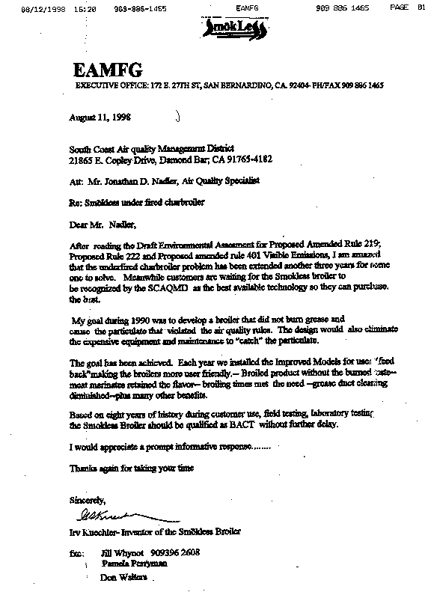
1-1

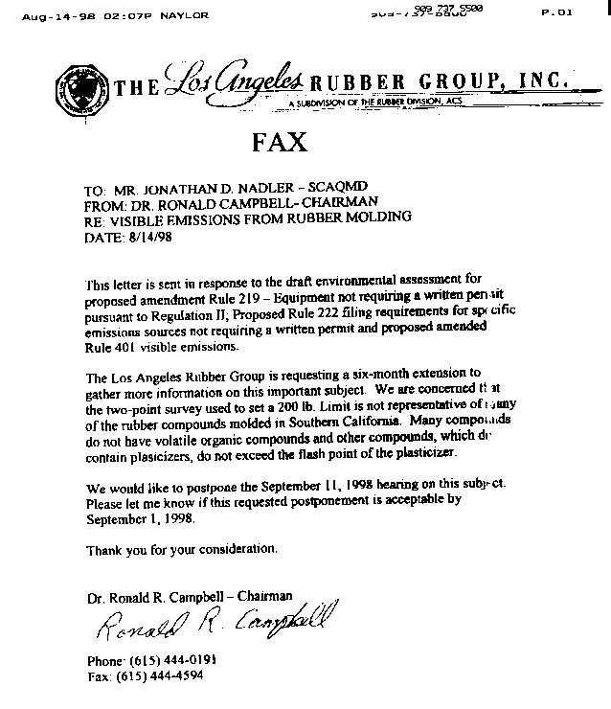
2-1
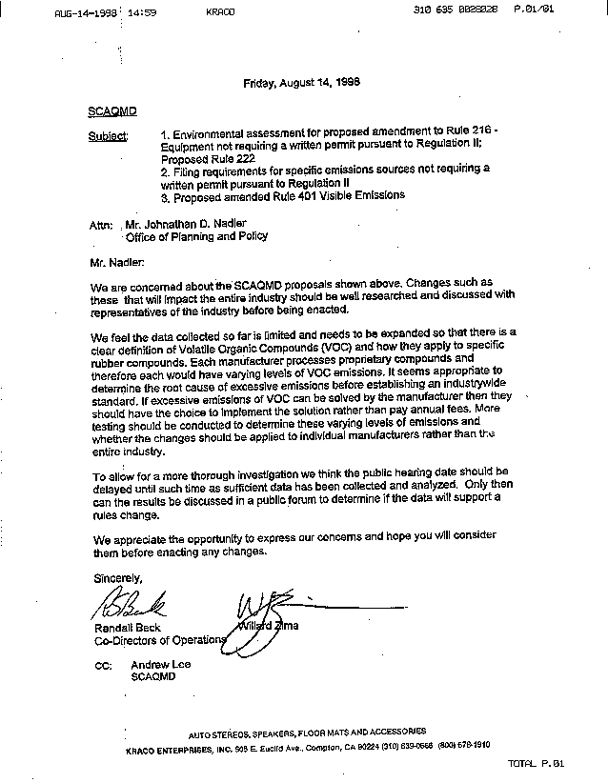
3-1
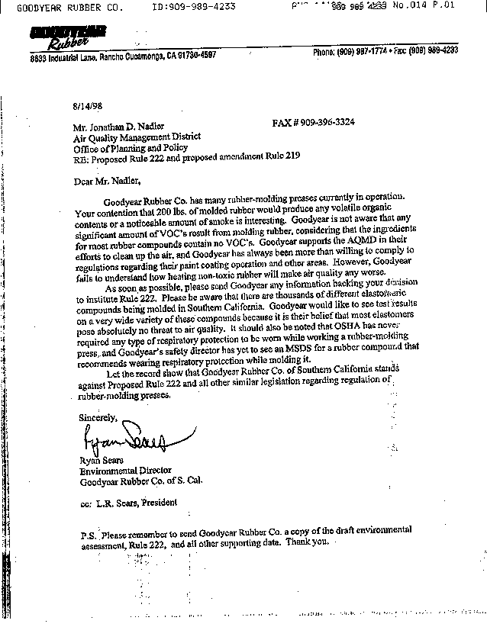
4-1

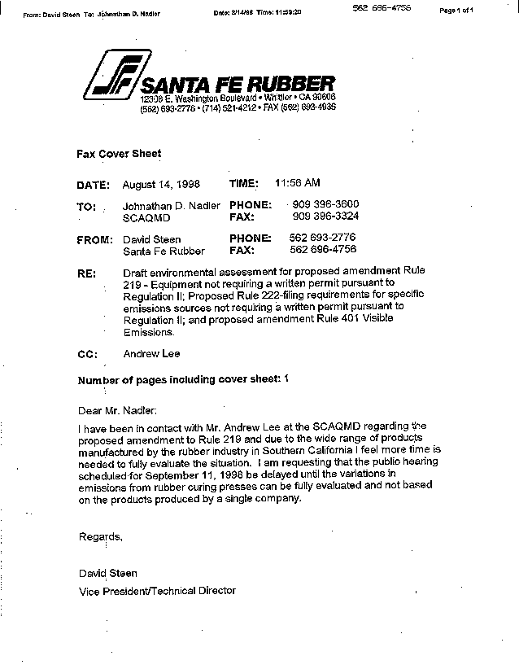
5-1

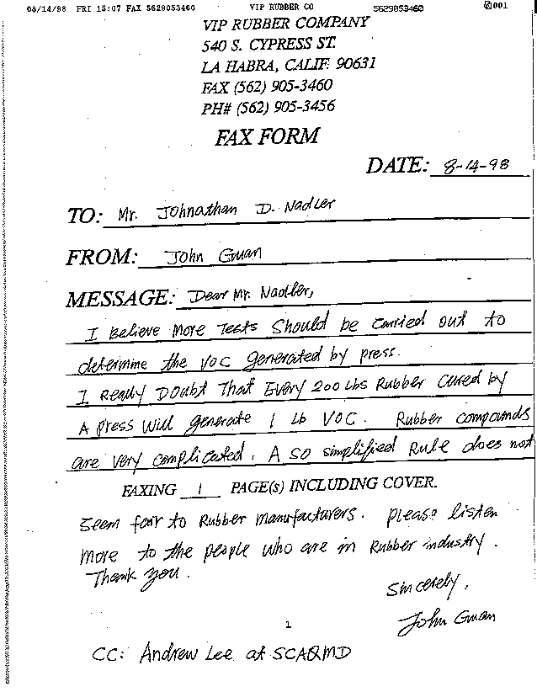
6-1

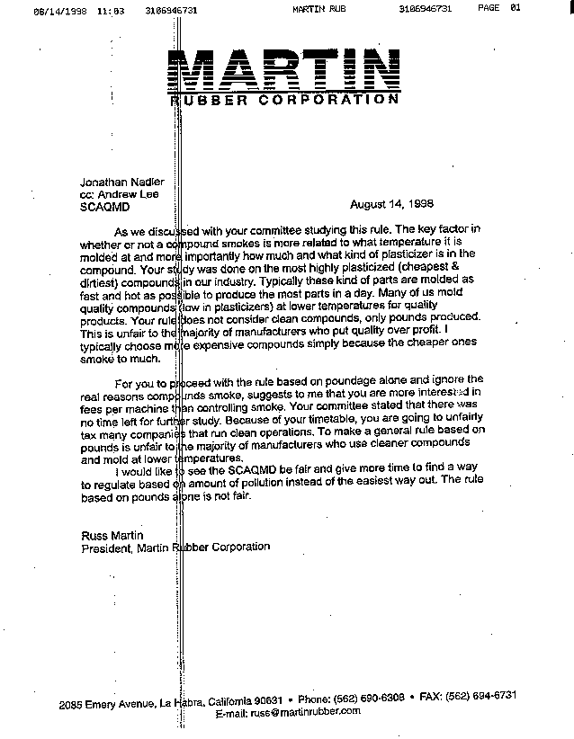
7-1

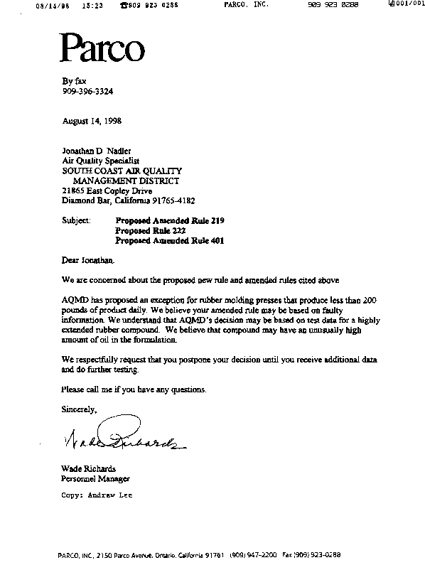
8-1

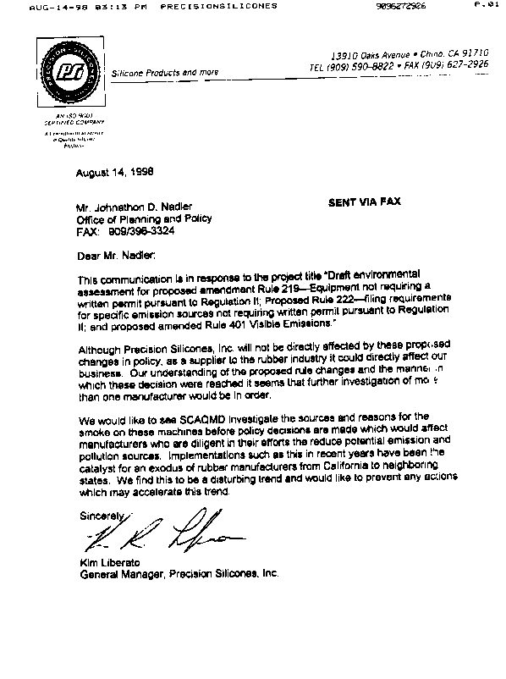
9-1

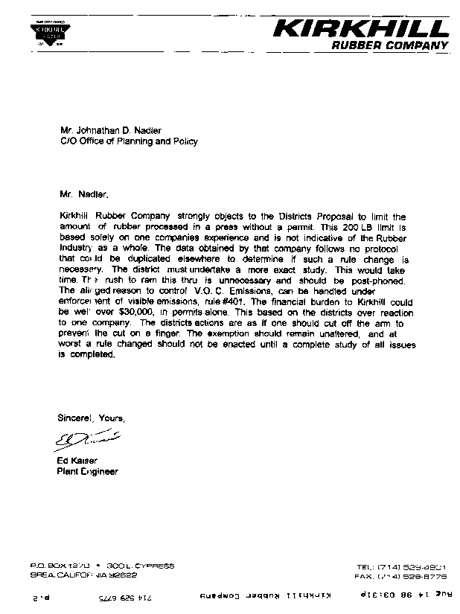
10-1
comment letter #1
EAMFG
August 13, 1998

  - The SCAQMD requires a Best Available Control Technology (BACT) analysis to be conducted on all permitted equipment. If a permit is not required, a BACT analysis is not conducted and BACT is not required. The determination of BACT is a process separate and distinct from rule development.

Existing Rule 219 – Equipment Not Requiring a Written Permit Pursuant to Regulation II, exempts from permits “equipment used in eating establishments for the purpose of preparing food for human consumption, excluding direct-fired charbroilers.” The Smokless Broiler is not considered a direct-fired charbroiler pursuant to AQMD rules and, thus, does not require an SCAQMD permit or an associated BACT determination. Further, the SCAQMD intends to remove the permit requirement for charbroilers pursuant to provisions of proposed Rule 222.

In summary, it would be inappropriate for the Smokless Broiler to be considered BACT for charbroilers since 1) it is not considered a charbroiler and is exempt from SCAQMD permits, and 2) proposed Rule 222 would remove charbroilers from the permit system and associated BACT requirements.

It must be noted that this determination in no way precludes customers from choosing the Smokless Broiler as an alternative to other cooking devices. An incentive for using the Smokless Broiler has been that it has not required an SCAQMD permit or associated fees.

Please note that the SCAQMD is currently developing amendments to Rule 1138 – Control of Emissions from Restaurant Operations, and is interested in this technology as a possible compliance option.

comment letter #2
The los angeles rubber group, inc.
August 14, 1998

  - The Environmental Assessment (EA) concluded that the potential environmental effects of the proposed Rule 219 modification for rubber manufacturing cannot be estimated at this time. This determination was made since this category of equipment is not currently subject to Regulation XIII – New Source Review, permits are not required, and Best Available Control Technology (BACT) has not been established. Potential emission reductions as well as potential secondary adverse effects which may accrue from control of the emissions from this equipment cannot be appraised at this time as the type and efficiency of control has not yet been determined.
Including or removing the Rule 219 proposal regarding rubber manufacturing would have no effect on the environmental analysis set forth in the EA. The California Environmental Quality Act (CEQA) document and determination would not change regardless of whether or not the proposed provision regarding rubber manufacturing is brought before the AQMD Governing Board or whether or not it is adopted.
Please see the Staff Report for the proposed project for more discussion of the proposed Rule 219 amendment regarding rubber manufacturing.

comment letter #3
kraco enterprises, inc.
August 14, 1998

3-1 Please refer to response to Comment # 2-1.

comment letter #4
goodyear rubber co.
August 14, 1998

4-1 Please refer to response to Comment # 2-1.

comment letter #5
santa fe rubber
August 14, 1998

5-1 Please refer to response to Comment # 2-1.

comment letter #6
vip rubber company
August 14, 1998

6-1 Please refer to response to Comment # 2-1.

comment letter #7
martin rubber corporation
August 14, 1998

7-1 Please refer to response to Comment # 2-1.

comment letter #8
parco, inc.
August 14, 1998

8-1 Please refer to response to Comment # 2-1.

comment letter #9
precision silicones, inc.
August 14, 1998

9-1 Please refer to response to Comment # 2-1.

comment letter #10
kirkhill rubber company
August 14, 1998

10-1 Please refer to response to Comment # 2-1.

Equipment included in Rule 222 would still be subject to all other applicable SCAQMD rules.
Laser sintering refers to the process of fusing a material by pressure and heat below the melting point. Laser sintering equipment used with nylon or plastic powders is used mainly in the aerospace industry to develop prototype or small scale models from computer drawings. A 3-dimensional drawing is created utilizing a computer. Appropriate materials are fed into the sintering machine. The machine reads the computer drawing and moves a laser beam on a thin layer of powder, one layer on top of another. The heat from the laser is just hot enough to make the polymer particles fuse together and bind to form the proper model. The particles are fused together as the sintering temperature is below the melting point of the material.
The exact specification of which rubber operations would or would not require permits may change. Modifying the specifications would not affect the environmental analysis.
Wet gate film printing utilizes a solvent as an integral part of the printing process. Perchloroethylene is used in the wet gate printing process due to its unique optical qualities. Perchloroethylene has a refractive index which allows the printing of film without the transfer of imperfections from the negative (e.g., scratches).
The United States Bureau of Mines publishes standardized opacity values in the form of a Ringelmann Chart. The opacity values range from Ringelmann No. 1 to Ringelmann No. 5, with No. 1 being the lightest and No. 5 the darkest.
Copies of Regulation XIII can be obtained from the SCAQMD’s Public Information Center by calling (909) 396-3600 or from the SCAQMD’s World Wide Website at www/aqmd.gov.
Recent emission testing performed during the development of Rule 1138 indicates that under-fired charbroilers cooking more than 42 pounds of meat per day could result in one pound of PM10 emissions. Current permitting practice, however, retains 125 pounds of cooked meat per day as the threshold for triggering BACT. While future rule development for under-fired charbroilers will refine the emission profile of this emission source, the analysis in this EA appropriately considers the emission profile used for permitting.
The United States Bureau of Mines publishes standardized opacity values in the form of a Ringelmann Chart. The opacity values range from Ringelmann No. 1 to Ringelmann No. 5, with No. 1 being the lightest and No. 5 the darkest.

