A P P E N D I X C

C O M M E N T S O N T H E D R A F T E A A N D R E S P O N S E S

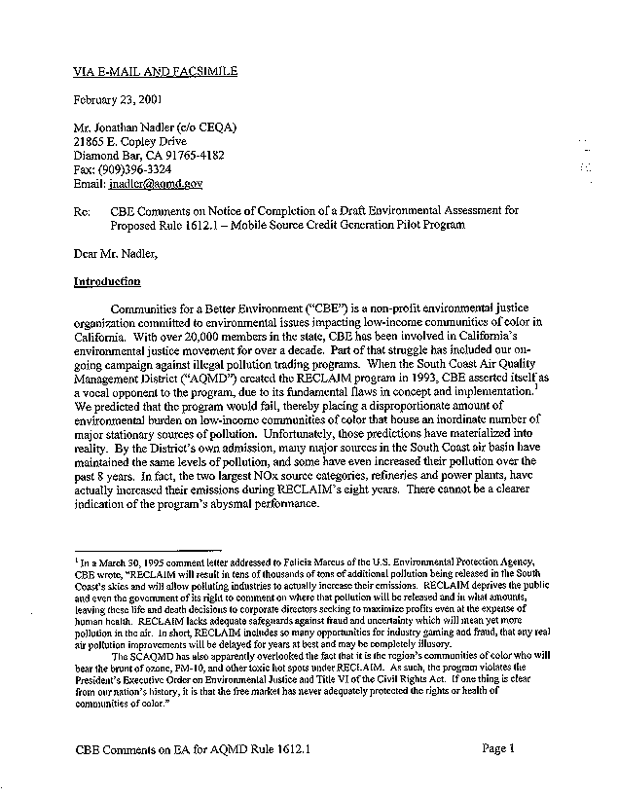
1-1

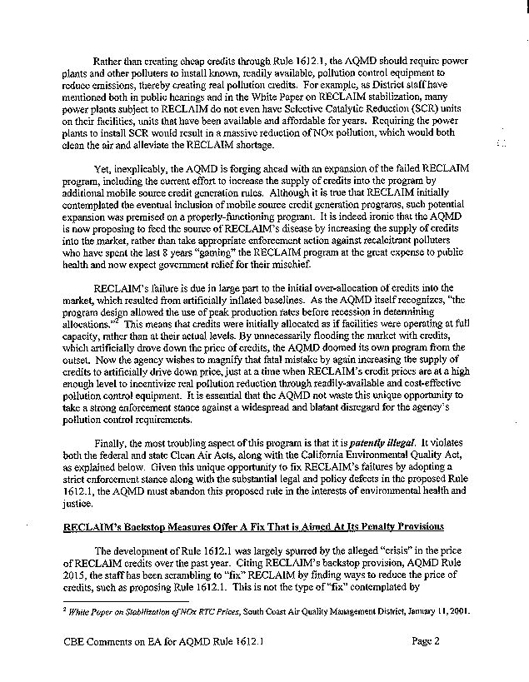
1-1
cont.
1-2

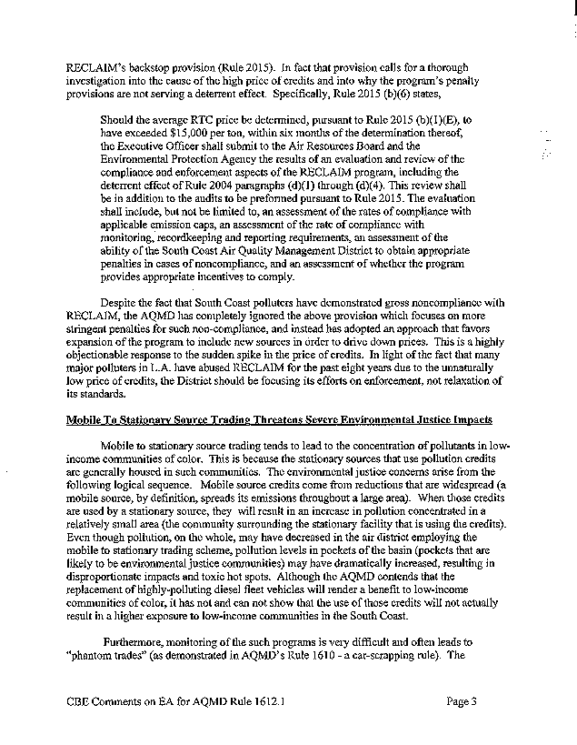
1-2
cont.
1-3
1-4

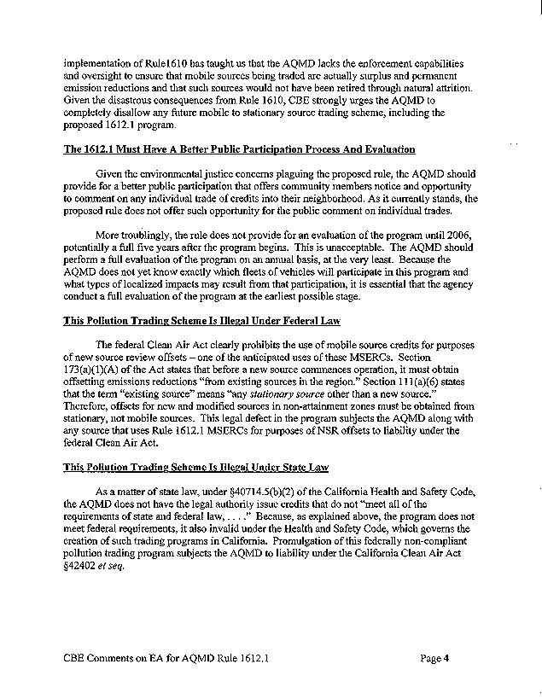
1-4
cont.
1-5
1-6
1-7

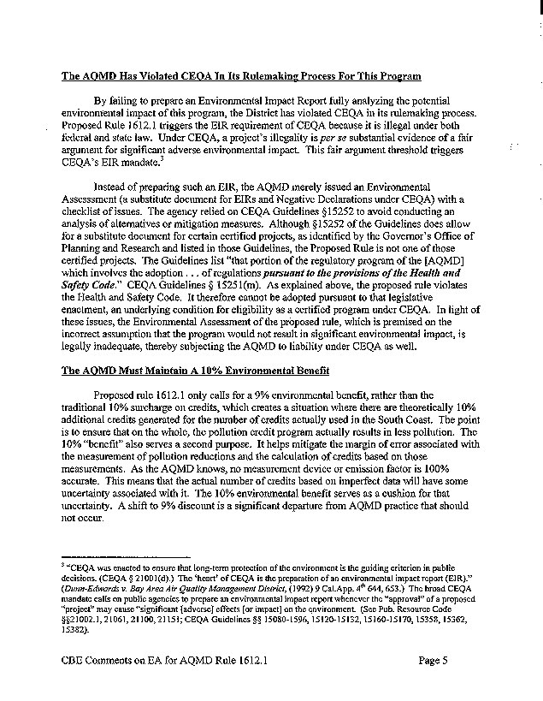
1-8
1-9

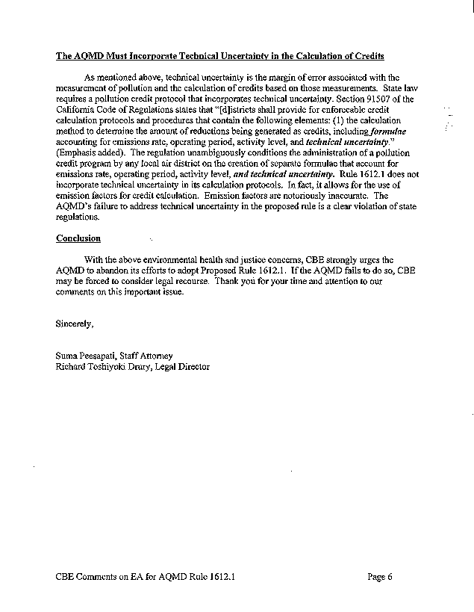
1-10
1-11

COMMENT LETTER 1
COMMUNITIES FOR A BETTER ENVIRONMENT
February 23, 2001

- The SCAQMD does not agree with the commentator that RECLAIM is illegal or that the program has failed. From 1994 to 1999, NOx emissions, in aggregate, were below allocations, and compliance rates were high. Beginning June 2000, a sharp and sudden price increase occurred, mainly due to the increased demand from the electric power industry.
SCAQMD is proposing several changes to the RECLAIM program, which is a separate process from PR 1612.1. The CEQA analysis for the proposed RECLAIM changes will address use of MSERCs by RECLAIM facilities. Original allocations and other issues raised are not relevant to PR 1612.1. The commentator focuses primarily on the proposed amendments to RECLAIM, which are independent of PR 1612.1. RECLAIM, adopted in 1993, already allows the use of mobile source credits (see Rule 2008) and PR 1612.1 does not change the RECLAIM program.
PR 1612.1 was developed independently from recent issues surrounding the stabilization of RTC prices in the RECLAIM trading market. The SCAQMD staff began working with the trading working group, including representatives of the environmental community, on the concepts for PR 1612.1 in May 2000, well before RECLAIM credit issues began to surface. The impetus for developing PR 1612.1 was to develop a mobile source credit generation pilot program that would meet state and federal approvability requirements.
PR 1612.1 has been carefully designed with input from EPA, ARB, the business and environmental communities to ensure emission reductions meet state and federal requirements. PR 1612.1 is a “credit generation” protocol for generating NO_{x} mobile source emission reduction credits (MSERCs). PR 1612.1 specifies under subdivision (l) that “MSERCs generated under this rule may be used as RTCs under the provisions of Regulation XX – RECLAIM. Thus the “credit use” provisions for using MSERCs reside under the RECLAIM rules.
When the RECLAIM program was adopted in October 1993, Rule 2008 – Mobile Source Credits allowed mobile source emission reductions generated by Rule 1610 and future 1600 series rules to be used as RTCs. The objective as stated in the RECLAIM October 1993 Staff Report is to “provide the opportunity for RECLAIM facilities to pursue the most cost-effective approach to reduce facility emissions – through stationary source emission controls or possibly by reducing mobile source emissions through old-vehicle scrapping.” Although Rule 1610 was the only mobile source credit generation rule at the time of adoption of Regulation XX, future mobile source credit generation rules were anticipated. As stated in the October 1993 RECLAIM Staff Report, “the District is currently developing other Regulation XVI rules that will be applicable to RECLAIM facilities through Rule 2008.” In addition, these future Regulation XVI rules, “would allow facility credits for emission reductions from these on-site/off-road equipment.”
The Draft Environmental Assessment (DEA) for PR 1612.1 analyzes the impacts for generating NO_{x} MSERCs from replacing diesel-fueled heavy-duty vehicles and yard hostlers with similar vehicles and yard hostlers powered with clean technologies. The analysis concluded that project implementation would not result in significant adverse impacts. Impacts associated with using MSERCs under RECLAIM were analyzed during the adoption of the RECLAIM program and will be part of the analysis for the pending RECLAIM rule changes.
Issues surrounding use of credits versus installing pollution control equipment is a RECLAIM issue and were addressed at the time RECLAIM was adopted in 1993. The SCAQMD staff is working with a RECLAIM Working Group to develop proposed amendments to the RECLAIM rules to address California energy issues and market stability and price issues.
- Proposed amendments to the RECLAIM rules are scheduled for a May 11, 2001 SCAQMD Governing Board meeting. The SCAQMD staff is working with the RECLAIM Working Group on amendments to RECLAIM rules to address stabilization of RTC prices. Initial proposed amendments are designed to strengthen the RECLAIM program by requiring utilities to submit compliance plans and install pollution control equipment. None of the proposed amendments would make changes to Rule 2008, which already allows the use of mobile source credits in the RECLAIM program. Proposed rule language and a preliminary draft staff report for proposed amendments to Regulation XX can be accessed via http://www.SCAQMD.gov/rules/reclaim/reclaim_home_page.html or from the SCAQMD’s Public Information Center.
- As documented in the Draft EA, the ability of stationary sources to use RTCs for regulatory compliance is already set forth in the provisions of Regulation XX. Since PR 1612.1 does not alter a stationary source’s ability to use credits as a means of compliance with RECLAIM, the proposed project would not alter the existing setting relative to this issue and, thus, would not be considered an impact under CEQA. The use of MSERCs in the RECLAIM credit market is an inherent part of the program. Nevertheless, as part of the effort to address concerns relative to localized impacts, staff intends to track the use of credits and report the findings to the Governing Board as part of PR 1612.1 implementation.
As further documented in the Draft EA, regional air quality benefits would accrue from 1) the rule provision that automatically retires nine percent of MSERCs generated for the benefit of the environment, 2) the non-credited reduction of diesel emissions components other than NOx, and 3) the accelerated and increased replacement of heavy-duty diesel vehicles with alternative clean fuel vehicles.
Localized benefits would accrue in those areas where participating heavy-duty vehicle diesel engine emissions are concentrated. While NOx credits (at a 10 percent discount) would be used by RECLAIM facilities, there would be reductions of particulate and toxic air contaminant emissions that are not eligible for PR 1612.1 credits from replacement of heavy-duty diesel-fueled vehicles. These localized benefits are notable since particulate matter in the exhaust of diesel–fueled engines is considered a toxic air contaminant (based on data linking diesel particulate emissions to increased risks of lung cancer and respiratory disease).
Additionally, SCAQMD staff is bringing a series of proposals to the SCAQMD Governing Board for potential modifications to the RECLAIM program (i.e., Regulation XX) to address current issues regarding the cost and availability of RTCs. The proposed amendments to Regulation XX are currently undergoing CEQA review that will include, as applicable, examination of potential adverse air quality impacts in the vicinity of RECLAIM facilities and possible increased use of MSERCs for conversion to RTCs.
- Please refer to Response to Comment #1-1. As previously stated, PR 1612.1 is not an amendment to the existing RECLAIM program. RECLAIM allows mobile to stationary source trades. The SCAQMD staff is aware that CBE is fundamentally opposed to the use of mobile source credits and sensitive to the issues raised by the environmental community regarding trading issues. As a result, PR 1612.1 is limited in scope and has been developed as a pilot program, where no applications to generate credits will be accepted after January 1, 2003.
As indicated in the Draft Staff Report, no Regulation XVI rule has been federally approved. As a result, the primary objective for developing PR 1612.1 is to work with stakeholders to develop a mobile source credit generation rule that can meet state and federal requirements.
Over the past 10 months, the SCAQMD staff has worked closely with EPA and ARB to ensure that PR 1612.1 meets state and federal requirements and will be enforceable. The following highlights some key elements of PR 1612.1 to ensure that emission reductions are enforceable:
- Requires credit generators to submit an Application prior to generating credits, which is an enforceable document, which will document the credit generation project.
- Contingent on credit generation and issuance, requires credit generator to demonstrate proof of delivery of the new replacement vehicle and proof of transfer of ownership of the replaced vehicle.
- Requires a written certification or signed declaration that the replaced vehicle has not and will not be operated in the district.
- Requires maintenance of quarterly records of the activity level for the project.
- Establishes penalty requirements for the generator and user, to ensure no shortfall in emission reductions will occur.
In addition, the proposed rule requires that existing diesel-fueled vehicles are replaced with heavy-duty vehicles with an engine that is “certified” to meet an ARB NO_{x} optional credit standard, and concurrence by EPA. This engine certification holds the engine manufacturer responsible for achieving the optional emission factor for the life of the engine. ARB has the authority to enforce engine manufacturers’ warranties and guarantees for emissions certifications, thereby strengthening the enforcement of PR 1612.1.
  - Credit use provisions are established under the RECLAIM program. The RECLAIM program allows facilities to trade RTCs and RTCs converted from MSERCs without public notification. PR 1612.1 does not change any aspect of RECLAIM. Regardless if a facility is using an RTC or an RTC that was converted from an MSERC to offset emission, the emissions still exist.
Notifying community members for each individual trade may not be meaningful to the surrounding community, particularly when some trades may be to a broker or credits traded may not be used. In addition, it is difficult to determine if a particular RTC is actually used, if the facility has excess RTCs at the end of their cycle since the facility may have a mix of RTCs and RTCs that originated from MSERCs.
PR 1612.1 does include a periodic program review that includes a report to the Governing Board that will be available for public review. Under subdivision (n) of the Proposed Rule, the Executive Officer is required to review and present a report to the Governing Board on or before March 2002 and every two years thereafter. The objective of the report is to inform stakeholders of the efficacy of the program. The report will include, but is not limited to, the following information:
- General description of projects participating in the pilot program and the amount of NOx MSERCs, including the amount converted to RTCs;
- The location of the credit generation projects and facilities using RTCs;
- The amount of NOx MSERCs retired to benefit the environment; and
- The amount of concurrent non-NOx emission reductions that have been retired to benefit the environment.
The source category evaluation that the commentator referenced is different than the program review. The source category evaluation is the evaluation that the SCAQMD, ARB, and EPA will complete on Class 7 and 8 vehicles and yard hostlers to determine whether future MSERCs need to be either discontinued or discounted to ensure credits are surplus. The commentator is correct that the first year that source category evaluation will occur is 2006. Prior to 2006, the three agencies agree that credits generated are surplus. The source category evaluation will occur every year thereafter, unless another schedule is agreed to by the three agencies.
1-6 State and federal law allows stationary sources to use mobile source credits. The RECLAIM program, including Rule 2008 was approved by CARB and EPA as complying with all state and federal laws including the Clean Air Act (CAA). The SCAQMD’s authority in state law to achieve emission reductions across a spectrum of sources, “including mobile, area, and stationary, which are within the district’s jurisdiction” which the district is authorized to include in a market-based emissions trading program.
The federal CAA does not prohibit the use of mobile source credits for offsetting under New Source Review. The commentator misinterprets the language of §173(a)(1)(A), which does not specify that all offsets must be from stationary sources. EPA has allowed MSERCs for stationary sources. Moreover, §173(a)(1)(A) does not require that each individual trade or permit gets offsets from another stationary source to demonstrate that a net reduction occurs, rather the evaluation is programmatic. The SCAQMD has demonstrated that RECLAIM, with all of its provisions, meets reasonable further progress required by the CAA.
Further, EPA has recently released its final guidance on Economic Incentive Programs (EIP). This guidance was developed pursuant to the CAA and recognizes the use of the CAA compliant programs such as RECLAIM in meeting attainment goals. The program may be used in both attainment and nonattainment areas and may include mobile, stationary, or area sources, and credits may also be used for New Source Review offsetting.
  - California Health and Safety Code §40440.1 requires the District to include mobile source credits in the market-based incentive program, RECLAIM. Health and Safety Code §39607.5 required the state to adopt a program to ensure that such credits are used in a manner that is consistent with state and federal requirements and RECLAIM credits do meet these requirements. The commentator asserts that the only problem with the use of MSERCs as a matter of state law is that the use does not comply with federal law. Since the credits comply with federal law, see Response #1-6, and meet the requirements of state law, RTCs generated from mobile sources comply with the requirements of Health and Safety Code §40714.5.
1-8 Comment 1-8 is predicated on the allegation that credits generated under PR 1612.1 may not be used in RECLAIM. The commentator has not alleged that the crediting of MSERCs by itself is illegal. RECLAIM is a program that is in full compliance with state and federal laws and has been approved by both CARB and EPA as a program that does meet state and federal requirements. The impacts of MSERC use were analyzed in 1993 with the adoption of the RECLAIM program. As discussed above, PR 1612.1 does not change the RECLAIM program in any way.
The SCAQMD disagrees that the proposed rule is an illegal program. In fact, as described in responses to comments 1-6 and 1-7, it is a program that is required by state law. Hence, the SCAQMD disagrees that there is per se a significant adverse impact. The SCAQMD thoroughly assessed the proposed project and prepared the document that was appropriate under CEQA. The SCAQMD did not rely on CEQA Guidelines §15252 “to avoid conducting an analysis of alternatives or mitigation measures.” Although the SCAQMD does have a certified regulatory program, the SCAQMD determined that the project as proposed has no significant adverse environmental impacts and the analysis of alternatives and mitigation measures is not require under CEQA or the SCAQMD certified regulatory program.
  - Implementation of PR 1612.1 will provide a nine percent environmental benefit relative to NO_{x} reductions and an environmental benefit from emission reductions of other non-NO_{x} criteria pollutants and toxic air contaminants, including diesel. In addition, any MSERCs or MSERCs that are converted to RTCs that are not used by the expiration date will be retired to benefit the environment. The overall environmental benefit is expected to exceed the required 10 percent environmental benefit since concurrent non-NO_{x} emission reductions will be fully retired. This information will be included in the program review as part of the evaluation of the pilot program.
  - The NO_{x} optional credit standard (or emission factor) used under PR 1612.1 are tested under a rigorous protocol established by the state that accounts for durability and deterioration of the engine that accounts for technical uncertainty. The optional emission factors used to calculate emission credits under PR 1612.1 are based on testing procedures in accordance with Title 13, Section 1956.8, California Exhaust Emission Standards and Test Procedures – 1985 and Subsequent Model Heavy-duty Diesel Vehicles and Engines. This state testing procedure is used for determining mandatory and optional emission factors.
Certification of an engine using ARB’s testing procedure is designed to account for the emissions throughout the engine’s useful life. The testing procedure requires that the engine operate 1,000 hours. For heavy-duty diesel vehicles, the emissions are then extrapolated to account for using the vehicle for 290,000 miles. This data is used to calculate a deterioration factor that is applied to the emission factor of the engine. The combination of durability testing and application of a deterioration factor for the specific engine type must be below the certified optional emission factor.
PR 1612.1 requires that engines be certified to meet the optional emission factor. “Certification” of an engine means that the manufacturers must warrantee and guarantee that the emissions of the engine will be below the certified emission factor for the life of the engine (290,000 miles for a heavy-duty diesel engine). In addition, under ARB’s certification program, ARB has the authority for enforcement to ensure that manufacturers meet their emissions obligations.
ARB requires that the optional emission factor be, at a minimum, 30 percent below the mandatory emission standard. This provides greater assurance that the manufacturer made an overt effort to lower the emissions and emission reductions are real and surplus. In addition, under ARB’s certification program lower emission factors below 30 percent of the mandatory standard are rounded to the next lower half-gram increment. This accounts for the certainty in emissions testing and to ensure that reductions are real and surplus.
1-11 The SCAQMD respectfully disagrees with the commentator. Implementation of the proposed rule is expected to provide environmental and health benefits from the accelerated turnover of diesel-fueled vehicles to those powered with a clean technology. In addition, retiring a percentage of emission reductions to benefit the environment and retiring non-NO_{x} emission reductions that occur from implementing a project under the proposed rule is expected to provide environmental and health benefits for the neighborhoods in which these vehicles are used. The SCAQMD staff will continue to work with the commentator to further address issues raised in this comment letter.

